
Ecology
Trophic Trouble
Simulation: edtechsims.com/trophic-trouble
Name: ____________________ Class: ______ Date: _______

Part A: Escape from Elmbrook Wood
On the sim: Choose Solo or Team mode. Solve at least 4 of the 6 stations (3 questions each) to unlock the Final Vault. In the vault, predict how 5 populations change; you need 4 of 5 correct.
A1 Record your progress. For each station you solve, note one misconception it warned you about.
Station | Solved (✓) | Misconception I learned about
Who Eats Whom?
Trophic Ladder
The Energy Leak
Falling Leaves
Rain on the Hill
Relationship Status
A2 Record your Final Vault case and results.
Vault case | Correct predictions | Final time
 | / 5

Part B: Station Practice
The game's questions vary. Use these questions, based on the food web in Fig. 1, to practise the same skills.
B1 Who Eats Whom?
Rabbits and mice eat grass. Mice also eat acorns from the oak tree. Caterpillars eat oak leaves. Blue tits eat caterpillars. Foxes eat rabbits and mice. Hawks eat rabbits, mice and blue tits.
(a) Draw arrows on Fig. 1 to complete the food web. [3]
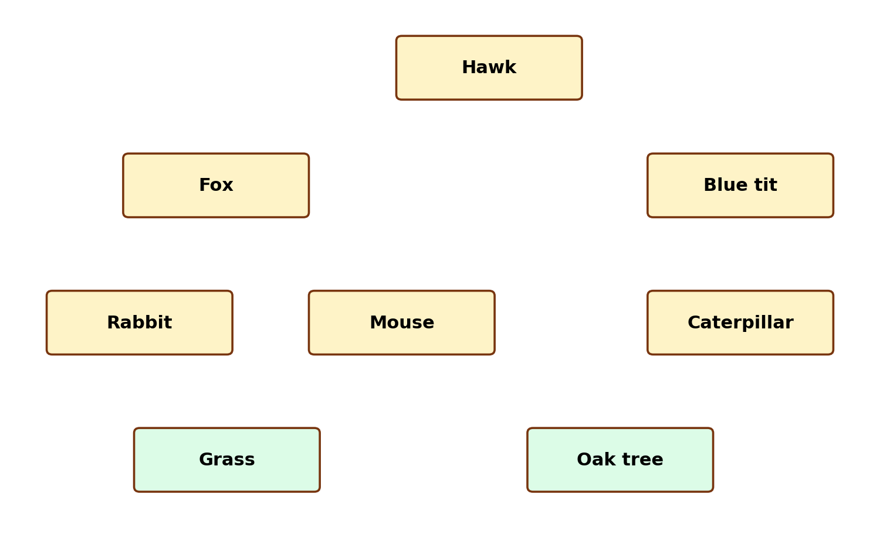
Fig. 1
(b) What does the direction of an arrow in a food web show? [1]

B2 Trophic Ladder
Complete Table 1 using the food web in Fig. 1. [4]
Organism | Trophic level(s)
Grass
Oak tree
Rabbit
Mouse
Caterpillar
Blue tit
Fox
Hawk
Table 1
(b) Explain why the hawk occupies more than one trophic level. [1]

(c) Why are decomposers not placed on a single rung of the food chain? [1]

B2 The Energy Leak
(a) Grass traps 20 000 kJ of energy. Assuming 10% is passed on at each step, calculate the energy reaching each level in grass → rabbit → fox. [2]
rabbit = ............ kJ fox = ............ kJ
(b) State three ways energy is lost between trophic levels. [3]

(c) Fig. 2 shows three pyramids for oak tree → caterpillar → blue tit. Which is the pyramid of numbers, and which is the pyramid of biomass? Explain. [3]
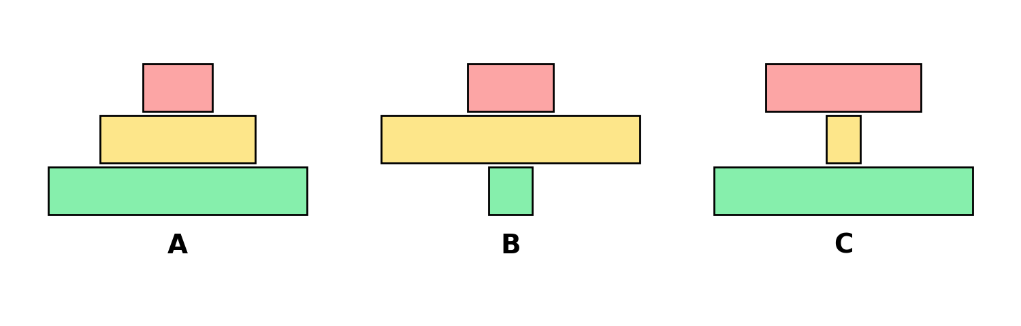
Fig. 2

B4 Falling Leaves
(a) Fig. 3 shows part of the carbon cycle. Name the processes P to V. [4]
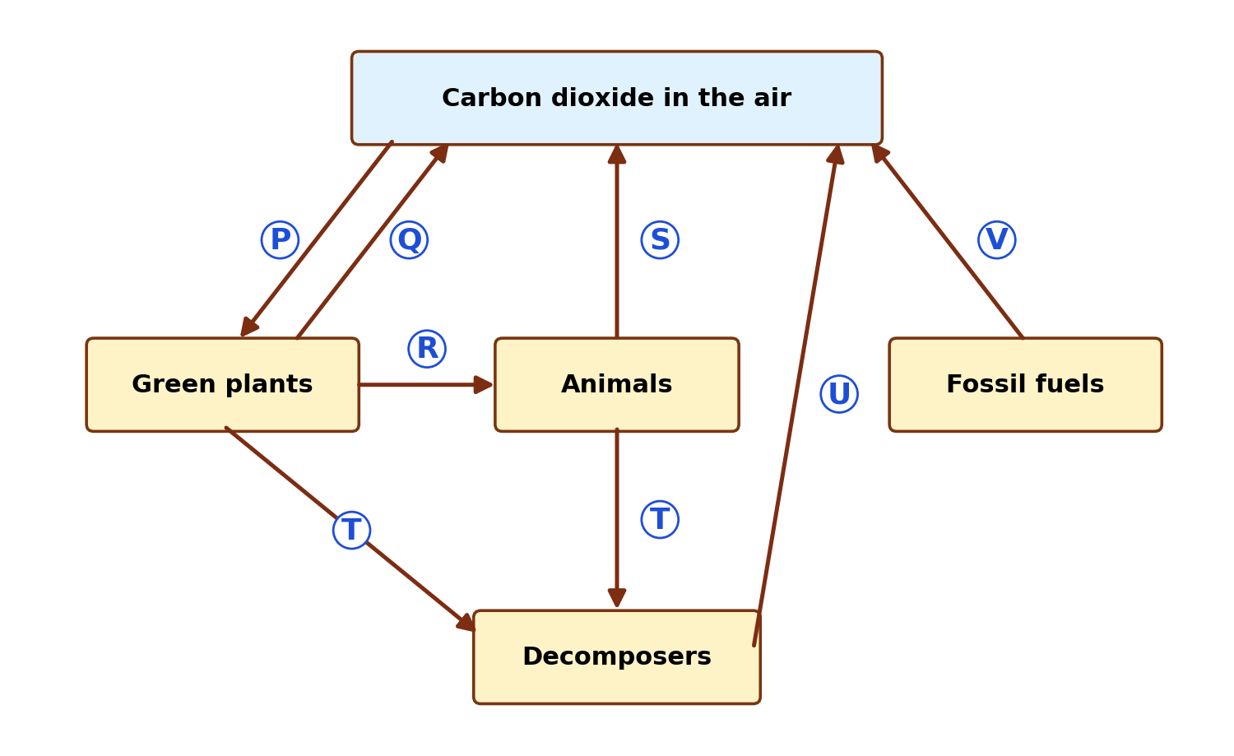
Fig. 3
P: ...................................... Q: ......................................
R: ...................................... S: ......................................
T: ...................................... U: ......................................
V: ......................................
(b) Predict what would happen to the leaf litter and to the CO₂ released if there were fewer decomposers in Elmbrook Wood. [2]

B5 Rain on the Hill
(a) Number the stages of the water cycle from 1 to 5, starting with water in the sea. [2]
Stage | Order
Water vapour cools and condenses to form clouds
Water evaporates from the sea
Water flows back to the sea as run-off and through rivers
Water vapour rises into the air
Water falls as rain (precipitation)
(b) Number the route water takes through a plant, from 1 to 5. [2]
Stage | Order
Water evaporates from mesophyll cells into air spaces
Water enters root hair cells by osmosis
Water vapour diffuses out through the stomata
Water moves up the xylem vessels
Water moves across the root cortex
(c) Explain the difference between evaporation and transpiration. [2]

B6 Relationship Status
Classify each relationship and give its signs (+, − or 0). [6]
Scenario | Relationship | Signs
A tapeworm lives in the human gut and absorbs digested food.
Bees collect nectar from flowers and carry pollen between them.
Barnacles attach to a whale to be carried to food-rich waters; the whale is unaffected.
A lion hunts and eats a zebra.
A clownfish shelters in a sea anemone and keeps it free of parasites.
Mistletoe grows on a tree and takes water and minerals from it.

Part C: The Final Vault
Case: A farmer sprays a pesticide that kills most of the caterpillars in Elmbrook Wood (Fig. 1). Predict what happens to each population, and explain.
Population | Increase / Decrease / Same | Reason
Caterpillar
Oak tree
Blue tit
Hawk
Mouse

Part D: Practice Questions
D1 In a food chain, the producers trap 15 000 kJ of energy and the primary consumers receive 1 200 kJ. Calculate the percentage of energy transferred. [2]
percentage = ................ %
D2 Explain why food chains rarely have more than four or five trophic levels. [2]

D3 Large areas of forest are cut down and burned. Explain how this affects the carbon dioxide concentration in the air. [3]

TEACHER COPY
Answer Key: Trophic Trouble

Part A: Escape from Elmbrook Wood
On the sim: Choose Solo or Team mode. Solve at least 4 of the 6 stations (3 questions each) to unlock the Final Vault. In the vault, predict how 5 populations change; you need 4 of 5 correct.
A1 Record your progress. For each station you solve, note one misconception it warned you about.
Station | Solved (✓) | Misconception I learned about
Who Eats Whom?
Trophic Ladder
The Energy Leak
Falling Leaves
Rain on the Hill
Relationship Status
Student's own records. Examples: arrows drawn from predator to prey; decomposers placed on a consumer level; thinking energy is recycled; confusing pyramids of numbers and biomass; mixing up evaporation and transpiration; calling any close relationship mutualism.
A2 Record your Final Vault case and results.
Vault case | Correct predictions | Final time
 | / 5

Part B: Station Practice
The game's questions vary. Use these questions, based on the food web in Fig. 1, to practise the same skills.
B1 Who Eats Whom?
Rabbits and mice eat grass. Mice also eat acorns from the oak tree. Caterpillars eat oak leaves. Blue tits eat caterpillars. Foxes eat rabbits and mice. Hawks eat rabbits, mice and blue tits.
(a) Draw arrows on Fig. 1 to complete the food web. [3]
Fig. 1
Arrows from food to feeder: grass→rabbit, grass→mouse, oak→mouse, oak→caterpillar, caterpillar→blue tit, rabbit→fox, mouse→fox, rabbit→hawk, mouse→hawk, blue tit→hawk.
(b) What does the direction of an arrow in a food web show? [1]
The direction in which energy flows (from the organism eaten to the organism that eats it).
B2 Trophic Ladder
Complete Table 1 using the food web in Fig. 1. [4]
Organism | Trophic level(s)
Grass | Producer
Oak tree | Producer
Rabbit | Primary consumer
Mouse | Primary consumer
Caterpillar | Primary consumer
Blue tit | Secondary consumer
Fox | Secondary consumer
Hawk | Secondary and tertiary consumer
Table 1
(b) Explain why the hawk occupies more than one trophic level. [1]
It eats primary consumers (mice, rabbits), making it a secondary consumer, and a secondary consumer (blue tit), making it a tertiary consumer.
(c) Why are decomposers not placed on a single rung of the food chain? [1]
They feed on dead organic matter and waste from every trophic level.

B3 The Energy Leak
(a) Grass traps 20 000 kJ of energy. Assuming 10% is passed on at each step, calculate the energy reaching each level in grass → rabbit → fox. [2]
Rabbit: 2 000 kJ. Fox: 200 kJ.
(b) State three ways energy is lost between trophic levels. [3]
Any three: heat from respiration; movement; undigested material in faeces; excretion (urine); parts not eaten (bones, roots); energy remaining in dead organisms passed to decomposers.
(c) Fig. 2 shows three pyramids for oak tree → caterpillar → blue tit. Which is the pyramid of numbers, and which is the pyramid of biomass? Explain. [3]
Fig. 2
Numbers: B. One oak tree supports many caterpillars, so the base is narrow. Biomass: A. The oak tree has a very large mass, so the base is widest and each level is smaller.
B4 Falling Leaves
(a) Fig. 3 shows part of the carbon cycle. Name the processes P to V. [4]
Fig. 3
P: photosynthesis. Q: respiration (plants). R: feeding. S: respiration (animals). T: death / decay (waste and dead matter). U: respiration by decomposers. V: combustion.
(b) Predict what would happen to the leaf litter and to the CO₂ released if there were fewer decomposers in Elmbrook Wood. [2]
Leaf litter would build up on the forest floor; less carbon dioxide would be returned to the air; nutrients would not be recycled.
B5 Rain on the Hill
(a) Number the stages of the water cycle from 1 to 5, starting with water in the sea. [2]
Stage | Order
Water vapour cools and condenses to form clouds | 3
Water evaporates from the sea | 1
Water flows back to the sea as run-off and through rivers | 5
Water vapour rises into the air | 2
Water falls as rain (precipitation) | 4
(b) Number the route water takes through a plant, from 1 to 5. [2]
Stage | Order
Water evaporates from mesophyll cells into air spaces | 4
Water enters root hair cells by osmosis | 1
Water vapour diffuses out through the stomata | 5
Water moves up the xylem vessels | 3
Water moves across the root cortex | 2
(c) Explain the difference between evaporation and transpiration. [2]
Evaporation is water turning to vapour from surfaces such as the sea and land. Transpiration is the loss of water vapour from plants, mainly through the stomata.
B6 Relationship Status
Classify each relationship and give its signs (+, − or 0). [6]
Scenario | Relationship | Signs
A tapeworm lives in the human gut and absorbs digested food. | Parasitism | + / −
Bees collect nectar from flowers and carry pollen between them. | Mutualism | + / +
Barnacles attach to a whale to be carried to food-rich waters; the whale is unaffected. | Commensalism | + / 0
A lion hunts and eats a zebra. | Predation | + / −
A clownfish shelters in a sea anemone and keeps it free of parasites. | Mutualism | + / +
Mistletoe grows on a tree and takes water and minerals from it. | Parasitism | + / −

Part C: The Final Vault
Case: A farmer sprays a pesticide that kills most of the caterpillars in Elmbrook Wood (Fig. 1). Predict what happens to each population, and explain.
Population | Increase / Decrease / Same | Reason
Caterpillar | Decrease | Killed directly by the pesticide.
Oak tree | Increase | Fewer caterpillars eat its leaves.
Blue tit | Decrease | Its only food source (caterpillars) falls.
Hawk | Stay about the same / decrease slightly | It loses blue tits but can switch to mice and rabbits.
Mouse | Decrease (accept increase with reasoning) | Hawks eat more mice to replace blue tits; accept increase if the student argues more acorns are available.

Part D: Practice Questions
D1 In a food chain, the producers trap 15 000 kJ of energy and the primary consumers receive 1 200 kJ. Calculate the percentage of energy transferred. [2]
(1 200 ÷ 15 000) × 100 = 8%
D2 Explain why food chains rarely have more than four or five trophic levels. [2]
Only about 10% of energy is passed on at each level; the rest is lost as heat, movement and waste. After four or five levels there is too little energy left to support another population.
D3 Large areas of forest are cut down and burned. Explain how this affects the carbon dioxide concentration in the air. [3]
Burning (combustion) releases CO₂ into the air. Fewer trees means less photosynthesis, so less CO₂ is removed. Both increase the CO₂ concentration.

