
Ecology
Trophic Trouble
Simulation: edtechsims.com/trophic-trouble
Name: ____________________ Class: ______ Date: _______

Part A: Escape from Elmbrook Wood
On the sim: Choose Solo or Team mode. Solve at least 4 of the 6 stations (3 questions each) to unlock the Final Vault. In the vault, predict how 5 populations change; you need 4 of 5 correct.
A1 Record your progress. For each station you solve, note one misconception it warned you about.
Station | Solved (✓) | Misconception I learned about
Who Eats Whom?
Trophic Ladder
The Energy Leak
Falling Leaves
Rain on the Hill
Relationship Status
A2 Record your Final Vault case and results.
Vault case | Correct predictions | Final time
 | / 5

Part B: Station Practice
The game's questions vary. Use these questions, based on the food web in Fig. 1, to practise the same skills.
B1 Who Eats Whom?
Rabbits and mice eat grass. Mice also eat acorns from the oak tree. Caterpillars eat oak leaves. Blue tits eat caterpillars. Foxes eat rabbits and mice. Hawks eat rabbits, mice and blue tits.
(a) Draw arrows on Fig. 1 to complete the food web. [3]
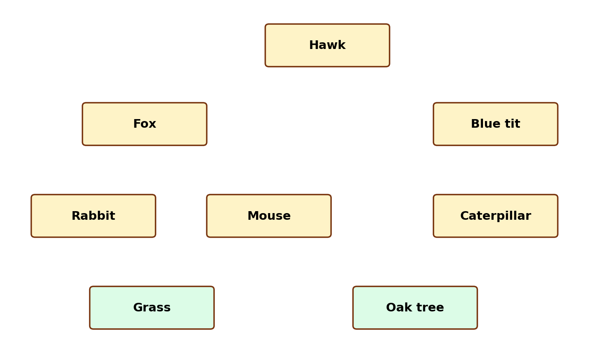
Fig. 1
(b) What does the direction of an arrow in a food web show? [1]

B2 Trophic Ladder
Complete Table 1 using the food web in Fig. 1. [4]
Organism | Trophic level(s)
Grass
Oak tree
Rabbit
Mouse
Caterpillar
Blue tit
Fox
Hawk
Table 1
(b) Explain why the hawk occupies more than one trophic level. [1]

(c) Why are decomposers not placed on a single rung of the food chain? [1]

B2 The Energy Leak
(a) Grass traps 20 000 kJ of energy. Assuming 10% is passed on at each step, calculate the energy reaching each level in grass → rabbit → fox. [2]
rabbit = ............ kJ fox = ............ kJ
(b) State three ways energy is lost between trophic levels. [3]

(c) Fig. 2 shows three pyramids for oak tree → caterpillar → blue tit. Which is the pyramid of numbers, and which is the pyramid of biomass? Explain. [3]
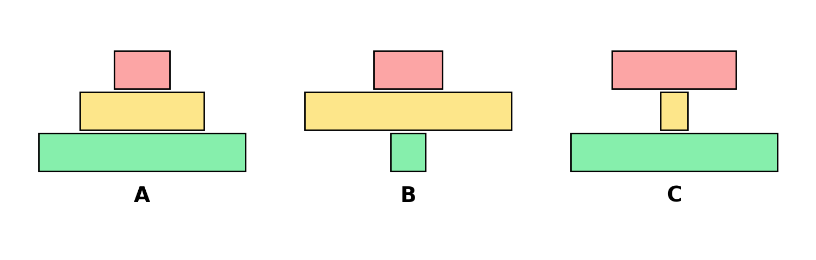
Fig. 2

B4 Falling Leaves
(a) Fig. 3 shows part of the carbon cycle. Name the processes P to V. [4]
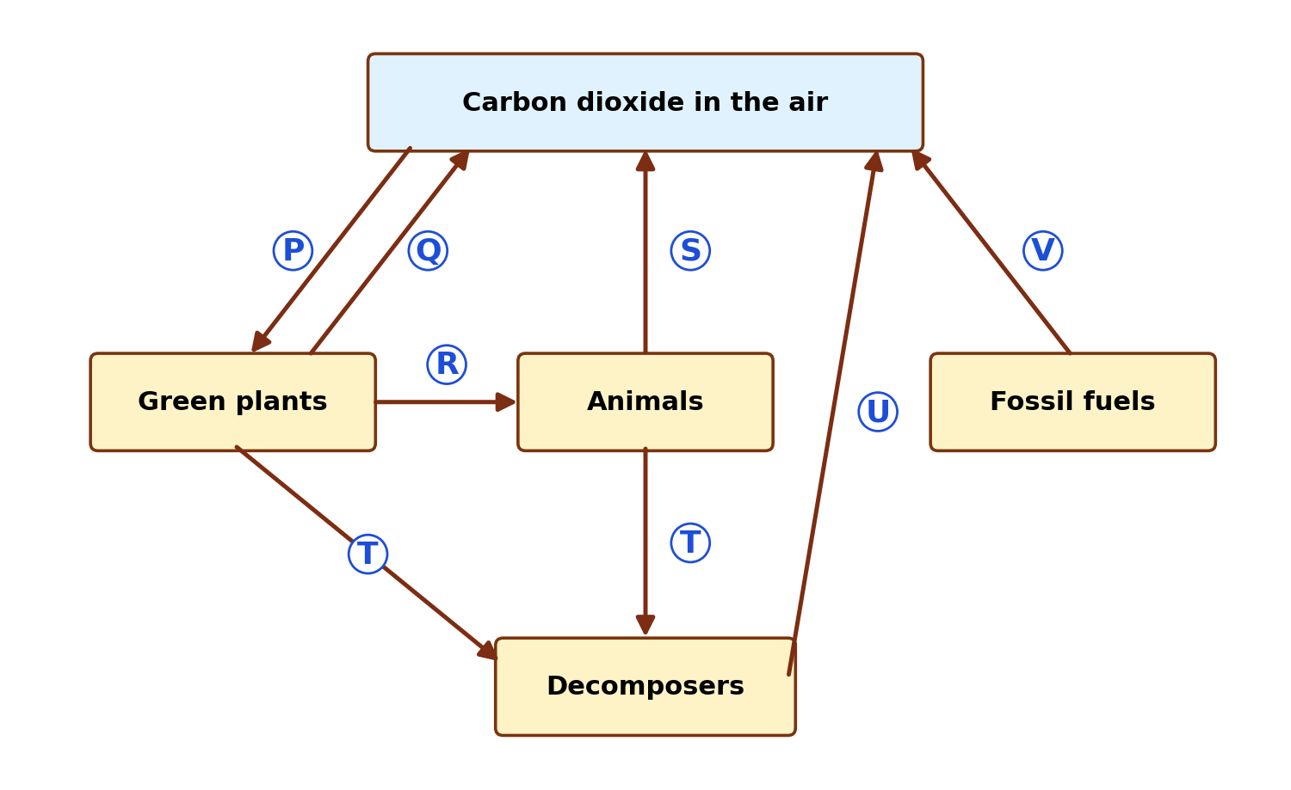
Fig. 3
P: ...................................... Q: ......................................
R: ...................................... S: ......................................
T: ...................................... U: ......................................
V: ......................................
(b) Predict what would happen to the leaf litter and to the CO₂ released if there were fewer decomposers in Elmbrook Wood. [2]

B5 Rain on the Hill
(a) Number the stages of the water cycle from 1 to 5, starting with water in the sea. [2]
Stage | Order
Water vapour cools and condenses to form clouds
Water evaporates from the sea
Water flows back to the sea as run-off and through rivers
Water vapour rises into the air
Water falls as rain (precipitation)
(b) Number the route water takes through a plant, from 1 to 5. [2]
Stage | Order
Water evaporates from mesophyll cells into air spaces
Water enters root hair cells by osmosis
Water vapour diffuses out through the stomata
Water moves up the xylem vessels
Water moves across the root cortex
(c) Explain the difference between evaporation and transpiration. [2]

B6 Relationship Status
Classify each relationship and give its signs (+, − or 0). [6]
Scenario | Relationship | Signs
A tapeworm lives in the human gut and absorbs digested food.
Bees collect nectar from flowers and carry pollen between them.
Barnacles attach to a whale to be carried to food-rich waters; the whale is unaffected.
A lion hunts and eats a zebra.
A clownfish shelters in a sea anemone and keeps it free of parasites.
Mistletoe grows on a tree and takes water and minerals from it.

Part C: The Final Vault
Case: A farmer sprays a pesticide that kills most of the caterpillars in Elmbrook Wood (Fig. 1). Predict what happens to each population, and explain.
Population | Increase / Decrease / Same | Reason
Caterpillar
Oak tree
Blue tit
Hawk
Mouse

Part D: Practice Questions
D1 In a food chain, the producers trap 15 000 kJ of energy and the primary consumers receive 1 200 kJ. Calculate the percentage of energy transferred. [2]
percentage = ................ %
D2 Explain why food chains rarely have more than four or five trophic levels. [2]

D3 Large areas of forest are cut down and burned. Explain how this affects the carbon dioxide concentration in the air. [3]

