
Sound
Sound Lab
Simulation: edtechsims.com/sound
Name: ____________________ Class: ______ Date: _______

Part A: Sound Waves (Tab 1)
On the sim: Open Tab 1. Read Key Concepts, then watch the loudspeaker push the air particles. Follow the red tracer particle.
A1 Fig. 1 shows the air particles in front of a vibrating loudspeaker.
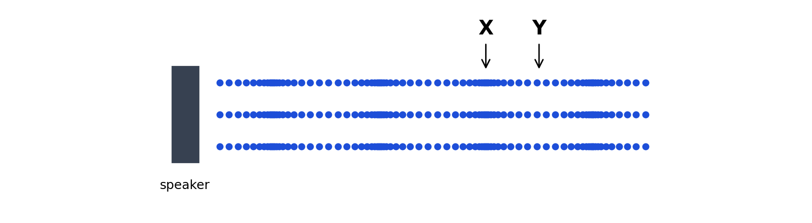
Fig. 1
(a) Name the regions labelled X and Y. [2]
X: ....................................................
Y: ....................................................
(b) On Fig. 1, draw a double-headed arrow to show one wavelength. Label it λ. [1]
A2 Describe the motion of the red tracer particle. Does it travel from the loudspeaker to the listener? [2]

A3 Complete the sentences. [3]
Sound is a ____________ wave: the particles vibrate ____________ to the direction in which the wave travels.
Sound is produced by ____________ objects.
A4 Use the frequency slider. Record the wavelength for three frequencies, then calculate f × λ. [3]
Frequency f / Hz | Wavelength λ / m | f × λ / (m/s)
What do you notice about f × λ?

Check Your Understanding score: ______ / ______

Part B: Sound Needs a Medium (Tab 2)
On the sim: Open Tab 2. Ring the bell, then pump the air out of the bell jar. Then run the speed race through air, water and steel.
B1 Describe what you hear as the air is pumped out. Explain why the hammer is still seen moving. [3]

B2 Why can astronauts not hear an explosion in space? [1]

B3 Record the speed of sound and the time taken to travel 1 km in each medium. [3]
Medium | Speed of sound / (m/s) | Time to travel 1 km / s
Air
Water
Steel
B4 Explain why sound travels fastest in solids and slowest in gases. [2]

Check Your Understanding score: ______ / ______

Part C: Pitch & Loudness (Tab 3)
On the sim: Open Tab 3. Use the CRO Tone Studio: change the frequency and amplitude sliders and listen. Then play Compare the Traces and Test Your Hearing Range.
C1 Complete the sentences. [4]
The pitch of a sound depends on its ____________. A higher frequency gives a ____________ pitch.
The loudness of a sound depends on its ____________. A larger amplitude gives a ____________ sound.
C2 Set the timebase to 1 ms/div. Choose a frequency, then count the divisions for one complete wave. [3]
Frequency set / Hz | Divisions for one wave | Period T / ms | f = 1 / T / Hz

C3 Record your hearing range from the hearing test. [2]
Lowest: ................ Hz Highest: ................ Hz
Compare the Traces score: ______ / 8 Check Your Understanding score: ______ / ______

Part D: Echo Method (Tab 4)
On the sim: Open Tab 4. Set a distance to the wall, start clapping in time with the echoes, and time 20 intervals with the stopwatch. Repeat for three readings.
D1 Complete Table 1. [4]
Reading | Distance d / m | Time for 20 intervals / s | Time for 1 interval t / s | v = 2d / t / (m/s)
1
2
3
Average speed of sound: ....................................................
D2 Why is the distance multiplied by 2 in v = 2d / t? [1]

D3 Why are 20 intervals timed instead of just one? [2]

D4 Suggest why the wall should be at least 50 m away. [1]

Check Your Understanding score: ______ / ______

Part E: Ultrasound (Tab 5)
On the sim: Open Tab 5. Move the ship, send a pulse and read the echo time. Calculate the depth, then reveal the seabed after five readings.
E1 What is ultrasound? [1]

E2 Record your sonar readings in Table 2. [4]
Position | Echo time t / s | Speed of sound in water / (m/s) | Depth = v × t ÷ 2 / m
1
2
3
4
5
E3 Did your map match the hidden seabed? Suggest one reason why your map may differ. [2]

E4 State two other uses of ultrasound. [2]

Check Your Understanding score: ______ / ______

Part F: Practice Questions
F1 A student stands 85 m from a tall wall and claps. She hears the echo 0.50 s later. Calculate the speed of sound in air. [2]
speed = ................ m/s

F2 Fig. 2 shows the trace of a sound on a CRO. The timebase is set to 1 ms/div.
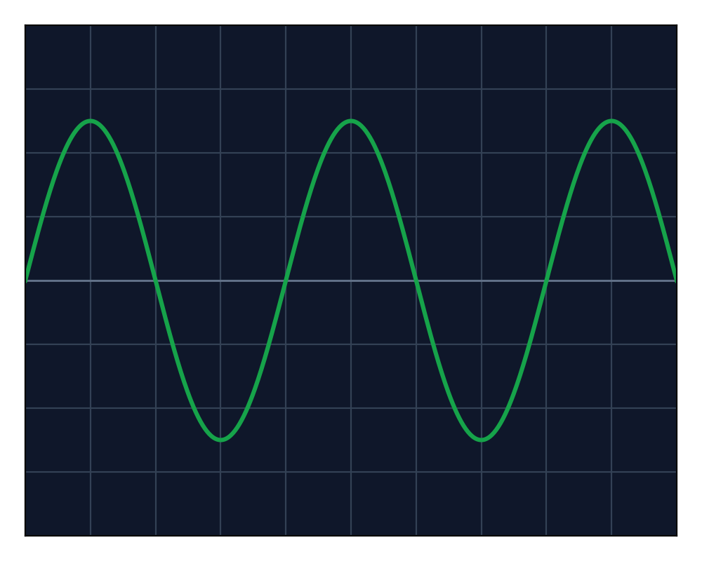
Fig. 2
(a) Calculate the frequency of the sound. [2]
frequency = ................ Hz
(b) The sound is made louder and its pitch is raised. On Fig. 2, sketch the new trace. [2]
F3 Fig. 3 shows the CRO traces of two sounds, P and Q, on the same settings.
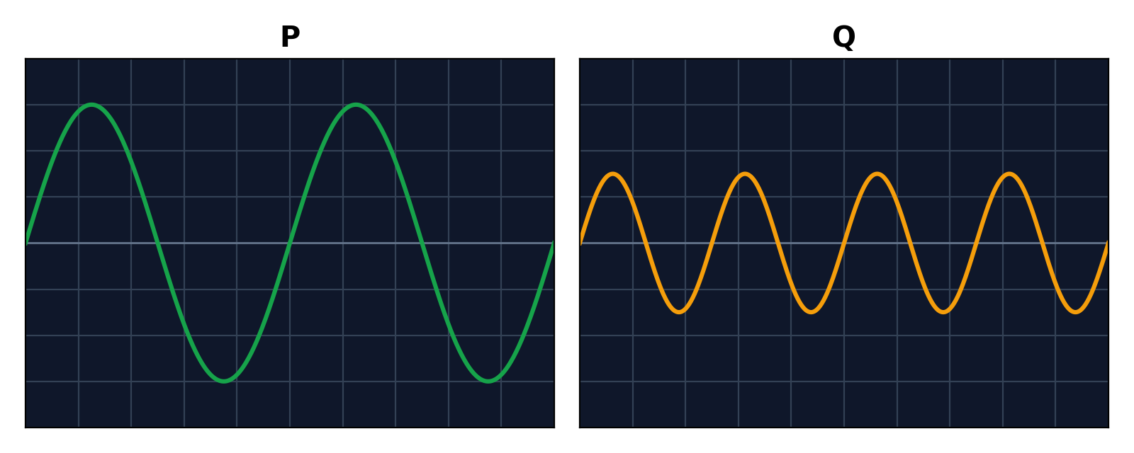
Fig. 3
(a) Which sound is louder? Explain. [1]

(b) Which sound has the higher pitch? Explain. [1]

F4 A ship sends an ultrasound pulse to the seabed. The echo returns 0.80 s later. The speed of sound in sea water is 1500 m/s. Calculate the depth of the sea. [2]
depth = ................ m
F5 During a storm, thunder is heard 3.0 s after the lightning is seen. Calculate the distance to the lightning, and explain why the lightning is seen first. (Speed of sound in air = 340 m/s.) [3]

