

Cell Division
Mitosis
Simulation: edtechsims.com/mitosis
Name: ____________________ Class: ______ Date: _______

Part A: Key Terms
On the sim: Open the Key Concepts section and read about chromosomes, chromatids and the spindle.
A1 Complete the sentences. [4]
A chromosome is a thread of ______________ found in the nucleus. Before a cell divides, each chromosome is copied, so it is made of two identical sister ______________, held together at the ______________. During division, ______________ pull them apart. A body cell with two sets of chromosomes is described as diploid (2n).
A2 Fig. 1 shows a cell during mitosis. Name the structures labelled A to D. [4]

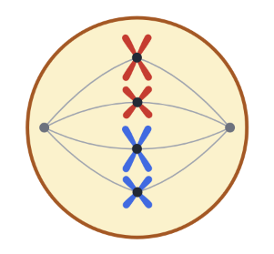
A
C
D
B

Fig. 1
A
B
C
D

Part B: The Stages of Mitosis
On the sim: Step through the stages with Next (or Play). Watch the red and blue chromosomes. This cell has 2n = 4.
Fig. 2 shows six diagrams of an animal cell, in the wrong order.
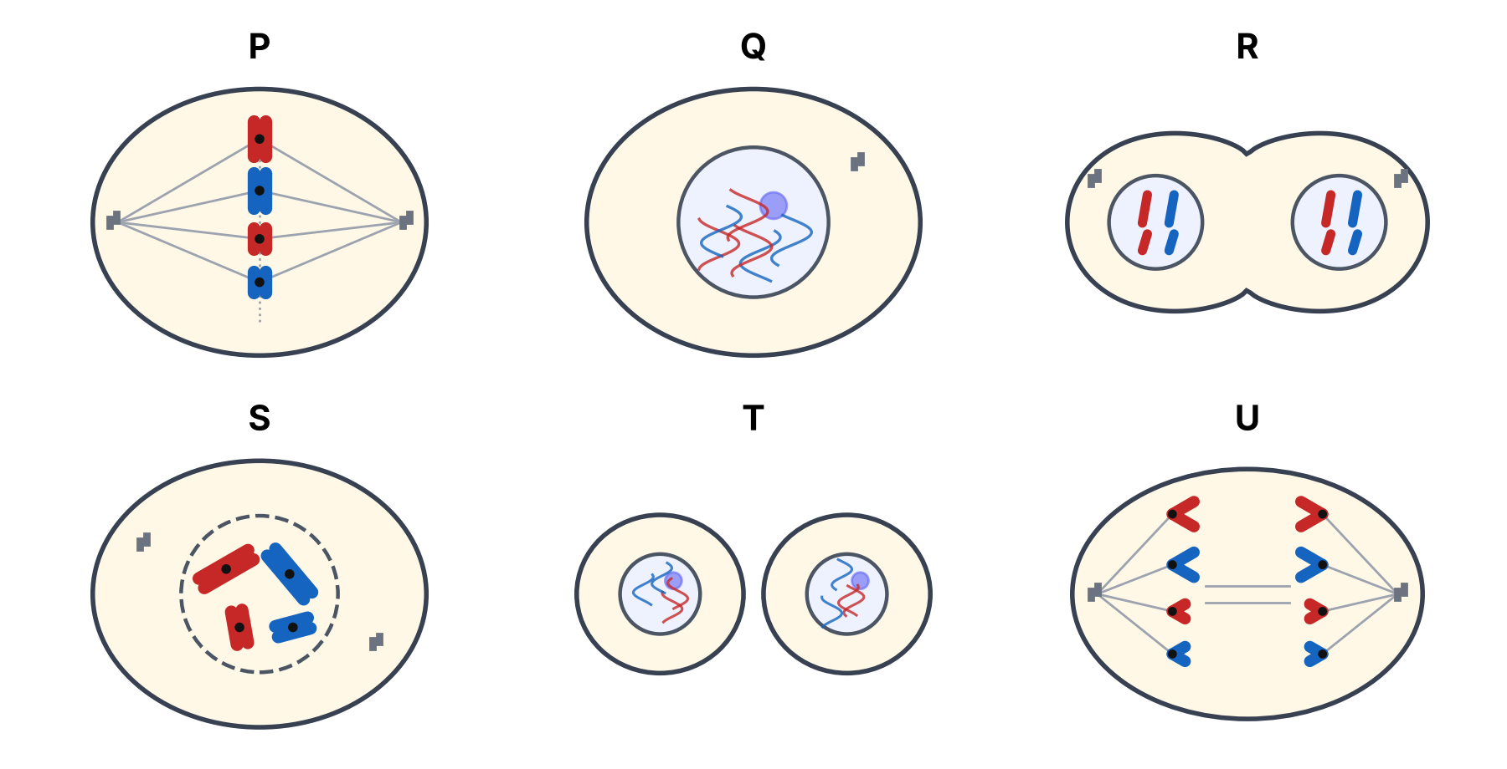
Fig. 2
B1 Complete Table 1. [8]
Diagram | Stage | What is happening
P | Metaphase
Q |  | Not dividing; DNA replicates so each chromosome becomes two sister chromatids; chromatin is thin and not visible.
R | Telophase
S |  | Chromosomes condense and become visible as two chromatids; nuclear envelope breaks down; spindle starts to form.
T
U
Table 1
B2 Write the letters P to U in the correct order, starting with interphase. [1]
____ → ____ → ____ → ____ → ____ → ____
B3 Name the stage at which the number of chromosomes in the cell is briefly doubled. Explain. [2]

Part C: Counting Chromosomes
On the sim: Use the chromosome counter in the sim. Count the chromosomes and chromatids at metaphase and in each daughter cell.
C1 For the cell in the sim (2n = 4), state:
(a) the number of chromosomes at metaphase [1]
…………………
(b) the number of chromatids at metaphase [1]
…………………
(c) the number of chromosomes in each daughter cell. [1]
…………………
C2 Complete Table 2. [4]
Organism | Chromosomes in a body cell | Chromosomes in each daughter cell | Chromatids at metaphase | Chromosomes at each pole in anaphase
Human | 46
Onion | 16
Fruit fly | 8
Dog | 78
Table 2
C3 Explain why the two daughter cells produced by mitosis are genetically identical to the parent cell. [3]

Part D: Mitosis or Meiosis?
Mitosis gives genetically identical diploid cells. Meiosis gives genetically different haploid gametes.
D1 For each situation, state whether mitosis or meiosis takes place. [6]
Situation | Mitosis or meiosis?
Growth of a baby into an adult
Healing of a cut on the skin
A strawberry plant producing new plants from runners
Production of sperm cells in the testes
Replacing red blood cells in the bone marrow
Production of egg cells in the ovaries
Table 3
D2 State three uses of mitosis in living organisms. [3]

Part E: Practice Questions
E1 Fig. 3 shows how the mass of DNA in a cell changes over two cell cycles.
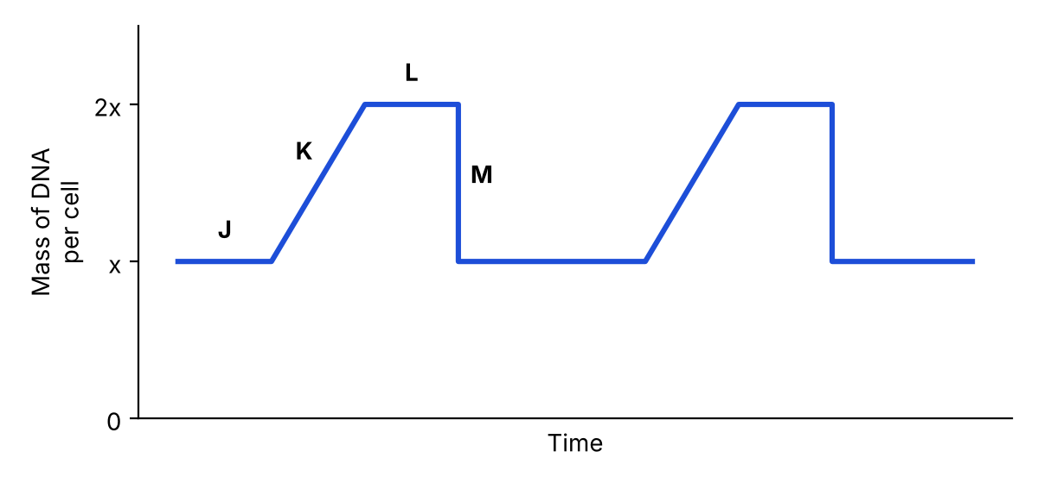
Fig. 3
(a) Explain why the mass of DNA doubles during stage K. [2]

(b) Explain why the mass of DNA halves at M. [2]

E2 A student counted the cells at each stage in a root tip squash: 172 in interphase, 14 in prophase, 6 in metaphase, 3 in anaphase and 5 in telophase.
(a) Calculate the percentage of cells undergoing mitosis. [2]
……………… %
(b) Suggest why most of the cells were in interphase. [1]

E3 Cancer cells divide by mitosis. Suggest how the division of cancer cells differs from normal cell division. [2]

E4 A liver cell of a horse contains 64 chromosomes. State the number of chromosomes in (a) a horse skin cell formed by mitosis and (b) a horse sperm cell. [2]

TEACHER COPY
Answer Key: Mitosis

Part A: Key Terms
On the sim: Open the Key Concepts section and read about chromosomes, chromatids and the spindle.
A1 Complete the sentences. [4]
A chromosome is a thread of DNA found in the nucleus. Before a cell divides, each chromosome is copied, so it is made of two identical sister chromatids, held together at the centromere. During division, spindle fibres pull them apart. A body cell with two sets of chromosomes is described as diploid (2n).
A2 Fig. 1 shows a cell during mitosis. Name the structures labelled A to D. [4]
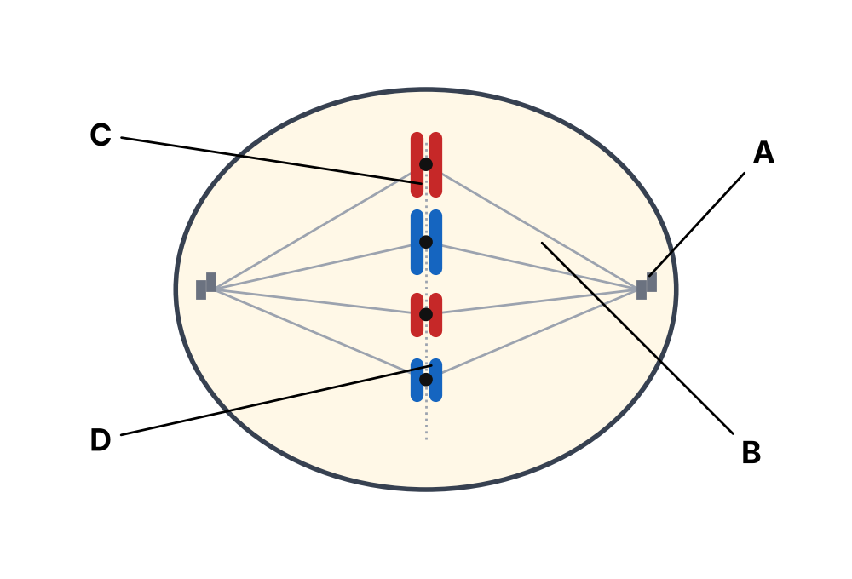
Fig. 1
A: centriole B: spindle fibre C: centromere D: (sister) chromatid

Part B: The Stages of Mitosis
On the sim: Step through the stages with Next (or Play). Watch the red and blue chromosomes. This cell has 2n = 4.
Fig. 2 shows six diagrams of an animal cell, in the wrong order.
Fig. 2
B1 Complete Table 1. [12]
Diagram | Stage | What is happening
P | Metaphase | Chromosomes line up on the equator; spindle fibres attach to the centromeres.
Q | Interphase | Not dividing; DNA replicates so each chromosome becomes two sister chromatids; chromatin is thin and not visible.
R | Telophase | Chromosomes reach the poles; a nuclear envelope reforms around each set; the cell starts to pinch in.
S | Prophase | Chromosomes condense and become visible as two chromatids; nuclear envelope breaks down; spindle starts to form.
T | Cytokinesis | Cytoplasm divides, giving two genetically identical daughter cells.
U | Anaphase | Centromeres split; sister chromatids are pulled to opposite poles by spindle fibres.
Table 1
B2 Write the letters P to U in the correct order, starting with interphase. [1]
Q → S → P → U → R → T
B3 Name the stage at which the number of chromosomes in the cell is briefly doubled. Explain. [2]
Anaphase. The centromeres split, so each chromatid becomes a separate chromosome (8 in this cell) until the cell divides.

Part C: Counting Chromosomes
On the sim: Use the chromosome counter in the sim. Count the chromosomes and chromatids at metaphase and in each daughter cell.
C1 For the cell in the sim (2n = 4), state:
(a) the number of chromosomes at metaphase [1]
4
(b) the number of chromatids at metaphase [1]
8
(c) the number of chromosomes in each daughter cell. [1]
4
C2 Complete Table 2. [4]
Organism | Chromosomes in a body cell | Chromosomes in each daughter cell | Chromatids at metaphase | Chromosomes at each pole in anaphase
Human | 46 | 46 | 92 | 46
Onion | 16 | 16 | 32 | 16
Fruit fly | 8 | 8 | 16 | 8
Dog | 78 | 78 | 156 | 78
Table 2
C3 Explain why the two daughter cells produced by mitosis are genetically identical to the parent cell. [3]
DNA is replicated exactly before division, so the two sister chromatids are identical. In anaphase, one chromatid of every chromosome goes to each pole, so each daughter nucleus receives the same number and type of chromosomes as the parent.

Part D: Mitosis or Meiosis?
Mitosis gives genetically identical diploid cells. Meiosis gives genetically different haploid gametes.
D1 For each situation, state whether mitosis or meiosis takes place. [6]
Situation | Mitosis or meiosis?
Growth of a baby into an adult | Mitosis
Healing of a cut on the skin | Mitosis
A strawberry plant producing new plants from runners | Mitosis
Production of sperm cells in the testes | Meiosis
Replacing red blood cells in the bone marrow | Mitosis
Production of egg cells in the ovaries | Meiosis
Table 3
D2 State three uses of mitosis in living organisms. [3]
Growth; repair/replacement of damaged or worn-out cells; asexual reproduction.

Part E: Practice Questions
E1 Fig. 3 shows how the mass of DNA in a cell changes over two cell cycles.
Fig. 3
(a) Explain why the mass of DNA doubles during stage K. [2]
DNA replication takes place (during interphase), so each chromosome is copied into two sister chromatids.
(b) Explain why the mass of DNA halves at M. [2]
The cell divides (cytokinesis after mitosis); the chromatids are shared equally, so each daughter cell gets half the DNA.
E2 A student counted the cells at each stage in a root tip squash: 172 in interphase, 14 in prophase, 6 in metaphase, 3 in anaphase and 5 in telophase.
(a) Calculate the percentage of cells undergoing mitosis. [2]
28 / 200 × 100 = 14%
(b) Suggest why most of the cells were in interphase. [1]
Interphase is the longest stage of the cell cycle, so most cells are in it at any one time.
E3 Cancer cells divide by mitosis. Suggest how the division of cancer cells differs from normal cell division. [2]
Cancer cells divide uncontrollably/repeatedly (mitosis is not regulated), forming a mass of cells called a tumour.
E4 A liver cell of a horse contains 64 chromosomes. State the number of chromosomes in (a) a horse skin cell formed by mitosis and (b) a horse sperm cell. [2]
(a) 64 (b) 32

