

Cell Division
Mitosis
Simulation: edtechsims.com/mitosis
Name: ____________________ Class: ______ Date: _______

Part A: Key Terms
On the sim: Open the Key Concepts section and read about chromosomes, chromatids and the spindle.
A1 Complete the sentences. [4]
A chromosome is a thread of ______________ found in the nucleus. Before a cell divides, each chromosome is copied, so it is made of two identical sister ______________, held together at the ______________. During division, ______________ pull them apart. A body cell with two sets of chromosomes is described as diploid (2n).
A2 Fig. 1 shows a cell during mitosis. Name the structures labelled A to D. [4]

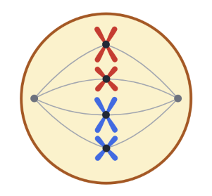
A
C
D
B

Fig. 1
A
B
C
D

Part B: The Stages of Mitosis
On the sim: Step through the stages with Next (or Play). Watch the red and blue chromosomes. This cell has 2n = 4.
Fig. 2 shows six diagrams of an animal cell, in the wrong order.
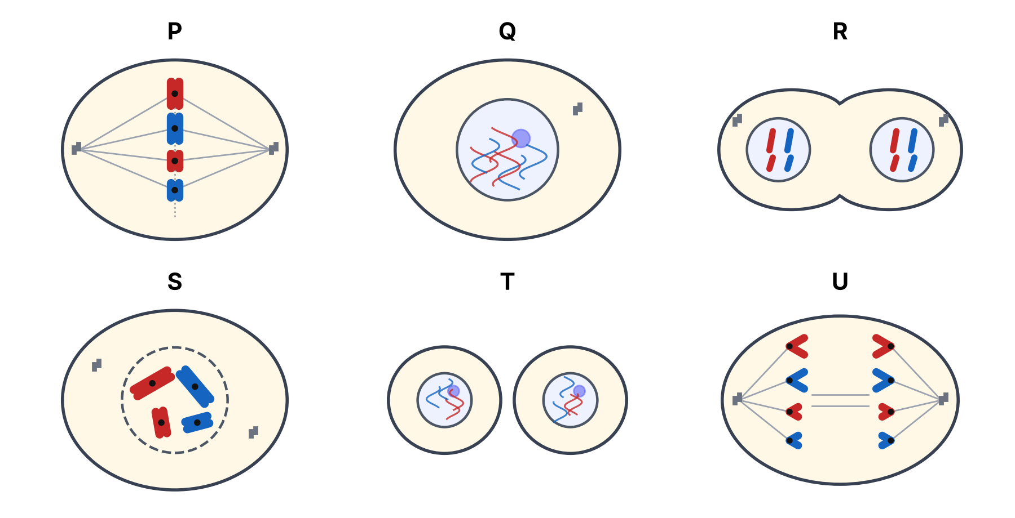
Fig. 2
B1 Complete Table 1. [8]
Diagram | Stage | What is happening
P | Metaphase
Q |  | Not dividing; DNA replicates so each chromosome becomes two sister chromatids; chromatin is thin and not visible.
R | Telophase
S |  | Chromosomes condense and become visible as two chromatids; nuclear envelope breaks down; spindle starts to form.
T
U
Table 1
B2 Write the letters P to U in the correct order, starting with interphase. [1]
____ → ____ → ____ → ____ → ____ → ____
B3 Name the stage at which the number of chromosomes in the cell is briefly doubled. Explain. [2]

Part C: Counting Chromosomes
On the sim: Use the chromosome counter in the sim. Count the chromosomes and chromatids at metaphase and in each daughter cell.
C1 For the cell in the sim (2n = 4), state:
(a) the number of chromosomes at metaphase [1]
…………………
(b) the number of chromatids at metaphase [1]
…………………
(c) the number of chromosomes in each daughter cell. [1]
…………………
C2 Complete Table 2. [4]
Organism | Chromosomes in a body cell | Chromosomes in each daughter cell | Chromatids at metaphase | Chromosomes at each pole in anaphase
Human | 46
Onion | 16
Fruit fly | 8
Dog | 78
Table 2
C3 Explain why the two daughter cells produced by mitosis are genetically identical to the parent cell. [3]

Part D: Mitosis or Meiosis?
Mitosis gives genetically identical diploid cells. Meiosis gives genetically different haploid gametes.
D1 For each situation, state whether mitosis or meiosis takes place. [6]
Situation | Mitosis or meiosis?
Growth of a baby into an adult
Healing of a cut on the skin
A strawberry plant producing new plants from runners
Production of sperm cells in the testes
Replacing red blood cells in the bone marrow
Production of egg cells in the ovaries
Table 3
D2 State three uses of mitosis in living organisms. [3]

Part E: Practice Questions
E1 Fig. 3 shows how the mass of DNA in a cell changes over two cell cycles.
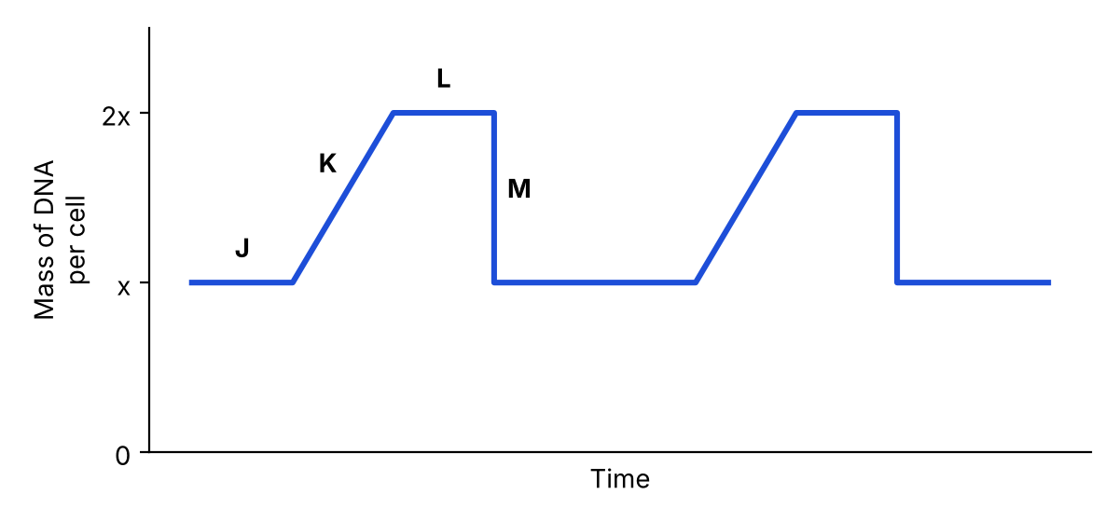
Fig. 3
(a) Explain why the mass of DNA doubles during stage K. [2]

(b) Explain why the mass of DNA halves at M. [2]

E2 A student counted the cells at each stage in a root tip squash: 172 in interphase, 14 in prophase, 6 in metaphase, 3 in anaphase and 5 in telophase.
(a) Calculate the percentage of cells undergoing mitosis. [2]
……………… %
(b) Suggest why most of the cells were in interphase. [1]

E3 Cancer cells divide by mitosis. Suggest how the division of cancer cells differs from normal cell division. [2]

E4 A liver cell of a horse contains 64 chromosomes. State the number of chromosomes in (a) a horse skin cell formed by mitosis and (b) a horse sperm cell. [2]

