
Kinematics
Marina Bay Night Race
Simulation: edtechsims.com/marina-bay-night-race
Name: ____________________ Class: ______ Date: _______

Data
Useful information (take g = 10 m/s²)
speed = distance ÷ time velocity = displacement ÷ time
acceleration = change in velocity ÷ time 1 m/s = 3.6 km/h

Part A: The Stewards' Inquiry
On the sim: A car broke the pit-lane speed limit. You are a race steward. Clear stations to collect evidence and unlock the Final Verdict, then name the guilty car. Wrong answers cost +15 s and hints cost +30 s.
A1 Record your progress. For each station you clear, note one misconception it warned you about.
Station | Cleared (✓) | Misconception I learned about
Track Map
Scalar or Vector?
Speed Trap
Pit Lane Limit
Telemetry: s–t
Throttle & Brake
Turbo Boost
Braking Zone
Rain Check
A2 Record your final results.
Final time | Wrong answers | Hints used

Part B: Station Practice
The game's numbers change every time. Use these questions to practise the same skills.
B1 Track Map: distance and displacement
(a) A car drives 300 m east, then turns and drives 400 m north. Calculate its distance travelled and its displacement. [3]

distance = ............ m displacement = ............ m
(b) The car completes one full lap and stops at the start line. What is its displacement? Explain. [1]

B2 Scalar or Vector?
Classify each quantity as a scalar or a vector. [4]
Quantity | Scalar / Vector | Quantity | Scalar / Vector
Distance |  | Displacement
Speed |  | Velocity
Acceleration |  | Time
Mass |  | Weight
B3 Speed Trap: average speed
(a) Two timing gates are 50 m apart. A car takes 2.5 s to pass between them. Calculate its average speed in m/s and in km/h. [2]

speed = ............ m/s = ............ km/h
(b) Why is a speed calculated from timing gates more accurate than one from a stopwatch held by a steward? [1]

B4 Pit Lane Limit: unit conversion
Complete Table 1. [3]
Speed in km/h | Speed in m/s | Above 80 km/h limit?
80
 | 25
72
Table 1

B5 Telemetry: displacement–time graphs
Fig. 1 shows the displacement–time graph of a car in the pit lane.
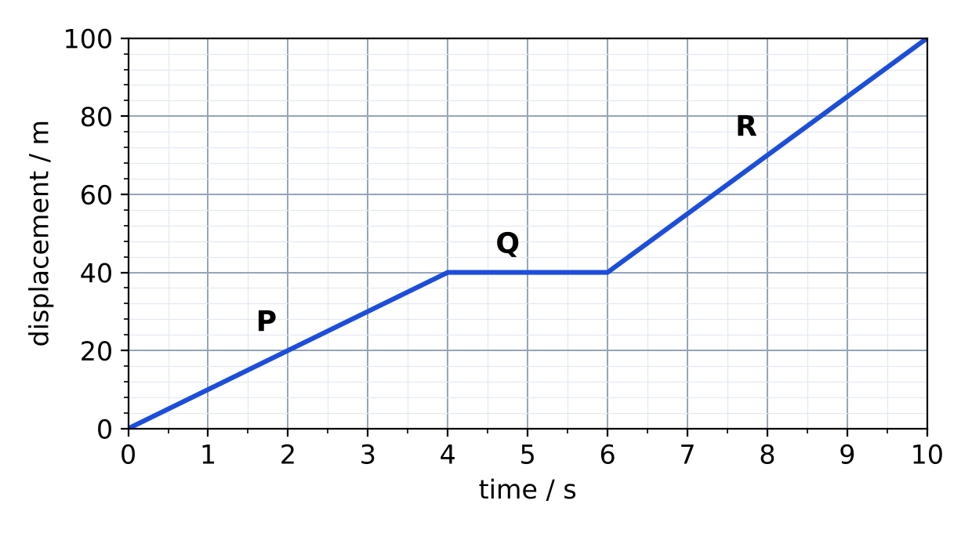
Fig. 1
(a) Calculate the speed of the car in section P and in section R. [2]

P = ............ m/s R = ............ m/s
(b) Describe the motion in section Q. [1]

(c) Calculate the average speed for the whole 10 s. [1]

average speed = ............ m/s

B6 Throttle & Brake: acceleration
(a) A car accelerates uniformly from rest to 30 m/s in 6.0 s. Calculate its acceleration. [2]

acceleration = ............ m/s²
(b) It then brakes uniformly from 30 m/s to rest in 3.0 s. Calculate its acceleration and explain the sign. [2]

B7 Turbo Boost: non-uniform acceleration
Fig. 2 shows the velocity–time graph of a car using its turbo boost. A tangent is drawn at point X.
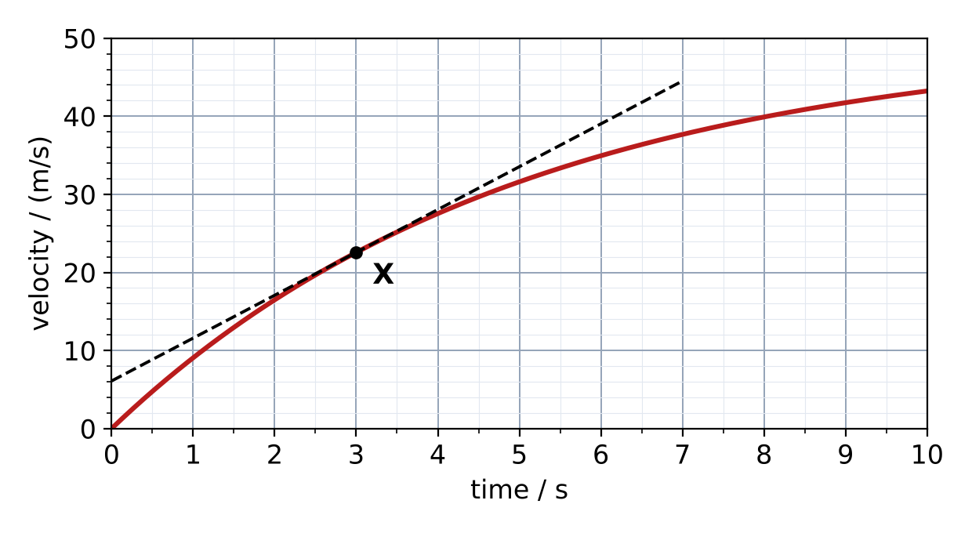
Fig. 2
(a) Use the tangent to find the acceleration of the car at X (t = 3 s). [2]

acceleration = ............ m/s²
(b) Describe how the acceleration of the car changes from 0 s to 10 s. Explain how the graph shows this. [2]

B8 Braking Zone: area under a v–t graph
A driver travelling at 25 m/s sees a hazard. After a reaction time of 0.80 s, the car decelerates uniformly and stops 5.0 s later. A barrier is 80 m ahead of the point where the driver saw the hazard.
(a) Sketch the v–t graph on Fig. 3. [2]
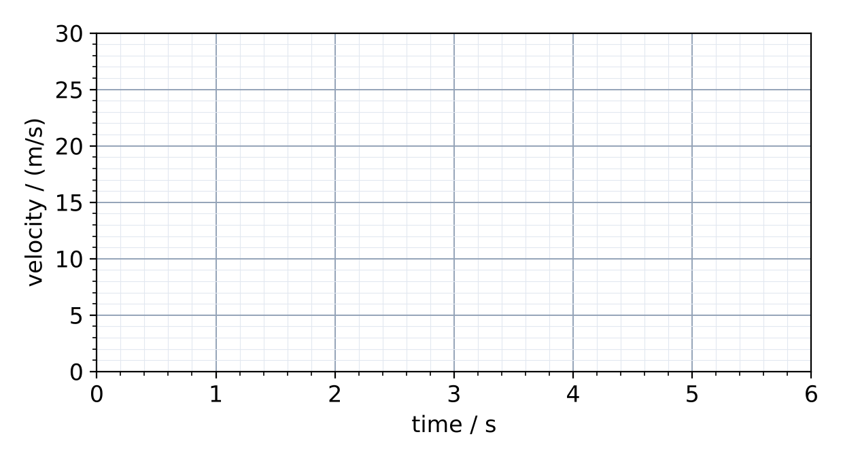
Fig. 3
(b) Calculate the stopping distance. Does the car hit the barrier? [3]

B9 Rain Check: free fall and terminal velocity
(a) A raindrop falls from rest. Ignoring air resistance, calculate its velocity after 2.0 s. [1]
velocity = ............ m/s
(b) Number the stages of a falling raindrop with air resistance from 1 to 4. [2]
Stage | Order
Air resistance equals weight; the drop falls at terminal velocity
The drop is released; only weight acts, so it accelerates at 10 m/s²
Air resistance increases, so the resultant force and acceleration decrease
As speed increases, air resistance starts to act upwards
(c) A student says, "A heavy stone falls faster than a light stone in a vacuum." Is the student correct? Explain. [1]

Part C: The Final Verdict
Case file: a car's average speed through the 10 s pit-lane timing zone must not be more than 80 km/h. Each car brakes uniformly, then holds a steady speed. The speed gun records Car A's velocity every 2 s:
Time / s | 0 | 2 | 4 | 6 | 8 | 10
Velocity / (m/s) | 30 | 25 | 20 | 20 | 20 | 20
Step 1 Plot the v–t graph for Car A on Fig. 4. [2]
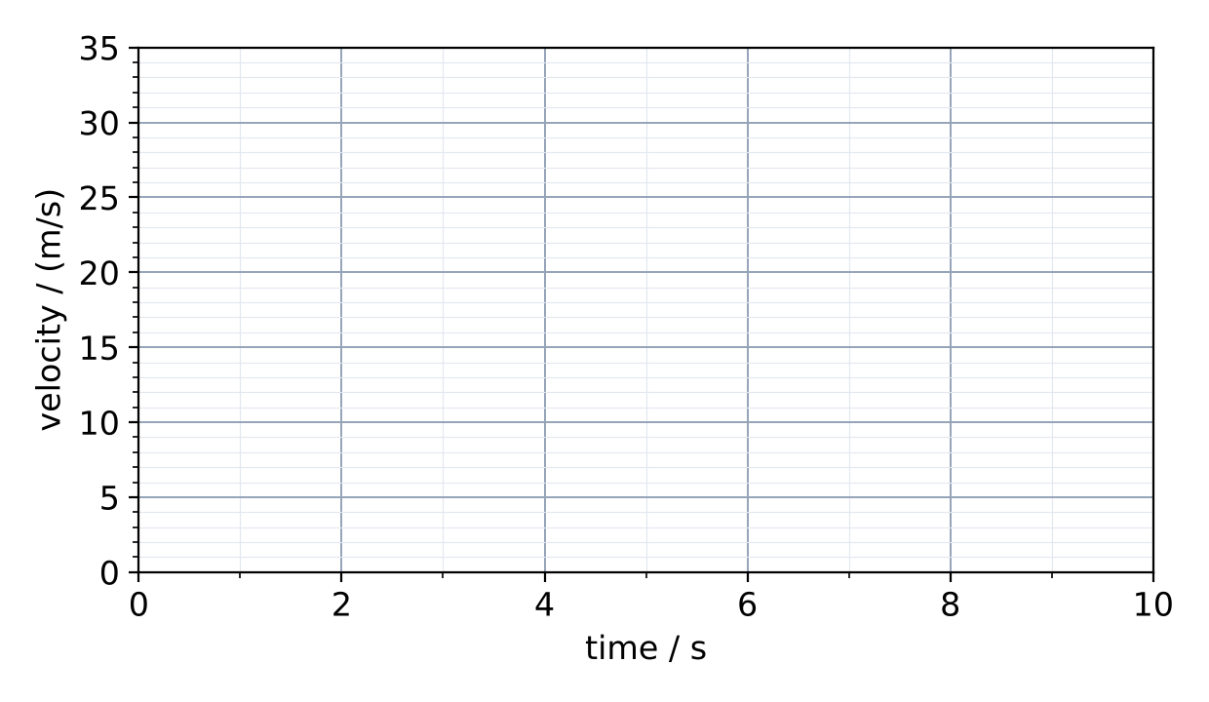
Fig. 4
Step 2 Calculate Car A's acceleration while braking. [2]

acceleration = ............ m/s²
Step 3 Calculate the distance Car A travels in the zone. [2]

distance = ............ m
Step 4 Calculate Car A's average speed in km/h. [2]

average speed = ............ km/h
Step 5 The stewards have found that Car B's average speed was 23.0 m/s and Car C's was 21.5 m/s. Which car is guilty? Show your working. [2]

Part D: Practice Questions
D1 A car travels 1.2 km along Raffles Avenue in 1.5 minutes. Calculate its average speed in m/s and km/h. [2]
speed = ............ m/s = ............ km/h
D2 Explain why a car moving at a constant speed around a bend is accelerating. [2]

D3 A skydiver jumps from a plane and later opens a parachute. Describe and explain how the skydiver's velocity changes from the moment of jumping until landing. [4]

