General Wave Properties  Longitudinal & Transverse Waves  Simulation: edtechsims.com/longitudinal-transverse-waves  Name: ____________________ Class: ______ Date: _______ |   Scan to open
By the end of this activity, you should be able to:
- describe how particles move in transverse and longitudinal waves relative to the direction of wave travel
- identify crests, troughs, compressions and rarefactions
- identify amplitude and wavelength on a wave diagram
- give examples of transverse and longitudinal waves
- apply the wave equation v = fλ

Part A: Transverse Waves
On the sim: Click Transverse. Tick both Show Particles and Show Wave Form. Leave the sliders at their starting values.
A1 Focus on ONE particle. Describe how it moves as the wave passes. [1]

A2 State the direction in which the wave travels across the screen. [1]

A3 Using your answers to A1 and A2, complete the sentence:
In a transverse wave, the particles vibrate ______________________________ to the direction of wave travel.
A4 Click Pause. Fig. 1 shows a transverse wave like the one on your screen.
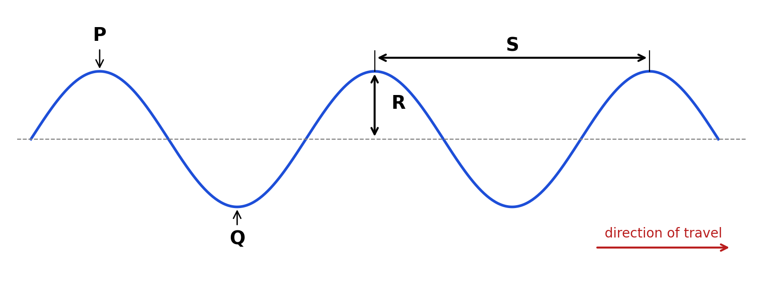
Fig. 1
State what is shown by each of the letters P, Q, R and S.
P: ....................................................
Q: ....................................................
R: ....................................................
S: ....................................................
A5 Click Play. Does any particle travel from the left side of the screen to the right side? What does the wave transfer from left to right? [2]

Part B: Longitudinal Waves
On the sim: Click Longitudinal. Keep both boxes ticked.
B1 Focus on ONE particle. Describe how it moves as the wave passes. [1]

B2 Complete the sentence:
In a longitudinal wave, the particles vibrate ______________________________ to the direction of wave travel.
B3 Click Pause. Fig. 2 shows the particles in a longitudinal wave.
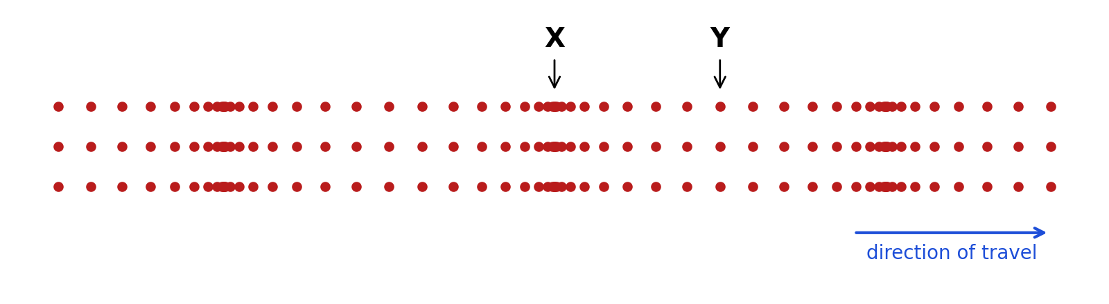
Fig. 2
(a) Name the regions labelled X and Y. [2]
X: ....................................................
Y: ....................................................
(b) On Fig. 2, draw a double-headed arrow to show one wavelength. Label it λ. [1]
(c) Describe, in terms of the spacing of particles, the difference between X and Y. [2]

Part C: Comparing the Two Waves
On the sim: Click Compare Both and watch both waves for about 30 seconds.
C1 Complete Table 1. [4]
 | Transverse wave | Longitudinal wave
Direction of particle vibration relative to wave travel
Features formed
Two examples
Do the particles travel along with the wave?
Table 1
C2 Open Check Your Understanding at the bottom of the sim. Answer all 5 questions and submit.
My score: ______ / 5. One thing I got wrong or was unsure about:

Part D: Applying Your Knowledge
D1 Tick (✓) the correct column for each wave in Table 2. [4]
Wave | Transverse | Longitudinal
Sound travelling through air
Light
Ripples on the surface of a pond
Seismic P-wave
Seismic S-wave
A slinky pushed and pulled along its length
A slinky shaken from side to side
Radio waves
Table 2
D2 A sound wave has a frequency of 440 Hz and a wavelength of 0.75 m. Calculate the speed of the sound wave. [2]
speed = .............................. m/s

D3 Ripples on a pond travel at 0.24 m/s. The frequency of the ripples is 3.0 Hz. Calculate the wavelength of the ripples. [2]
wavelength = .............................. m

Part E: Practice Questions
E1 Fig. 3 shows the displacement–distance graph for a transverse wave at one instant.
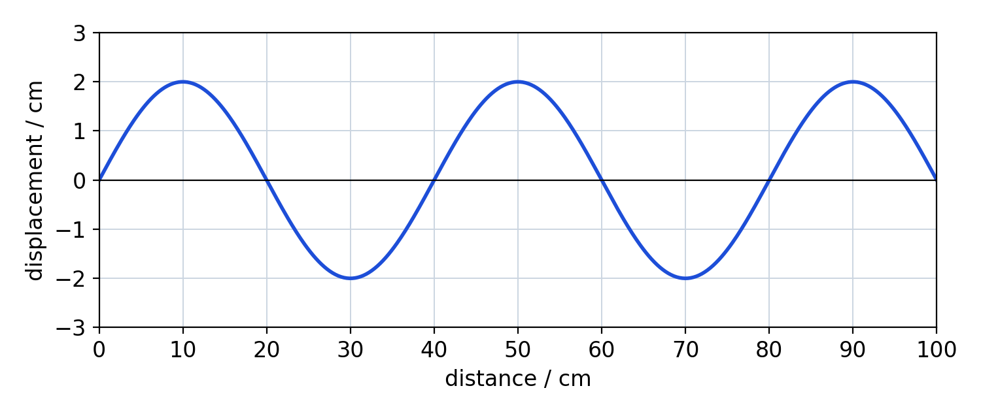
Fig. 3
(a) State the amplitude of the wave. [1]
amplitude = .............................. cm
(b) Determine the wavelength of the wave. [1]
wavelength = .............................. cm
(c) The frequency of the wave is 5.0 Hz. Calculate the speed of the wave in m/s. [2]
speed = .............................. m/s
E2 A loudspeaker produces a sound wave in air.
(a) Describe how the sound wave travels through the air. Refer to the air particles in your answer. [3]

(b) Explain why sound cannot travel through a vacuum. [1]

E3 A student produces a longitudinal wave on a slinky. Fig. 4 shows part of the slinky at one instant.
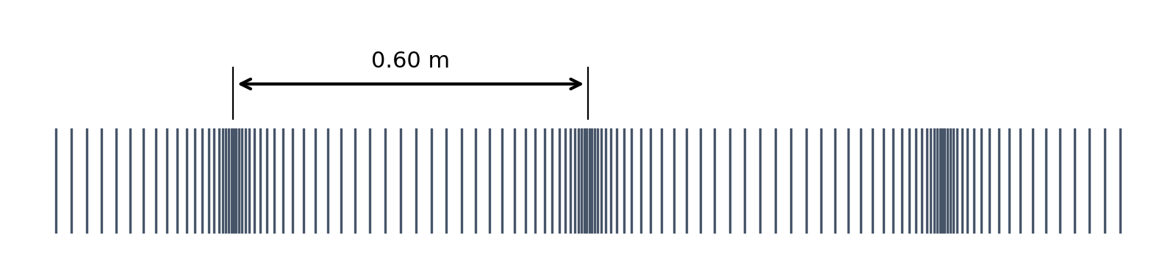
Fig. 4
The student counts 5 compressions passing a fixed point in 2.0 s.
(a) Calculate the frequency of the wave. [1]
frequency = .............................. Hz
(b) Calculate the speed of the wave along the slinky. [2]
speed = .............................. m/s

TEACHER COPY
Answer Key: Longitudinal & Transverse Waves

Part A
A1 The particle moves up and down (vibrates about a fixed rest position).
A2 From left to right.
A3 perpendicular (at right angles)
A4 P: crest. Q: trough. R: amplitude (maximum displacement from the rest position). S: wavelength (distance between two successive crests).
A5 No. Each particle only vibrates about its rest position. The wave transfers energy, not matter.

Part B
B1 The particle moves back and forth (left and right) about a fixed rest position.
B2 parallel (along the same line as)
B3(a) X: compression. Y: rarefaction.
B3(b) Arrow from the centre of one compression to the centre of the next compression (or rarefaction to rarefaction).
B3(c) At X the particles are closer together; at Y the particles are further apart.

Part C
 | Transverse wave | Longitudinal wave
Direction of particle vibration | Perpendicular to wave travel | Parallel to wave travel
Features formed | Crests and troughs | Compressions and rarefactions
Two examples | Light, water ripples, S-waves, EM waves | Sound, P-waves, slinky pushed along its length
Particles travel with wave? | No, they vibrate about fixed positions | No, they vibrate about fixed positions

C2 Sim answers: 1 False, 2 False, 3 True, 4 False, 5 False.

Part D
D1 Transverse: light, pond ripples, S-wave, slinky shaken side to side, radio waves. Longitudinal: sound in air, P-wave, slinky pushed and pulled.
D2 v = fλ = 440 × 0.75 = 330 m/s
D3 λ = v / f = 0.24 / 3.0 = 0.080 m

Part E
E1(a) 2.0 cm
E1(b) 40 cm
E1(c) v = fλ = 5.0 × 0.40 = 2.0 m/s [1 mark for converting 40 cm to 0.40 m]
E2(a) Any three: the loudspeaker cone vibrates; air particles vibrate back and forth parallel to the direction of wave travel; this produces a series of compressions and rarefactions; energy is passed from particle to particle (the particles themselves do not travel with the wave).
E2(b) Sound needs a medium (particles) to travel; a vacuum has no particles.
E3(a) f = 5 / 2.0 = 2.5 Hz
E3(b) λ = 0.60 m (distance between adjacent compressions); v = fλ = 2.5 × 0.60 = 1.5 m/s

