General Wave Properties  Longitudinal & Transverse Waves  Simulation: edtechsims.com/longitudinal-transverse-waves  Name: ____________________ Class: ______ Date: _______ |   Scan to open
By the end of this activity, you should be able to:
- describe how particles move in transverse and longitudinal waves relative to the direction of wave travel
- identify crests, troughs, compressions and rarefactions
- identify amplitude and wavelength on a wave diagram
- give examples of transverse and longitudinal waves
- apply the wave equation v = fλ

Part A: Transverse Waves
On the sim: Click Transverse. Tick both Show Particles and Show Wave Form. Leave the sliders at their starting values.
A1 Focus on ONE particle. Describe how it moves as the wave passes. [1]

A2 State the direction in which the wave travels across the screen. [1]

A3 Using your answers to A1 and A2, complete the sentence:
In a transverse wave, the particles vibrate ______________________________ to the direction of wave travel.
A4 Click Pause. Fig. 1 shows a transverse wave like the one on your screen.
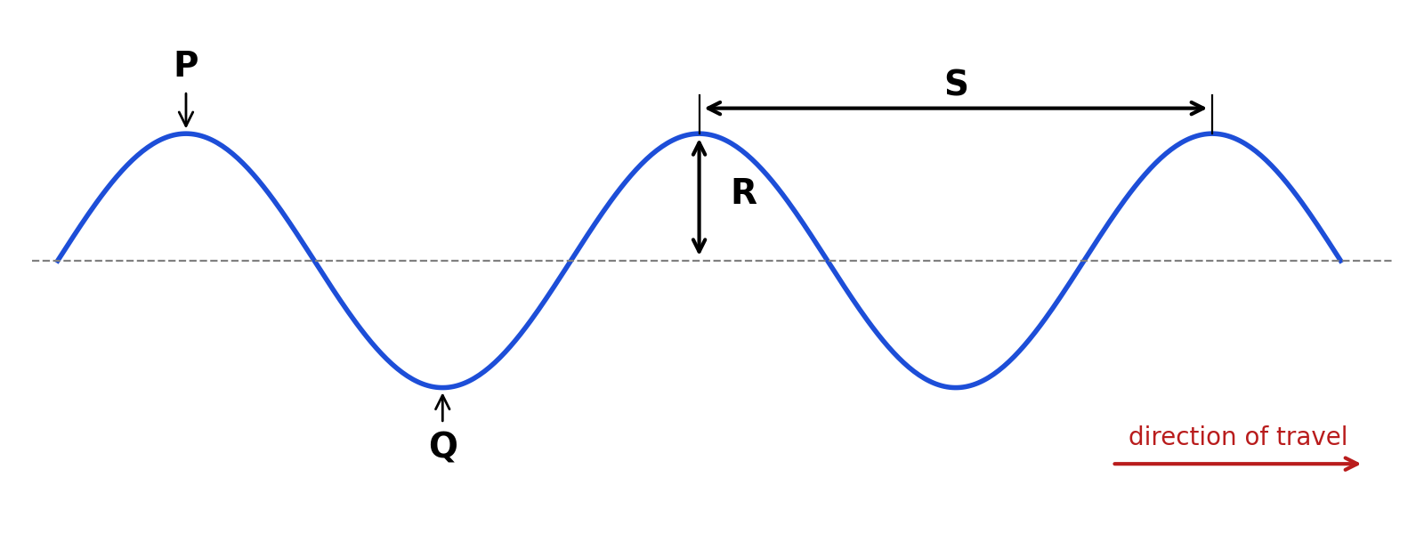
Fig. 1
State what is shown by each of the letters P, Q, R and S.
P: ....................................................
Q: ....................................................
R: ....................................................
S: ....................................................
A5 Click Play. Does any particle travel from the left side of the screen to the right side? What does the wave transfer from left to right? [2]

Part B: Longitudinal Waves
On the sim: Click Longitudinal. Keep both boxes ticked.
B1 Focus on ONE particle. Describe how it moves as the wave passes. [1]

B2 Complete the sentence:
In a longitudinal wave, the particles vibrate ______________________________ to the direction of wave travel.
B3 Click Pause. Fig. 2 shows the particles in a longitudinal wave.
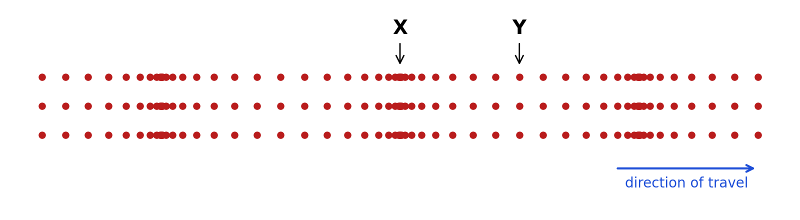
Fig. 2
(a) Name the regions labelled X and Y. [2]
X: ....................................................
Y: ....................................................
(b) On Fig. 2, draw a double-headed arrow to show one wavelength. Label it λ. [1]
(c) Describe, in terms of the spacing of particles, the difference between X and Y. [2]

Part C: Comparing the Two Waves
On the sim: Click Compare Both and watch both waves for about 30 seconds.
C1 Complete Table 1. [4]
 | Transverse wave | Longitudinal wave
Direction of particle vibration relative to wave travel
Features formed
Two examples
Do the particles travel along with the wave?
Table 1
C2 Open Check Your Understanding at the bottom of the sim. Answer all 5 questions and submit.
My score: ______ / 5. One thing I got wrong or was unsure about:

Part D: Applying Your Knowledge
D1 Tick (✓) the correct column for each wave in Table 2. [4]
Wave | Transverse | Longitudinal
Sound travelling through air
Light
Ripples on the surface of a pond
Seismic P-wave
Seismic S-wave
A slinky pushed and pulled along its length
A slinky shaken from side to side
Radio waves
Table 2
D2 A sound wave has a frequency of 440 Hz and a wavelength of 0.75 m. Calculate the speed of the sound wave. [2]
speed = .............................. m/s

D3 Ripples on a pond travel at 0.24 m/s. The frequency of the ripples is 3.0 Hz. Calculate the wavelength of the ripples. [2]
wavelength = .............................. m

Part E: Practice Questions
E1 Fig. 3 shows the displacement–distance graph for a transverse wave at one instant.
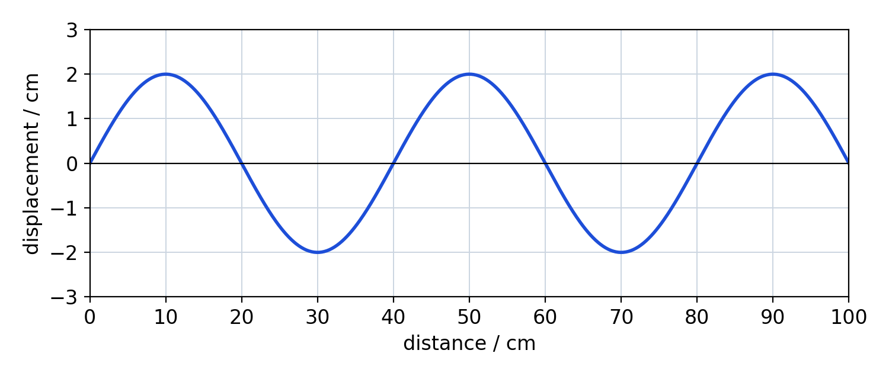
Fig. 3
(a) State the amplitude of the wave. [1]
amplitude = .............................. cm
(b) Determine the wavelength of the wave. [1]
wavelength = .............................. cm
(c) The frequency of the wave is 5.0 Hz. Calculate the speed of the wave in m/s. [2]
speed = .............................. m/s
E2 A loudspeaker produces a sound wave in air.
(a) Describe how the sound wave travels through the air. Refer to the air particles in your answer. [3]

(b) Explain why sound cannot travel through a vacuum. [1]

E3 A student produces a longitudinal wave on a slinky. Fig. 4 shows part of the slinky at one instant.

Fig. 4
The student counts 5 compressions passing a fixed point in 2.0 s.
(a) Calculate the frequency of the wave. [1]
frequency = .............................. Hz
(b) Calculate the speed of the wave along the slinky. [2]
speed = .............................. m/s

