
Infectious Diseases
Disease Transmission Simulator
Simulation: edtechsims.com/infectious-diseases
Name: ____________________ Class: ______ Date: _______

Part A: How the Simulator Works
On the sim: Read the key to the simulator. Leave the default settings and press Reset to start a new run.
A1 Complete Table 1 to describe what each type of dot represents. [3]
Dot | What it represents
White dot
Red dot
Green dot
Blue-ringed dot
Table 1
A2 Complete the sentences. [3]
A disease that can be passed from one person to another is an ______________ disease. It is caused by a ______________, such as a bacterium or virus. In the simulator, a new infection happens when an infected dot ______________ an uninfected dot.

Part B: The Baseline Run
On the sim: Use 50 dots, recovery OFF and 0% preventive measures. Run the simulation until every dot is infected. Show the chart.
B1 Record the time taken for all 50 dots to become infected. [1]
time = ................ s
B2 Sketch the shape of the number of infected (red) and uninfected (white) individuals on the grid below. [2]
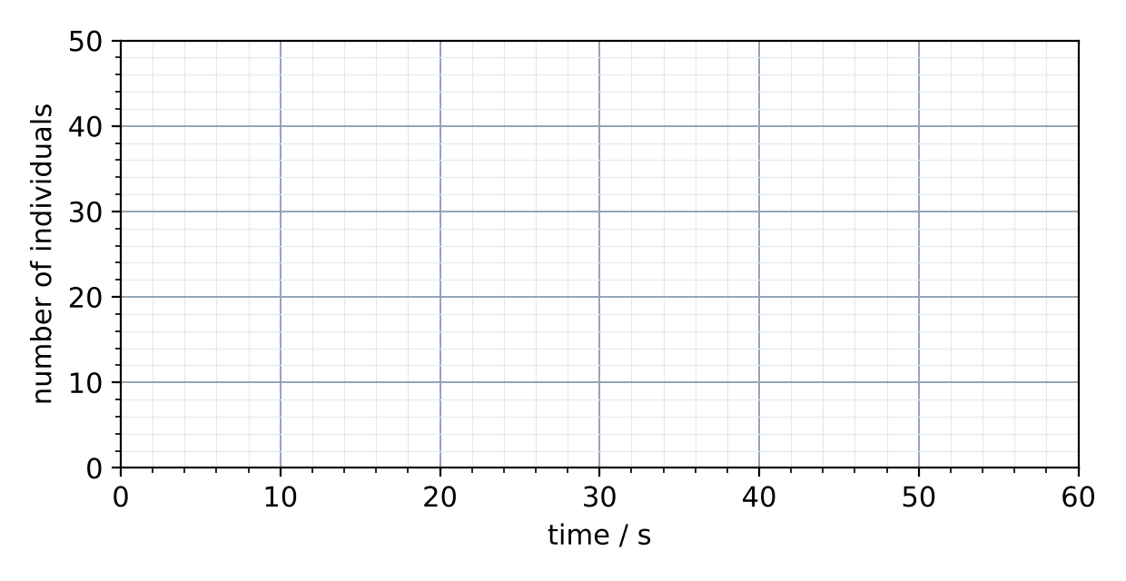
B3 Explain why the number of infected dots rises slowly at first, then very quickly. [2]

Part C: Investigating Preventive Measures
On the sim: Keep 50 dots and recovery OFF. Change the percentage of dots using preventive measures. For each value, record the number infected after 30 s.
C1 Identify the variables in this investigation. [3]
Variable | In this investigation
Independent
Dependent
Controlled (two)
C2 Complete Table 2. [3]
Preventive measures / % | Number infected after 30 s | Infected / %
0
25
50
75
Table 2
C3 Describe the trend in Table 2. Suggest why each run may give a slightly different result, and how to make the results more reliable. [3]

C4 Increase the speed slider. What does speed represent, and what happens to the spread? [2]

Part D: Recovery
On the sim: Turn recovery ON. Use 50 dots and 0% preventive measures. Run the simulation and show the chart.
D1 Describe how the number of infected (red) dots changes over time when recovery is on. [2]

D2 Increase the recovery time. Describe and explain the effect on the peak number of infected dots. [2]

Part E: Disease Scenarios
On the sim: Open each scenario, use the suggested settings, then answer its Check Your Understanding questions.
E1 Complete Table 3. [6]
Disease | Type of pathogen | Main way it spreads | Recovery in the sim (on / off)? Why?
HIV/AIDS
Influenza
Pneumococcal disease
Table 3
HIV score: ______ / 3 Influenza score: ______ / 3 Pneumococcal score: ______ / 3
E2 For each disease, give one preventive measure that the blue-ringed dots could represent. [3]
HIV:
Influenza:
Pneumococcal disease:

Part F: Practice Questions
F1 Fig. 1 shows the number of people infected with influenza in two towns of 1000 people.
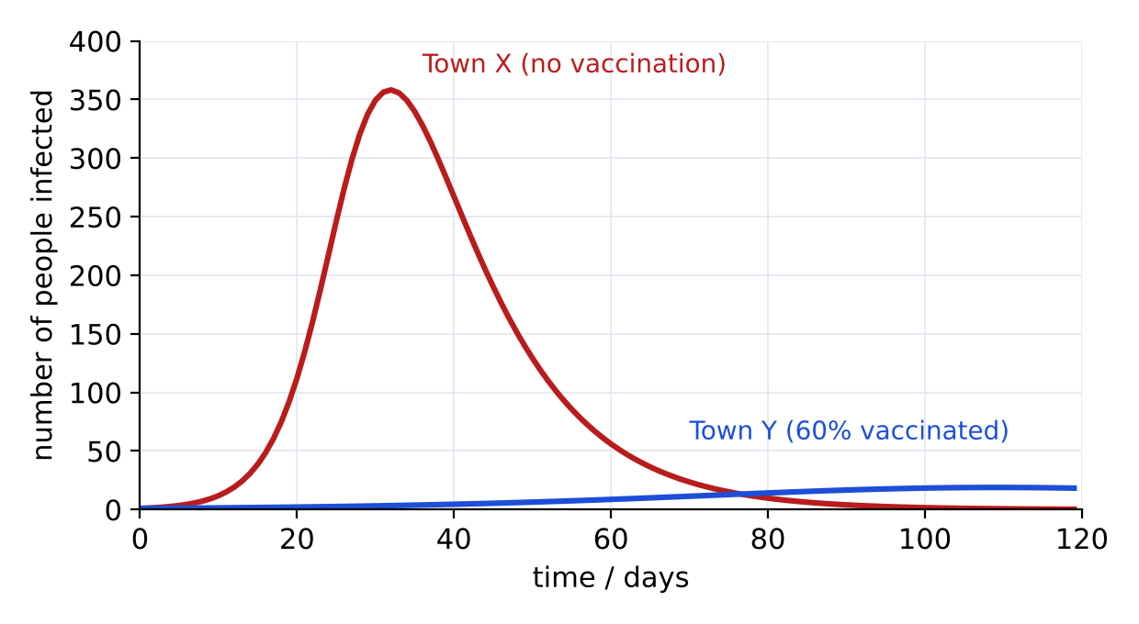
Fig. 1
(a) State the maximum number of people infected at one time in Town X, and the day on which it occurs. [2]
........ people on day ........
(b) Explain why the outbreak in Town Y is much smaller, even though 40% of people are not vaccinated. [3]

F2 A student with influenza asks a doctor for antibiotics. Explain why the doctor refuses. [2]

F3 Explain how a vaccine protects a person from a disease. [3]

TEACHER COPY
Answer Key: Disease Transmission Simulator

Part A: How the Simulator Works
On the sim: Read the key to the simulator. Leave the default settings and press Reset to start a new run.
A1 Complete Table 1 to describe what each type of dot represents. [3]
Dot | What it represents
White dot | An uninfected (susceptible) individual
Red dot | An infected individual
Green dot | A recovered individual (only when recovery is on)
Blue-ringed dot | An individual using preventive measures (e.g. vaccination, distancing, condoms, masks)
Table 1
A2 Complete the sentences. [3]
A disease that can be passed from one person to another is an infectious disease. It is caused by a pathogen, such as a bacterium or virus. In the simulator, a new infection happens when an infected dot comes into contact with an uninfected dot.

Part B: The Baseline Run
On the sim: Use 50 dots, recovery OFF and 0% preventive measures. Run the simulation until every dot is infected. Show the chart.
B1 Record the time taken for all 50 dots to become infected. [1]
Value from the sim.
B2 Sketch the shape of the number of infected (red) and uninfected (white) individuals on the grid below. [2]
Red line: S-shaped, rising slowly at first, then rapidly, then levelling off at 50. White line: the mirror image, falling to 0.
B3 Explain why the number of infected dots rises slowly at first, then very quickly. [2]
At first there are few infected dots, so contacts with uninfected dots are rare. As more dots become infected, each can infect others, so the number of new infections increases rapidly.

Part C: Investigating Preventive Measures
On the sim: Keep 50 dots and recovery OFF. Change the percentage of dots using preventive measures. For each value, record the number infected after 30 s.
C1 Identify the variables in this investigation. [3]
Variable | In this investigation
Independent | Percentage of dots using preventive measures
Dependent | Number of dots infected after 30 s
Controlled (two) | Number of dots; speed; recovery setting; time
C2 Complete Table 2. [3]
Preventive measures / % | Number infected after 30 s | Infected / %
0
25
50
75
Table 2
Values from the sim; the number infected decreases as the percentage using preventive measures increases.
C3 Describe the trend in Table 2. Suggest why each run may give a slightly different result, and how to make the results more reliable. [3]
As the percentage using preventive measures increases, fewer dots are infected. Dot movement is random, so results vary; repeat each run three times and calculate a mean.
C4 Increase the speed slider. What does speed represent, and what happens to the spread? [2]
Speed represents how often people interact (more contact). The disease spreads faster at a higher speed.

Part D: Recovery
On the sim: Turn recovery ON. Use 50 dots and 0% preventive measures. Run the simulation and show the chart.
D1 Describe how the number of infected (red) dots changes over time when recovery is on. [2]
It rises to a peak, then falls as infected dots recover and there are fewer uninfected dots left to infect.
D2 Increase the recovery time. Describe and explain the effect on the peak number of infected dots. [2]
The peak is higher, because each infected dot stays infectious for longer and can infect more dots.

Part E: Disease Scenarios
On the sim: Open each scenario, use the suggested settings, then answer its Check Your Understanding questions.
E1 Complete Table 3. [6]
Disease | Type of pathogen | Main way it spreads | Recovery in the sim (on / off)? Why?
HIV/AIDS | Virus | Body fluids: sexual contact, shared needles, mother to baby | Off; there is no cure
Influenza | Virus | Airborne droplets from coughing and sneezing | On; most people recover in about a week
Pneumococcal disease | Bacterium | Airborne droplets / close contact | On; treated with antibiotics
Table 3
Scores from the sim.
E2 For each disease, give one preventive measure that the blue-ringed dots could represent. [3]
HIV: condoms / PrEP / not sharing needles / regular testing. Influenza: flu vaccine / masks / hand washing / staying home when ill. Pneumococcal: pneumococcal vaccine / covering coughs.

Part F: Practice Questions
F1 Fig. 1 shows the number of people infected with influenza in two towns of 1000 people.
Fig. 1
(a) State the maximum number of people infected at one time in Town X, and the day on which it occurs. [2]
About 360 people, on about day 32.
(b) Explain why the outbreak in Town Y is much smaller, even though 40% of people are not vaccinated. [3]
Vaccinated people cannot become infected or pass on the virus. With 60% immune, an infected person is unlikely to meet a susceptible person, so the chain of transmission is broken. This protects the unvaccinated too (herd immunity).

F2 A student with influenza asks a doctor for antibiotics. Explain why the doctor refuses. [2]
Influenza is caused by a virus. Antibiotics only kill bacteria and have no effect on viruses; overuse can also lead to antibiotic-resistant bacteria.
F3 Explain how a vaccine protects a person from a disease. [3]
A vaccine contains a weakened/dead pathogen or its antigens. It stimulates white blood cells (lymphocytes) to produce antibodies and memory cells. If the real pathogen enters later, antibodies are produced quickly, so the person does not become ill.

