
Infectious Diseases
Disease Transmission Simulator
Simulation: edtechsims.com/infectious-diseases
Name: ____________________ Class: ______ Date: _______

Part A: How the Simulator Works
On the sim: Read the key to the simulator. Leave the default settings and press Reset to start a new run.
A1 Complete Table 1 to describe what each type of dot represents. [3]
Dot | What it represents
White dot
Red dot
Green dot
Blue-ringed dot
Table 1
A2 Complete the sentences. [3]
A disease that can be passed from one person to another is an ______________ disease. It is caused by a ______________, such as a bacterium or virus. In the simulator, a new infection happens when an infected dot ______________ an uninfected dot.

Part B: The Baseline Run
On the sim: Use 50 dots, recovery OFF and 0% preventive measures. Run the simulation until every dot is infected. Show the chart.
B1 Record the time taken for all 50 dots to become infected. [1]
time = ................ s
B2 Sketch the shape of the number of infected (red) and uninfected (white) individuals on the grid below. [2]
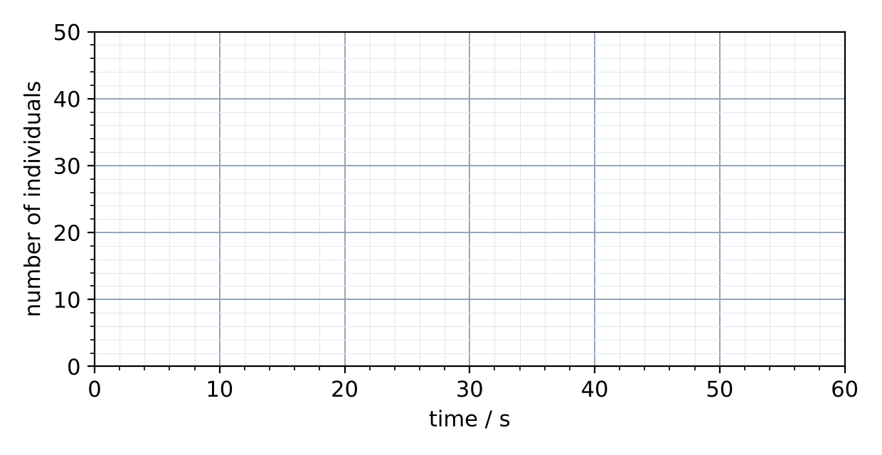
B3 Explain why the number of infected dots rises slowly at first, then very quickly. [2]

Part C: Investigating Preventive Measures
On the sim: Keep 50 dots and recovery OFF. Change the percentage of dots using preventive measures. For each value, record the number infected after 30 s.
C1 Identify the variables in this investigation. [3]
Variable | In this investigation
Independent
Dependent
Controlled (two)
C2 Complete Table 2. [3]
Preventive measures / % | Number infected after 30 s | Infected / %
0
25
50
75
Table 2
C3 Describe the trend in Table 2. Suggest why each run may give a slightly different result, and how to make the results more reliable. [3]

C4 Increase the speed slider. What does speed represent, and what happens to the spread? [2]

Part D: Recovery
On the sim: Turn recovery ON. Use 50 dots and 0% preventive measures. Run the simulation and show the chart.
D1 Describe how the number of infected (red) dots changes over time when recovery is on. [2]

D2 Increase the recovery time. Describe and explain the effect on the peak number of infected dots. [2]

Part E: Disease Scenarios
On the sim: Open each scenario, use the suggested settings, then answer its Check Your Understanding questions.
E1 Complete Table 3. [6]
Disease | Type of pathogen | Main way it spreads | Recovery in the sim (on / off)? Why?
HIV/AIDS
Influenza
Pneumococcal disease
Table 3
HIV score: ______ / 3 Influenza score: ______ / 3 Pneumococcal score: ______ / 3
E2 For each disease, give one preventive measure that the blue-ringed dots could represent. [3]
HIV:
Influenza:
Pneumococcal disease:

Part F: Practice Questions
F1 Fig. 1 shows the number of people infected with influenza in two towns of 1000 people.
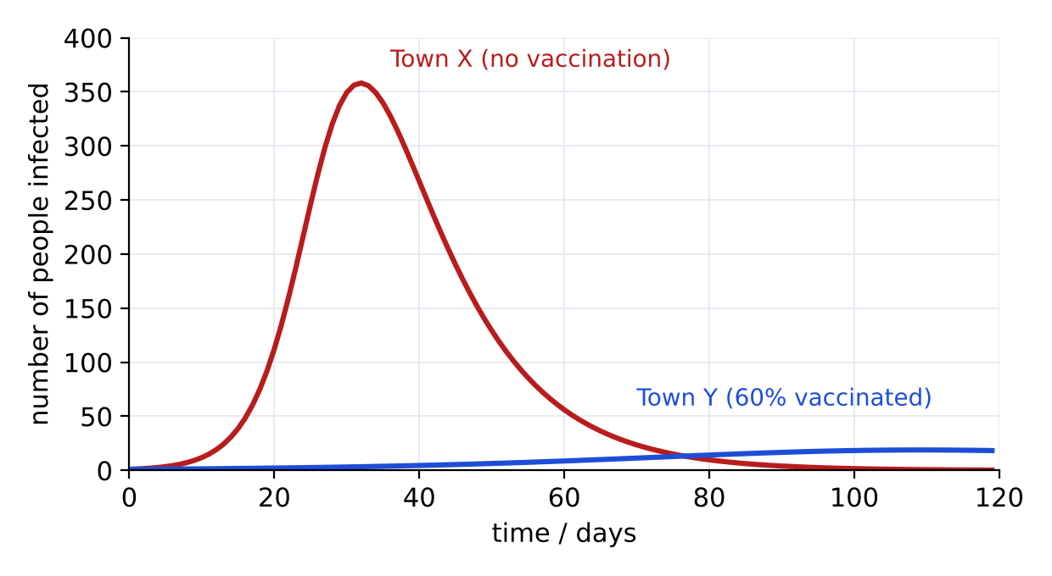
Fig. 1
(a) State the maximum number of people infected at one time in Town X, and the day on which it occurs. [2]
........ people on day ........
(b) Explain why the outbreak in Town Y is much smaller, even though 40% of people are not vaccinated. [3]

F2 A student with influenza asks a doctor for antibiotics. Explain why the doctor refuses. [2]

F3 Explain how a vaccine protects a person from a disease. [3]

