
Genetics and Heredity
The Haunted Helix
Simulation: edtechsims.com/haunted-helix
Name: ____________________ Class: ______ Date: _______

Codon Table
Use these mRNA codons throughout the worksheet. You do not need to memorise them.
Codon | Amino acid | Codon | Amino acid | Codon | Amino acid
AUG | Met | UGG | Trp | AGC | Ser
GAG | Glu | CAU | His | UAU | Tyr
GUG | Val | CAC | His | GCU | Ala
AAA | Lys | GGC | Gly | UUU | Phe

Part A: Escape the Manor
On the sim: It is Halloween night in Dr. Mendelstein's manor. Solve any 5 of the 9 rooms to open the Sealed Crypt, then break the curse in The Cursed Bloodline. Wrong answers cost +15 s, hints +30 s and a failed crypt attempt +60 s.
A1 Record your progress. For each room you solve, note one misconception it warned you about.
Room | Solved (✓) | Misconception I learned about
The Bone Crypt
Skeleton Zipper
The Witch's Cauldron
Mutant Mirror
Black Cat Alley
Pumpkin Patch
Haunted Family Portrait
Ghost Census
Frankenstein's Bacteria
A2 Record your final results.
Final time | Wrong answers | Hints used

Part B: Room Practice
The game's questions change every time. Use these questions to practise the same skills.
B1 The Bone Crypt: DNA structure
(a) Name the three parts of a DNA nucleotide. [1]

(b) Complete the description of DNA. [3]
DNA is made of two strands twisted into a ______________. Each strand has a backbone of alternating __________ and __________ groups, and the strands are held together by pairs of __________.
B2 Skeleton Zipper: base pairing
(a) Write the complementary DNA strand for: A T G C C A T G A [2]
complementary strand: ......................................
(b) In a DNA molecule, 30% of the bases are adenine. Calculate the percentage of thymine, guanine and cytosine. [3]
T = ........ % G = ........ % C = ........ %
B3 The Witch's Cauldron: gene expression
(a) Number the steps of protein synthesis from 1 to 4. [2]
Step | Order
mRNA moves out of the nucleus to a ribosome
Amino acids are joined in the order of the codons to form a polypeptide
The gene is copied into mRNA in the nucleus
The ribosome reads the mRNA three bases (one codon) at a time
(b) Use the codon table to decode this mRNA: A U G U U U G G C [2]
amino acids: ......................................
B4 Mutant Mirror: mutation
(a) A DNA template strand changes from T A C A A A C C G to T A C A T A C C G. Write the mRNA for each, and use the codon table to find the change in the protein. [4]

(b) Sort each example into gene mutation (G) or chromosome mutation (C). [3]
Example | G / C
One base in a gene is replaced by another
A person with Down syndrome has 47 chromosomes
Sickle-cell anaemia caused by a change in the haemoglobin gene
(c) A mutation occurs in a skin cell. Can it be passed on to children? Explain. [1]

B5 Black Cat Alley: monohybrid cross and test cross
In cats, black fur (B) is dominant to white fur (b).
(a) Draw a genetic diagram for the cross Bb × Bb. State the expected phenotypic ratio. [4]

(b) A black cat could be BB or Bb. Describe a test cross to find out, and explain the results. [3]

B6 Pumpkin Patch: codominance and multiple alleles
In ghost pumpkins, the alleles for orange and white are codominant. A pumpkin with one of each allele is speckled.
(a) Two speckled pumpkins are crossed and produce 40 seeds. How many seeds are expected to grow into speckled pumpkins? Show your working. [3]

(b) Complete Table 1 for the ABO blood groups. [3]
Genotype | Blood group
I^{A}I^{A}
I^{A}I^{B}
I^{B}i
ii
Table 1
B7 Haunted Family Portrait: pedigrees and sex determination
Fig. 1 shows the inheritance of a ghostly pale skin in Dr. Mendelstein's family.
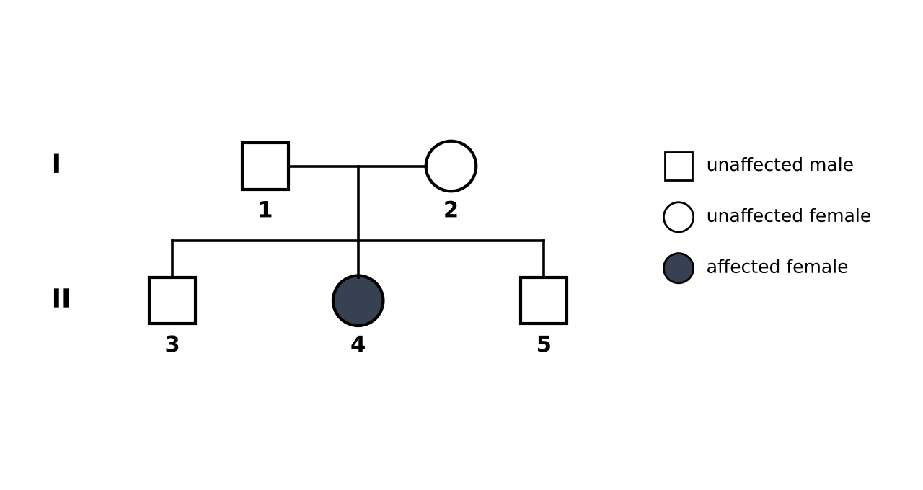
Fig. 1
(a) Explain how Fig. 1 shows that pale skin is caused by a recessive allele. [2]

(b) Calculate the chance that the next child of 1 and 2 is affected. [1]
chance = ............
(c) Parents 1 and 2 have two sons and one daughter. A relative says their next child is "bound to be a girl" to even things out. Explain why this is wrong. [2]

B8 Ghost Census: variation
The heights of 30 ghosts were measured and grouped:
140–149: 2 150–159: 5 160–169: 9 170–179: 8 180–189: 4 190–199: 2
(a) Draw a histogram of the data on Fig. 2. [3]
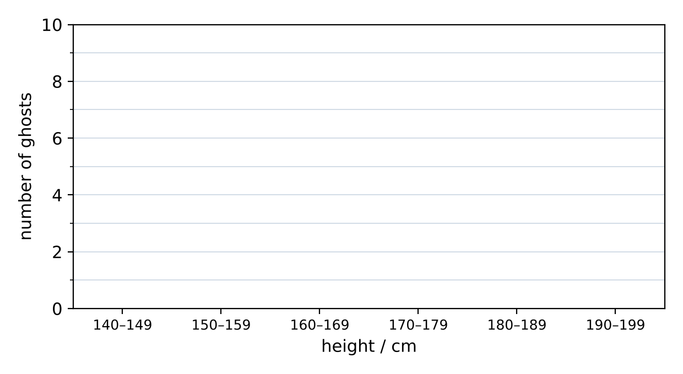
Fig. 2
(b) Classify each feature as continuous (C) or discontinuous (D) variation. [4]
Feature | C / D | Feature | C / D
Height |  | ABO blood group
Body mass |  | Ability to roll tongue
(c) Explain why height shows continuous variation. [2]

B9 Frankenstein's Bacteria: genetic engineering
(a) Number the steps for making human insulin using bacteria from 1 to 5. [3]
Step | Order
The human insulin gene and plasmid are joined by DNA ligase
The bacteria multiply in a fermenter and make insulin
The insulin gene is cut from human DNA using a restriction enzyme
The recombinant plasmid is taken up by a bacterium
A plasmid is cut open with the same restriction enzyme
(b) Give one benefit and one concern of genetic engineering. [2]

Part C: The Sealed Crypt — The Cursed Bloodline
Count Dracul's family carry a gene for a blood protein. In some of them, one base in the gene has changed, and their blood turns pale.
DNA template strand | Sequence
Normal | T A C C T C T T T
Mutant | T A C C A C T T T
Step 1 Write the mRNA made from the normal DNA template. [1]
mRNA: ......................................
Step 2 What type of change has happened to the DNA? [1]

Step 3 Use the codon table to give the amino acid sequence of the normal and the mutant protein. [2]

Step 4 Explain why this one change can make the blood pale. [2]

Step 5 The pale-blood allele is recessive. Two carriers have a child. Calculate the chance the child has pale blood. Show a genetic diagram. [3]

Part D: Practice Questions
D1 Explain the difference between a gene and an allele. [2]

D2 A student says, "Dominant alleles are always more common in a population." Explain why the student is wrong. [2]

D3 A man with blood group A (Iᴬi) and a woman with blood group B (Iᴮi) have children. Draw a genetic diagram to show all possible blood groups of their children. [4]

TEACHER COPY
Answer Key: The Haunted Helix

Codon Table
Use these mRNA codons throughout the worksheet. You do not need to memorise them.
Codon | Amino acid | Codon | Amino acid | Codon | Amino acid
AUG | Met | UGG | Trp | AGC | Ser
GAG | Glu | CAU | His | UAU | Tyr
GUG | Val | CAC | His | GCU | Ala
AAA | Lys | GGC | Gly | UUU | Phe

Part A: Escape the Manor
On the sim: It is Halloween night in Dr. Mendelstein's manor. Solve any 5 of the 9 rooms to open the Sealed Crypt, then break the curse in The Cursed Bloodline. Wrong answers cost +15 s, hints +30 s and a failed crypt attempt +60 s.
A1 Record your progress. For each room you solve, note one misconception it warned you about.
Room | Solved (✓) | Misconception I learned about
The Bone Crypt
Skeleton Zipper
The Witch's Cauldron
Mutant Mirror
Black Cat Alley
Pumpkin Patch
Haunted Family Portrait
Ghost Census
Frankenstein's Bacteria
Student's own records. Examples: uracil placed in DNA; T used in mRNA; reading the codon table with DNA bases; thinking every mutation is harmful or inherited; dominant means more common; setting up a test cross with a dominant parent; 'a girl is due' after several boys; mixing up continuous and discontinuous variation.
A2 Record your final results.
Final time | Wrong answers | Hints used

Part B: Room Practice
The game's questions change every time. Use these questions to practise the same skills.
B1 The Bone Crypt: DNA structure
(a) Name the three parts of a DNA nucleotide. [3]
A phosphate group, a deoxyribose sugar and a nitrogenous base.
(b) Complete the description of DNA. [3]
DNA is made of two strands twisted into a double helix. Each strand has a backbone of alternating sugar and phosphate groups, and the strands are held together by pairs of bases.
B2 Skeleton Zipper: base pairing
(a) Write the complementary DNA strand for: A T G C C A T G A [2]
T A C G G T A C T
(b) In a DNA molecule, 30% of the bases are adenine. Calculate the percentage of thymine, guanine and cytosine. [3]
T = 30% (pairs with A); G + C = 40%, so G = 20% and C = 20%.
B3 The Witch's Cauldron: gene expression
(a) Number the steps of protein synthesis from 1 to 4. [2]
Step | Order
mRNA moves out of the nucleus to a ribosome | 2
Amino acids are joined in the order of the codons to form a polypeptide | 4
The gene is copied into mRNA in the nucleus | 1
The ribosome reads the mRNA three bases (one codon) at a time | 3
(b) Use the codon table to decode this mRNA: A U G U U U G G C [2]
Met – Phe – Gly
B4 Mutant Mirror: mutation
(a) A DNA template strand changes from T A C A A A C C G to T A C A T A C C G. Write the mRNA for each, and use the codon table to find the change in the protein. [4]
Normal mRNA: AUG UUU GGC → Met – Phe – Gly. Mutant mRNA: AUG UAU GGC → Met – Tyr – Gly. One base was substituted, so Phe is replaced by Tyr.
(b) Sort each example into gene mutation (G) or chromosome mutation (C). [3]
Example | G / C
One base in a gene is replaced by another | G
A person with Down syndrome has 47 chromosomes | C
Sickle-cell anaemia caused by a change in the haemoglobin gene | G
(c) A mutation occurs in a skin cell. Can it be passed on to children? Explain. [1]
No. Only mutations in gametes (sex cells) can be inherited.

B5 Black Cat Alley: monohybrid cross and test cross
In cats, black fur (B) is dominant to white fur (b).
(a) Draw a genetic diagram for the cross Bb × Bb. State the expected phenotypic ratio. [4]
Gametes: B, b × B, b. Offspring: BB, Bb, Bb, bb. Ratio 3 black : 1 white.
(b) A black cat could be BB or Bb. Describe a test cross to find out, and explain the results. [3]
Cross it with a white (bb) cat. If any kittens are white, the black cat is Bb. If all kittens are black (in a large litter), it is probably BB.
B6 Pumpkin Patch: codominance and multiple alleles
In ghost pumpkins, the alleles for orange and white are codominant. A pumpkin with one of each allele is speckled.
(a) Two speckled pumpkins are crossed and produce 40 seeds. How many seeds are expected to grow into speckled pumpkins? Show your working. [3]
Speckled × speckled gives 1 orange : 2 speckled : 1 white. ½ of 40 = 20 speckled.
(b) Complete Table 1 for the ABO blood groups. [3]
Genotype | Blood group
I^{A}I^{A} | A
I^{A}I^{B} | AB
I^{B}i | B
ii | O
Table 1
B7 Haunted Family Portrait: pedigrees and sex determination
Fig. 1 shows the inheritance of a ghostly pale skin in Dr. Mendelstein's family.
Fig. 1
(a) Explain how Fig. 1 shows that pale skin is caused by a recessive allele. [2]
Individuals 1 and 2 are unaffected but have an affected child (4). They must both carry the recessive allele (Aa), hidden by the dominant allele.
(b) Calculate the chance that the next child of 1 and 2 is affected. [1]
Aa × Aa → ¼ (25%) aa
(c) Parents 1 and 2 have two sons and one daughter. A relative says their next child is "bound to be a girl" to even things out. Explain why this is wrong. [2]
Each child has an independent 50% chance of being a girl. XX × XY gives ½ XX : ½ XY every time; earlier children do not affect the next.
B8 Ghost Census: variation
The heights of 30 ghosts were measured and grouped: 140–149: 2 150–159: 5 160–169: 9 170–179: 8 180–189: 4 190–199: 2
(a) Draw a histogram of the data on Fig. 2. [3]
Fig. 2
Bars of heights 2, 5, 9, 8, 4, 2, touching, giving a roughly bell-shaped distribution.
(b) Classify each feature as continuous (C) or discontinuous (D) variation. [4]
Feature | C / D | Feature | C / D
Height | C | ABO blood group | D
Body mass | C | Ability to roll tongue | D
(c) Explain why height shows continuous variation. [2]
It is controlled by many genes and is also affected by the environment (e.g. diet), so it has a range of values with no distinct groups.
B9 Frankenstein's Bacteria: genetic engineering
(a) Number the steps for making human insulin using bacteria from 1 to 5. [3]
Step | Order
The human insulin gene and plasmid are joined by DNA ligase | 3
The bacteria multiply in a fermenter and make insulin | 5
The insulin gene is cut from human DNA using a restriction enzyme | 1
The recombinant plasmid is taken up by a bacterium | 4
A plasmid is cut open with the same restriction enzyme | 2
(b) Give one benefit and one concern of genetic engineering. [2]
Benefit: large amounts of human insulin made cheaply / pest-resistant crops / higher yields. Concern: unknown long-term effects / genes may spread to wild plants / ethical concerns.

Part C: The Sealed Crypt — The Cursed Bloodline
Count Dracul's family carry a gene for a blood protein. In some of them, one base in the gene has changed, and their blood turns pale.
DNA template strand | Sequence
Normal | T A C C T C T T T
Mutant | T A C C A C T T T
Step 1 Write the mRNA made from the normal DNA template. [1]
A U G G A G A A A
Step 2 What type of change has happened to the DNA? [1]
A gene mutation: one base (T) has been replaced by another (A) — a substitution.
Step 3 Use the codon table to give the amino acid sequence of the normal and the mutant protein. [2]
Normal: AUG GAG AAA → Met – Glu – Lys. Mutant: AUG GUG AAA → Met – Val – Lys.
Step 4 Explain why this one change can make the blood pale. [2]
One amino acid changes (Glu → Val), which can change the protein's shape, so it may not work properly.
Step 5 The pale-blood allele is recessive. Two carriers have a child. Calculate the chance the child has pale blood. Show a genetic diagram. [3]
Aa × Aa → AA, Aa, Aa, aa. Chance of pale blood (aa) = ¼ = 25%.

Part D: Practice Questions
D1 Explain the difference between a gene and an allele. [2]
A gene is a length of DNA that codes for one polypeptide. An allele is an alternative form of a gene (e.g. B and b).
D2 A student says, "Dominant alleles are always more common in a population." Explain why the student is wrong. [2]
Dominant only means the allele is expressed when one copy is present. How common an allele is depends on the population, not on dominance (e.g. some dominant conditions are rare).
D3 A man with blood group A (Iᴬi) and a woman with blood group B (Iᴮi) have children. Draw a genetic diagram to show all possible blood groups of their children. [4]
Gametes Iᴬ, i × Iᴮ, i. Offspring: IᴬIᴮ (AB), Iᴬi (A), Iᴮi (B), ii (O). Ratio 1 AB : 1 A : 1 B : 1 O.

