
Ammonia
The Haber Process
Simulation: edtechsims.com/haber-process
Name: ____________________ Class: ______ Date: _______

Part A: The Reaction
N₂(g) + 3H₂(g) ⇌ 2NH₃(g) forward reaction is exothermic
A1 Complete the sentences. [6]
The nitrogen used in the Haber process comes from ______________ (by fractional distillation of liquid air). The hydrogen comes from ______________ or the cracking of hydrocarbons.
The symbol ⇌ shows that the reaction is ______________. In a closed system it reaches ______________, where the forward and reverse reactions happen at the ______________.
Most of the ammonia made is used to make ______________, such as ammonium nitrate and ammonium sulfate.

Part B: Effect of Temperature
On the sim: Click on ‘A Microscopic View’. Observe the pressure at 200 atm. Unselect the iron catalyst checkbox. Select different temperatures and record the yields of ammonia.
B1 Complete Table 1. [3]
Temperature / °C | Yield of NH₃ / % | Speed of particles (slow / medium / fast)
350
450
550
Table 1
B2 Describe and explain the effect of increasing the temperature on the yield of ammonia. [2]

B3 Why is a very low temperature, such as 200 °C, not used even though it gives a higher yield? [2]

Part C: Effect of Pressure
On the sim: Click on ‘A Microscopic View’. Set the temperature to 450 °C. Unselect the iron catalyst checkbox. Change the pressure and record the yield of ammonia.
C1 Complete Table 2. [4]
Pressure / atm | Yield of NH₃ / %
100
200
300
400
Table 2
C2 How many molecules of gas are on each side of the equation? [1]
left side: ........ right side: ........
C3 Use your answer to C2 to explain the effect of increasing the pressure on the yield. [2]

C4 Suggest two reasons why the pressure is not raised to 1000 atm. [2]

Part D: Effect of the Iron Catalyst
On the sim: Click on ‘A Microscopic View’. Set 450 °C and 200 atm. Turn the iron catalyst on and off. Compare the yield and how quickly the particles react.
D1 Complete Table 3. [2]
Iron catalyst | Yield of NH₃ / % | Rate at which equilibrium is reached
Off |  | Slower
On |  | Faster
Table 3
D2 Explain why the catalyst does not change the yield but is still used. [2]

Part E: The Compromise Conditions
E1 Click on ‘Plant Manager’. Complete Table 4 with the conditions used in industry and the reason for each. [6]
Condition | Value | Reason
Temperature
Pressure
Catalyst
Table 4
E2 Only about 15% of the nitrogen and hydrogen is converted to ammonia each time the gases pass over the catalyst. Explain how the factory still uses almost all the raw materials. [2]

Part F: Practice Questions
F1 Fig. 1 shows the yield of ammonia at different temperatures and pressures (approximate data).
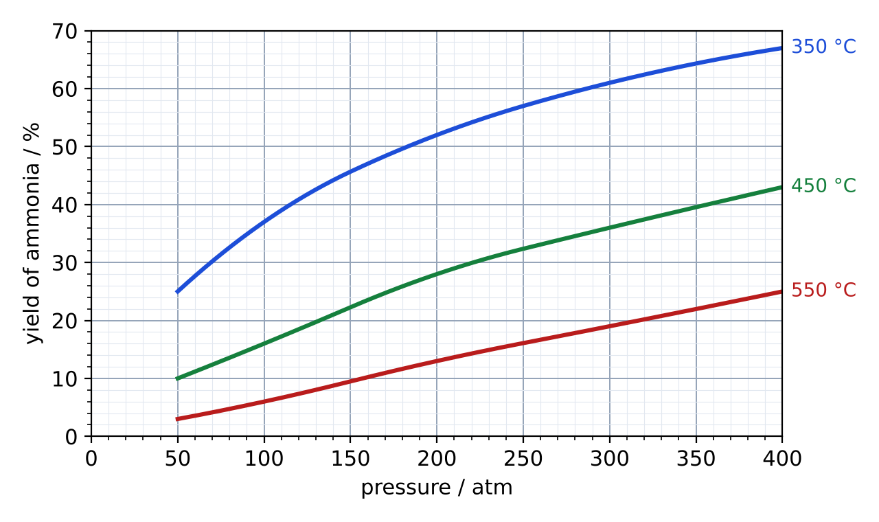
Fig. 1
(a) State the yield of ammonia at 450 °C and 200 atm. [1]
yield = ............ %
(b) Use Fig. 1 to describe the effect of temperature on the yield at 300 atm. [2]

(c) Suggest why a plant might choose 450 °C and 200 atm instead of 350 °C and 400 atm, even though the yield is lower. [2]

F2 Calculate the maximum mass of ammonia that can be made from 56 tonnes of nitrogen. (Ar: N = 14, H = 1) [3]

mass = ............ tonnes
F3 Describe a test for ammonia gas. [2]

TEACHER COPY
Answer Key: The Haber Process

Part A: The Reaction
N₂(g) + 3H₂(g) ⇌ 2NH₃(g) forward reaction is exothermic
A1 Complete the sentences. [6]
The nitrogen used in the Haber process comes from the air (by fractional distillation of liquid air). The hydrogen comes from natural gas (methane) or the cracking of hydrocarbons.
The symbol ⇌ shows that the reaction is reversible. In a closed system it reaches dynamic equilibrium, where the forward and reverse reactions happen at the same rate.
Most of the ammonia made is used to make fertilisers, such as ammonium nitrate and ammonium sulfate.

Part B: Effect of Temperature
On the sim: Click on ‘A Microscopic View’. Observe the pressure at 200 atm. Unselect the iron catalyst checkbox. Select different temperatures and record the yields of ammonia.
B1 Complete Table 1. [3]
Temperature / °C | Yield of NH₃ / % | Speed of particles (slow / medium / fast)
350 | 45.0 | Slow
450 | 28.0 | Medium
550 | 15.0 | Fast
Table 1
Yields from the sim; the yield decreases as temperature increases (roughly 50%, 30%, 13% at 200 atm).
B2 Describe and explain the effect of increasing the temperature on the yield of ammonia. [2]
The yield decreases. The forward reaction is exothermic, so a higher temperature favours the reverse (endothermic) reaction and the position of equilibrium shifts to the left.
B3 Why is a very low temperature, such as 200 °C, not used even though it gives a higher yield? [2]
The particles move slowly and collide less often with less energy, so the rate of reaction is too slow; ammonia would be made too slowly to be economical.

Part C: Effect of Pressure
On the sim: Click on ‘A Microscopic View’. Set the temperature to 450 °C. Unselect the iron catalyst checkbox. Change the pressure and record the yield of ammonia.
C1 Complete Table 2. [4]
Pressure / atm | Yield of NH₃ / %
100 | 14.0
200 | 28.0
300 | 38.0
400 | 43.0
Table 2
Yields from the sim; the yield increases as pressure increases.
C2 How many molecules of gas are on each side of the equation? [1]
Left: 1 + 3 = 4 molecules. Right: 2 molecules.
C3 Use your answer to C2 to explain the effect of increasing the pressure on the yield. [2]
The yield increases. A higher pressure favours the side with fewer gas molecules (the right), so the position of equilibrium shifts to the right and more NH₃ forms.
C4 Suggest two reasons why the pressure is not raised to 1000 atm. [2]
Any two: very expensive to build equipment strong enough; high energy cost to compress the gases; greater safety risk of explosion or leaks.

Part D: Effect of the Iron Catalyst
On the sim: Click on ‘A Microscopic View’. Set 450 °C and 200 atm. Turn the iron catalyst on and off. Compare the yield and how quickly the particles react.
D1 Complete Table 3. [2]
Iron catalyst | Yield of NH₃ / % | Rate at which equilibrium is reached
Off | 35.0 | Slower
On | 35.0 | Faster
Table 3
The yield is the same with and without the catalyst (about 28–30% at 450 °C, 200 atm).
D2 Explain why the catalyst does not change the yield but is still used. [2]
A catalyst speeds up the forward and reverse reactions equally, so the position of equilibrium does not change. It makes equilibrium (and ammonia) reached faster, which saves time and money.

Part E: The Compromise Conditions
E1 Click on ‘Plant Manager’. Complete Table 4 with the conditions used in industry and the reason for each. [6]
Condition | Value | Reason
Temperature | about 450 °C | Compromise: high enough for a fast rate, low enough for a reasonable yield
Pressure | about 200 atm | Compromise: gives a good yield without very high equipment and energy costs
Catalyst | Iron | Increases the rate of reaction; equilibrium reached faster
Table 4
E2 Only about 15% of the nitrogen and hydrogen is converted to ammonia each time the gases pass over the catalyst. Explain how the factory still uses almost all the raw materials. [2]
The ammonia is removed by cooling it until it liquefies. The unreacted nitrogen and hydrogen are recycled back over the catalyst.

Part F: Practice Questions
F1 Fig. 1 shows the yield of ammonia at different temperatures and pressures (approximate data).
Fig. 1
(a) State the yield of ammonia at 450 °C and 200 atm. [1]
about 28%
(b) Use Fig. 1 to describe the effect of temperature on the yield at 300 atm. [2]
As temperature increases from 350 °C to 550 °C, the yield decreases (from about 61% to about 19%).
(c) Suggest why a plant might choose 450 °C and 200 atm instead of 350 °C and 400 atm, even though the yield is lower. [2]
At 350 °C the rate is slower; 400 atm is more expensive and dangerous. 450 °C and 200 atm give an acceptable yield at a faster rate and lower cost.
F2 Calculate the maximum mass of ammonia that can be made from 56 tonnes of nitrogen. (Ar: N = 14, H = 1) [3]
n(N₂) = 56 ÷ 28 = 2 (× 10⁶) mol → n(NH₃) = 4 (× 10⁶) mol; mass = 4 × 17 = 68 tonnes
F3 Describe a test for ammonia gas. [2]
Place damp red litmus paper at the mouth of the tube; it turns blue.

