
Ammonia
The Haber Process
Simulation: edtechsims.com/haber-process
Name: ____________________ Class: ______ Date: _______

Part A: The Reaction
N₂(g) + 3H₂(g) ⇌ 2NH₃(g) forward reaction is exothermic
A1 Complete the sentences. [6]
The nitrogen used in the Haber process comes from ______________ (by fractional distillation of liquid air). The hydrogen comes from ______________ or the cracking of hydrocarbons.
The symbol ⇌ shows that the reaction is ______________. In a closed system it reaches ______________, where the forward and reverse reactions happen at the ______________.
Most of the ammonia made is used to make ______________, such as ammonium nitrate and ammonium sulfate.

Part B: Effect of Temperature
On the sim: Click on ‘A Microscopic View’. Observe the pressure at 200 atm. Unselect the iron catalyst checkbox. Select different temperatures and record the yields of ammonia.
B1 Complete Table 1. [3]
Temperature / °C | Yield of NH₃ / % | Speed of particles (slow / medium / fast)
350
450
550
Table 1
B2 Describe and explain the effect of increasing the temperature on the yield of ammonia. [2]

B3 Why is a very low temperature, such as 200 °C, not used even though it gives a higher yield? [2]

Part C: Effect of Pressure
On the sim: Click on ‘A Microscopic View’. Set the temperature to 450 °C. Unselect the iron catalyst checkbox. Change the pressure and record the yield of ammonia.
C1 Complete Table 2. [4]
Pressure / atm | Yield of NH₃ / %
100
200
300
400
Table 2
C2 How many molecules of gas are on each side of the equation? [1]
left side: ........ right side: ........
C3 Use your answer to C2 to explain the effect of increasing the pressure on the yield. [2]

C4 Suggest two reasons why the pressure is not raised to 1000 atm. [2]

Part D: Effect of the Iron Catalyst
On the sim: Click on ‘A Microscopic View’. Set 450 °C and 200 atm. Turn the iron catalyst on and off. Compare the yield and how quickly the particles react.
D1 Complete Table 3. [2]
Iron catalyst | Yield of NH₃ / % | Rate at which equilibrium is reached
Off |  | Slower
On |  | Faster
Table 3
D2 Explain why the catalyst does not change the yield but is still used. [2]

Part E: The Compromise Conditions
E1 Click on ‘Plant Manager’. Complete Table 4 with the conditions used in industry and the reason for each. [6]
Condition | Value | Reason
Temperature
Pressure
Catalyst
Table 4
E2 Only about 15% of the nitrogen and hydrogen is converted to ammonia each time the gases pass over the catalyst. Explain how the factory still uses almost all the raw materials. [2]

Part F: Practice Questions
F1 Fig. 1 shows the yield of ammonia at different temperatures and pressures (approximate data).
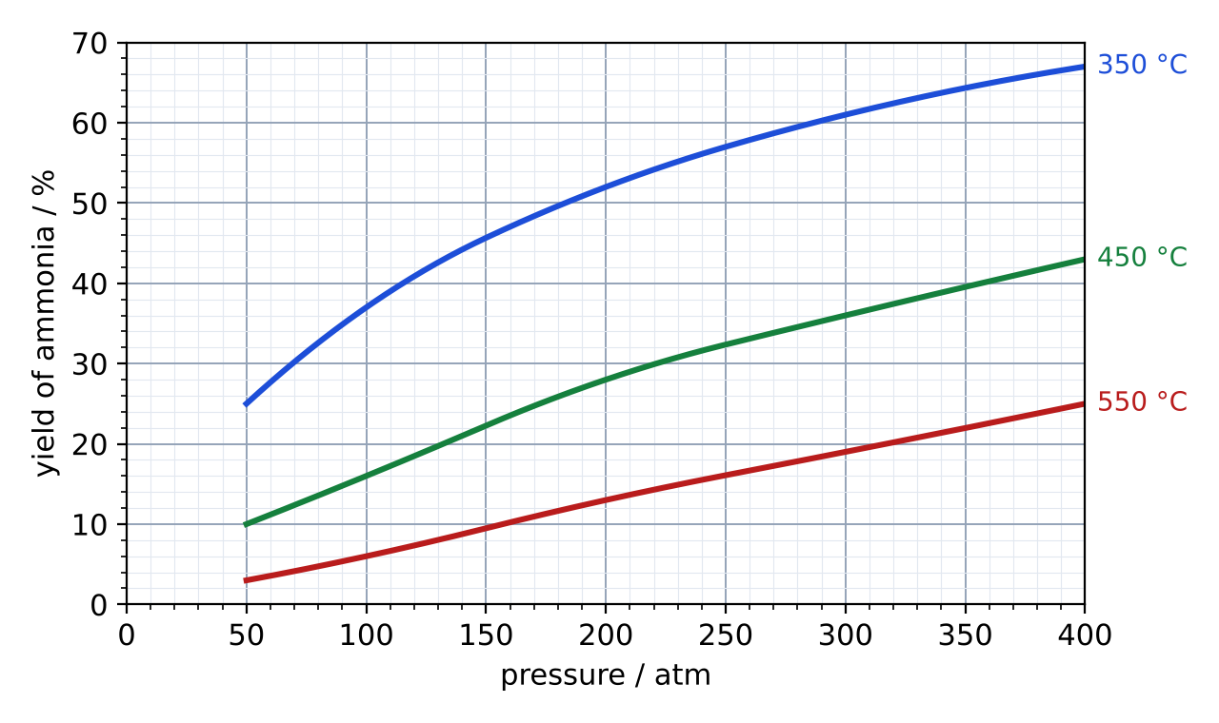
Fig. 1
(a) State the yield of ammonia at 450 °C and 200 atm. [1]
yield = ............ %
(b) Use Fig. 1 to describe the effect of temperature on the yield at 300 atm. [2]

(c) Suggest why a plant might choose 450 °C and 200 atm instead of 350 °C and 400 atm, even though the yield is lower. [2]

F2 Calculate the maximum mass of ammonia that can be made from 56 tonnes of nitrogen. (Ar: N = 14, H = 1) [3]

mass = ............ tonnes
F3 Describe a test for ammonia gas. [2]

