
Particulate Nature of Matter
Elements, Compounds and Mixtures
Simulation: edtechsims.com/elements-compounds-mixtures
Name: ____________________ Class: ______ Date: _______

Part A: Key Ideas
On the sim: Open How to Identify Elements, Compounds and Mixtures on the home page and read all six cards.
A1 Complete the definitions. [6]
An element is a substance made up of only ____________. It cannot be broken down into simpler substances by chemical means.
A compound is a substance made up of two or more different elements ____________ in a ____________ ratio.
A mixture contains two or more substances that are ____________. Its particles are ____________.
Air is a mixture made up mainly of ____________ and ____________.
A2 Write the three questions you should ask, in order, when classifying a particle diagram. [3]
1. ....................................................
2. ....................................................
3. ....................................................

Part B: Classifying Particle Diagrams
On the sim: Play the game at Level 1 and Level 2 in Practice mode. Then classify each diagram below.
B1 Fig. 1 shows eight particle diagrams. Each circle is an atom; atoms that touch are joined.
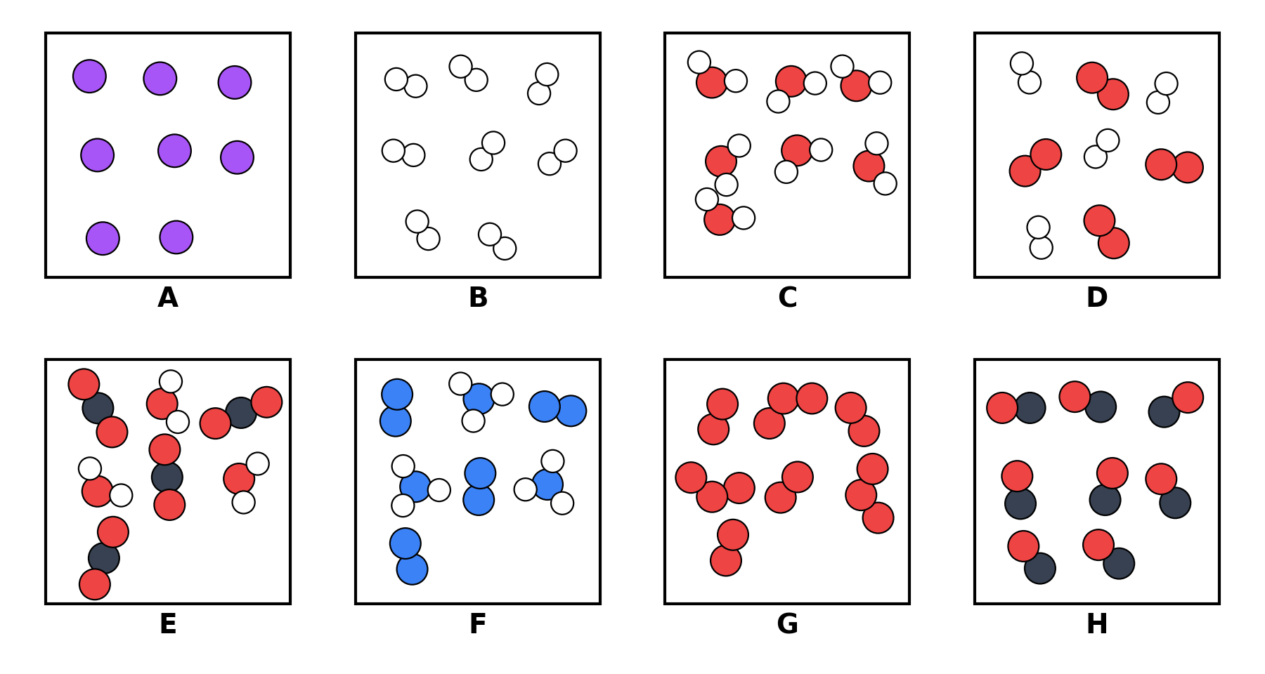
Fig. 1

Complete Table 1. In the last column, write the formula of each substance (Level 3). Use "+" for a mixture.
Box | Level 1: Element, compound or mixture? | Level 2: Type | Level 3: Formula
A
B
C
D
E
F
G
H
Table 1

Part C: Common Traps
C1 Circle True or False. If a statement is false, explain why. [10]
1. O₂ is a compound because it contains two atoms joined together.
True / False Reason:
2. A sample containing O₂ and O₃ molecules is an element because it has only one type of atom.
True / False Reason:
3. CO and CO₂ contain the same elements, so a sample of CO and CO₂ is a pure compound.
True / False Reason:
4. In a compound, every particle in the diagram must be identical.
True / False Reason:
5. A mixture of H₂ and O₂ can be written as H₂O.
True / False Reason:
C2 Why is H₂ + O₂ not the same as H₂O? [2]

Part D: Game Record
On the sim: Play the game in Timed mode (90 s) with all three levels selected. Record your best attempts.
Attempt | Levels selected | Mode | Score
1
2
3

Part E: Practice Questions
E1 Classify each substance as an element, a compound or a mixture. [4]
Substance | Classification | Substance | Classification
Air |  | Sodium chloride
Sea water |  | Copper
Distilled water |  | Brass
Nitrogen |  | Carbon dioxide
E2 A student mixes iron filings with sulfur powder. She then heats the mixture strongly to form iron(II) sulfide.
(a) Describe how the iron could be separated from the mixture before heating. [1]

(b) Explain why the iron cannot be separated from iron(II) sulfide in the same way. [2]

(c) State two differences between the properties of a mixture and a compound. [2]

E3 Sea water boils over a range of temperatures, but pure water boils at 100 °C. Explain this difference. [2]

TEACHER COPY
Answer Key: Elements, Compounds and Mixtures

Part A: Key Ideas
On the sim: Open How to Identify Elements, Compounds and Mixtures on the home page and read all six cards.
A1 Complete the definitions. [6]
An element is a substance made up of only one type of atom. It cannot be broken down into simpler substances by chemical means.
A compound is a substance made up of two or more different elements chemically combined in a fixed ratio.
A mixture contains two or more substances that are not chemically combined. Its particles are not all identical.
Air is a mixture made up mainly of N₂ and O₂.
A2 Write the three questions you should ask, in order, when classifying a particle diagram. [3]
1. How many types of atom are there?
2. Are different types of atom chemically joined?
3. Are all the particles identical?

Part B: Classifying Particle Diagrams
On the sim: Play the game at Level 1 and Level 2 in Practice mode. Then classify each diagram below.
B1 Fig. 1 shows eight particle diagrams. Each circle is an atom; atoms that touch are joined.
Fig. 1

Complete Table 1. In the last column, write the formula of each substance (Level 3). Use "+" for a mixture.
Box | Level 1: Element, compound or mixture? | Level 2: Type | Level 3: Formula
A | Element | Element (atoms) | Ne
B | Element | Element (molecules) | H₂
C | Compound | Compound | H₂O
D | Mixture | Mixture of elements | H₂ + O₂
E | Mixture | Mixture of compounds | CO₂ + H₂O
F | Mixture | Mixture of an element and a compound | N₂ + NH₃
G | Mixture | Mixture of elements | O₂ + O₃
H | Compound | Compound | CO
Table 1

Part C: Common Traps
C1 Circle True or False. If a statement is false, explain why. [10]
1. O₂ is a compound because it contains two atoms joined together.
False. Both atoms are oxygen, so O₂ is an element.
2. A sample containing O₂ and O₃ molecules is an element because it has only one type of atom.
False. The particles are not all identical, so it is a mixture (of two elements).
3. CO and CO₂ contain the same elements, so a sample of CO and CO₂ is a pure compound.
False. The atoms are joined in different ratios, so they are different compounds; the sample is a mixture of compounds.
4. In a compound, every particle in the diagram must be identical.
True. A compound has a fixed composition, so all its particles are the same.
5. A mixture of H₂ and O₂ can be written as H₂O.
False. The atoms are not chemically joined; the mixture is written H₂ + O₂.
C2 Why is H₂ + O₂ not the same as H₂O? [2]
In H₂ + O₂ the hydrogen and oxygen atoms are in separate molecules and not chemically joined. In H₂O each molecule contains hydrogen and oxygen atoms chemically combined.

Part D: Game Record
On the sim: Play the game in Timed mode (90 s) with all three levels selected. Record your best attempts.
Attempt | Levels selected | Mode | Score
1
2
3
Scores from the sim.

Part E: Practice Questions
E1 Classify each substance as an element, a compound or a mixture. [4]
Substance | Classification | Substance | Classification
Air | Mixture | Sodium chloride | Compound
Sea water | Mixture | Copper | Element
Distilled water | Compound | Brass | Mixture
Nitrogen | Element | Carbon dioxide | Compound
E2 A student mixes iron filings with sulfur powder. She then heats the mixture strongly to form iron(II) sulfide.
(a) Describe how the iron could be separated from the mixture before heating. [1]
Use a magnet; the iron filings are attracted to it and the sulfur is not.
(b) Explain why the iron cannot be separated from iron(II) sulfide in the same way. [2]
In iron(II) sulfide the iron and sulfur are chemically combined, so the iron is no longer free and the compound is not attracted to a magnet. It can only be separated by a chemical reaction.
(c) State two differences between the properties of a mixture and a compound. [2]
Any two: a mixture has a variable composition, a compound has a fixed composition; a mixture keeps the properties of its components, a compound has different properties from its elements; a mixture can be separated by physical methods, a compound only by chemical methods; no energy change on forming a mixture, but energy is usually given out or taken in when a compound forms.
E3 Sea water boils over a range of temperatures, but pure water boils at 100 °C. Explain this difference. [2]
Pure water is a single substance with a fixed boiling point. Sea water is a mixture with a variable composition, so it does not have a fixed boiling point (it boils above 100 °C over a range).

