
Particulate Nature of Matter
Elements, Compounds and Mixtures
Simulation: edtechsims.com/elements-compounds-mixtures
Name: ____________________ Class: ______ Date: _______

Part A: Key Ideas
On the sim: Open How to Identify Elements, Compounds and Mixtures on the home page and read all six cards.
A1 Complete the definitions. [6]
An element is a substance made up of only ____________. It cannot be broken down into simpler substances by chemical means.
A compound is a substance made up of two or more different elements ____________ in a ____________ ratio.
A mixture contains two or more substances that are ____________. Its particles are ____________.
Air is a mixture made up mainly of ____________ and ____________.
A2 Write the three questions you should ask, in order, when classifying a particle diagram. [3]
1. ....................................................
2. ....................................................
3. ....................................................

Part B: Classifying Particle Diagrams
On the sim: Play the game at Level 1 and Level 2 in Practice mode. Then classify each diagram below.
B1 Fig. 1 shows eight particle diagrams. Each circle is an atom; atoms that touch are joined.
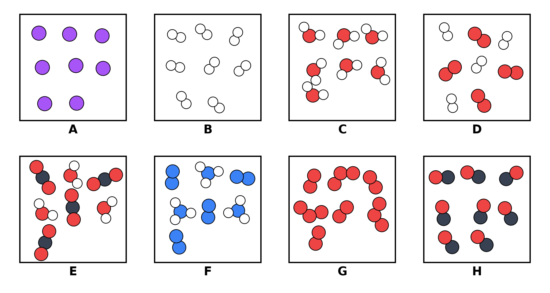
Fig. 1

Complete Table 1. In the last column, write the formula of each substance (Level 3). Use "+" for a mixture.
Box | Level 1: Element, compound or mixture? | Level 2: Type | Level 3: Formula
A
B
C
D
E
F
G
H
Table 1

Part C: Common Traps
C1 Circle True or False. If a statement is false, explain why. [10]
1. O₂ is a compound because it contains two atoms joined together.
True / False Reason:
2. A sample containing O₂ and O₃ molecules is an element because it has only one type of atom.
True / False Reason:
3. CO and CO₂ contain the same elements, so a sample of CO and CO₂ is a pure compound.
True / False Reason:
4. In a compound, every particle in the diagram must be identical.
True / False Reason:
5. A mixture of H₂ and O₂ can be written as H₂O.
True / False Reason:
C2 Why is H₂ + O₂ not the same as H₂O? [2]

Part D: Game Record
On the sim: Play the game in Timed mode (90 s) with all three levels selected. Record your best attempts.
Attempt | Levels selected | Mode | Score
1
2
3

Part E: Practice Questions
E1 Classify each substance as an element, a compound or a mixture. [4]
Substance | Classification | Substance | Classification
Air |  | Sodium chloride
Sea water |  | Copper
Distilled water |  | Brass
Nitrogen |  | Carbon dioxide
E2 A student mixes iron filings with sulfur powder. She then heats the mixture strongly to form iron(II) sulfide.
(a) Describe how the iron could be separated from the mixture before heating. [1]

(b) Explain why the iron cannot be separated from iron(II) sulfide in the same way. [2]

(c) State two differences between the properties of a mixture and a compound. [2]

E3 Sea water boils over a range of temperatures, but pure water boils at 100 °C. Explain this difference. [2]

