

Chemical Bonding
Dot-and-Cross Diagrams
Simulation: edtechsims.com/dot-and-cross-diagrams
Name: ____________________ Class: ______ Date: _______

Part A: Electronic Configurations
A1 Complete Table 1. [8]
Element | Proton number | Electronic configuration | Valence electrons | To get a noble gas configuration, it… | Ion formed
Sodium, Na | 11 | 2.8.1 | 1 | Loses 1 electron | Na⁺
Magnesium, Mg | 12
Calcium, Ca | 20
Oxygen, O | 8 | 2.6 | 6 | Gains 2 (or shares 2) | O²⁻
Chlorine, Cl | 17
Nitrogen, N | 7
Carbon, C | 6
Hydrogen, H | 1
Table 1

Part B: Ionic Compounds
On the sim: Open the Builder and choose Ionic compounds. Build NaCl, MgO and MgCl₂, transferring electrons from the metal to the non-metal.
Fig. 1 shows the dot-and-cross diagram of sodium chloride, with all shells shown. (× = electrons from Na, • = electrons from Cl)
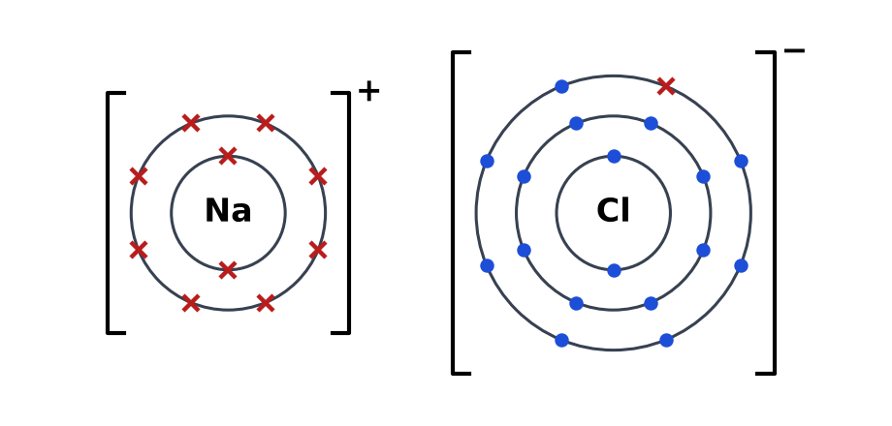
Fig. 1
B1 Complete the rules for drawing ionic dot-and-cross diagrams. [4]
The metal atom ______________ its valence electrons and the non-metal atom ______________ them. Each ion is drawn inside ______________, with its ______________ written at the top right.
B2 Complete Table 2. [6]
Compound | Electrons lost by each metal atom | Cation | Anion | Ratio of cation : anion | Formula
Sodium chloride | 1 | Na⁺ | Cl⁻ | 1 : 1 | NaCl
Magnesium oxide
Magnesium chloride
Sodium oxide
Calcium fluoride
Potassium sulfide
Table 2
B3 Draw dot-and-cross diagrams, showing all shells, for magnesium oxide and calcium fluoride. [4]
Magnesium oxide, MgO

Calcium fluoride, CaF₂

Part C: Covalent Molecules
On the sim: In the Builder, choose Covalent molecules. Build H₂O, NH₃, CO₂ and N₂, placing shared pairs in the overlap between atoms.
C1 Complete the sentences. [3]
In a covalent bond, a pair of electrons is ______________ between two non-metal atoms. A double bond contains ______________ shared pairs. Electrons in the outer shell that are not shared are called ______________ (non-bonding electrons).
C2 Complete Table 3. [10]
Molecule | Number of shared pairs in the molecule | Type(s) of bond | Lone pairs on the central atom
H₂ | 1 | Single | 0 (on each H)
Cl₂
HCl
H₂O | 2 | Single | 2 (on O)
NH₃
CH₄
O₂
N₂
CO₂
C₂H₄
Table 3
C3 Draw dot-and-cross diagrams, showing all shells, for water, ammonia, carbon dioxide and nitrogen. [8]
Water, H₂O

Ammonia, NH₃

Carbon dioxide, CO₂

Nitrogen, N₂

Part D: Spot the Mistake
On the sim: Open the Spot the Mistake tab and try the diagrams there. Then find the mistake in each diagram below.
D1 A student's diagram of sodium chloride. [2]
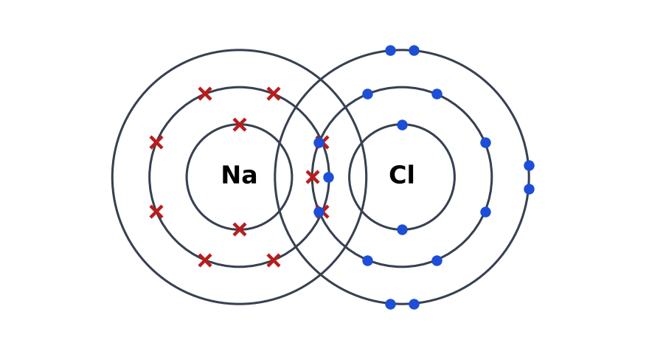
Mistake and correction:

D2 A student's diagram of magnesium oxide. [2]
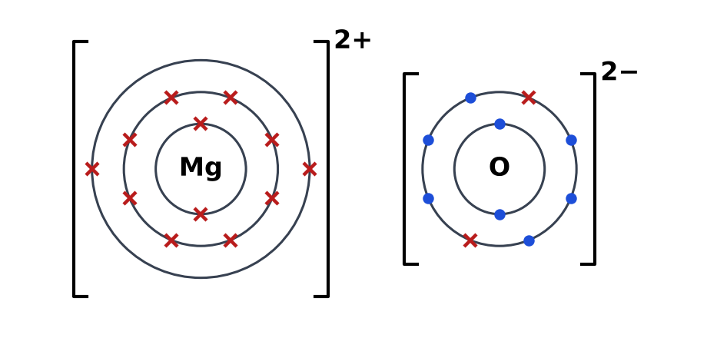
Mistake and correction:

D3 A student's diagram of water. [2]
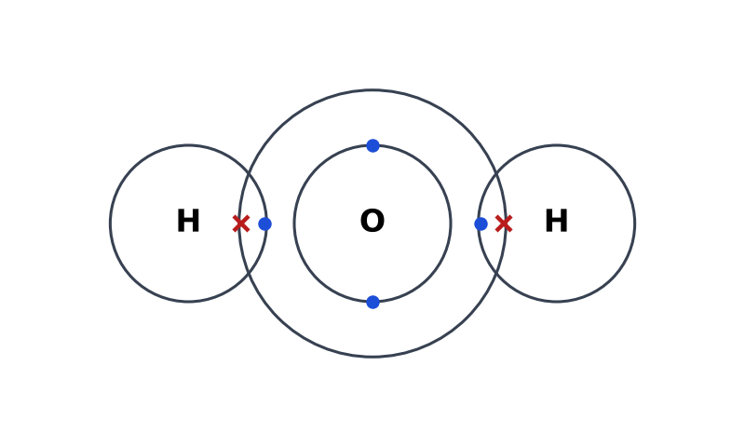
Mistake and correction:

D4 A student's diagram of nitrogen. [2]
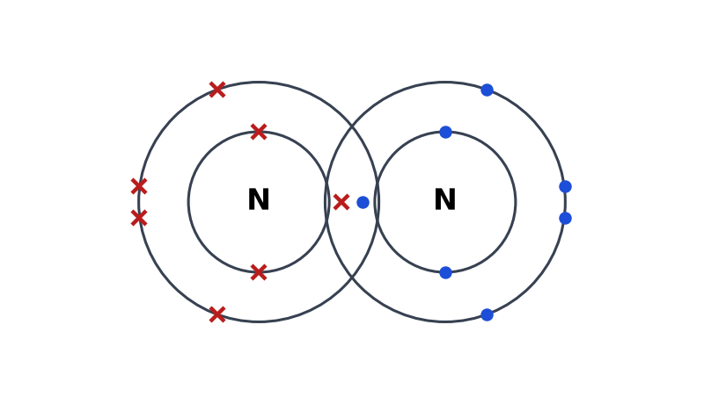
Mistake and correction:

Part E: Practice Questions
E1 Aluminium (2.8.3) reacts with oxygen (2.6) to form aluminium oxide.
(a) State the charges on the two ions formed. [2]

(b) Deduce the formula of aluminium oxide. Explain your answer using the charges. [2]

E2 Explain why the formula of water is H₂O and not HO, in terms of electrons. [2]

E3 Compare how the bonds form in magnesium chloride and in hydrogen chloride. [3]

TEACHER COPY
Answer Key: Dot-and-Cross Diagrams

Part A: Electronic Configurations
A1 Complete Table 1. [8]
Element | Proton number | Electronic configuration | Valence electrons | To get a noble gas configuration, it… | Ion formed
Sodium, Na | 11 | 2.8.1 | 1 | Loses 1 | Na⁺
Magnesium, Mg | 12 | 2.8.2 | 2 | Loses 2 | Mg²⁺
Calcium, Ca | 20 | 2.8.8.2 | 2 | Loses 2 | Ca²⁺
Oxygen, O | 8 | 2.6 | 6 | Gains 2 (or shares 2) | O²⁻
Chlorine, Cl | 17 | 2.8.7 | 7 | Gains 1 (or shares 1) | Cl⁻
Nitrogen, N | 7 | 2.5 | 5 | Shares 3 | —
Carbon, C | 6 | 2.4 | 4 | Shares 4 | —
Hydrogen, H | 1 | 1 | 1 | Shares 1 | —
Table 1

Part B: Ionic Compounds
On the sim: Open the Builder and choose Ionic compounds. Build NaCl, MgO and MgCl₂, transferring electrons from the metal to the non-metal.
Fig. 1 shows the dot-and-cross diagram of sodium chloride, with all shells shown. (× = electrons from Na, • = electrons from Cl)
Fig. 1
B1 Complete the rules for drawing ionic dot-and-cross diagrams. [4]
The metal atom loses its valence electrons and the non-metal atom gains them. Each ion is drawn inside square brackets, with its charge written at the top right.
B2 Complete Table 2. [6]
Compound | Electrons lost by each metal atom | Cation | Anion | Ratio of cation : anion | Formula
Sodium chloride | 1 | Na⁺ | Cl⁻ | 1 : 1 | NaCl
Magnesium oxide | 2 | Mg²⁺ | O²⁻ | 1 : 1 | MgO
Magnesium chloride | 2 | Mg²⁺ | Cl⁻ | 1 : 2 | MgCl₂
Sodium oxide | 1 | Na⁺ | O²⁻ | 2 : 1 | Na₂O
Calcium fluoride | 2 | Ca²⁺ | F⁻ | 1 : 2 | CaF₂
Potassium sulfide | 1 | K⁺ | S²⁻ | 2 : 1 | K₂S
Table 2
B3 Draw dot-and-cross diagrams, showing all shells, for magnesium oxide and calcium fluoride. [4]
Magnesium oxide, MgO
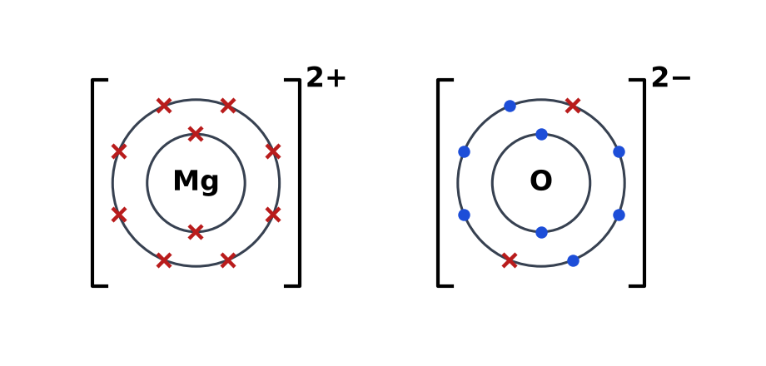

Calcium fluoride, CaF₂
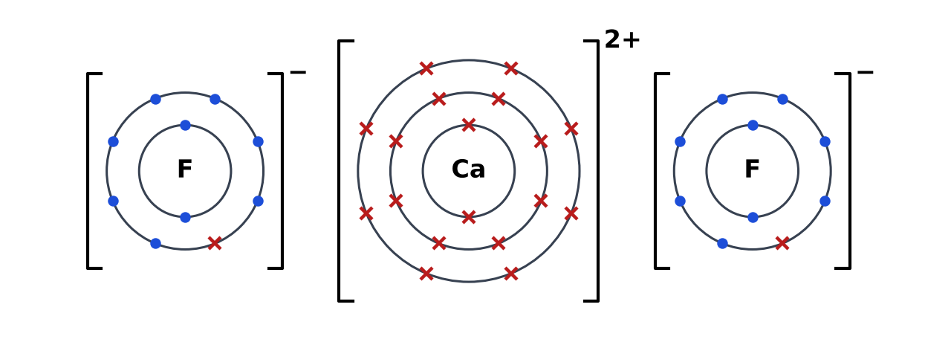
or one Ca²⁺ ion with a big two in front of F⁻ ion

Part C: Covalent Molecules
On the sim: In the Builder, choose Covalent molecules. Build H₂O, NH₃, CO₂ and N₂, placing shared pairs in the overlap between atoms.
C1 Complete the sentences. [3]
In a covalent bond, a pair of electrons is shared between two non-metal atoms. A double bond contains two shared pairs. Electrons in the outer shell that are not shared are called lone pairs (non-bonding electrons).
C2 Complete Table 3. [10]
Molecule | Number of shared pairs in the molecule | Type(s) of bond | Lone pairs on the central atom
H₂ | 1 | Single | 0 (on each H)
Cl₂ | 1 | Single | 3 (on each Cl)
HCl | 1 | Single | 3 (on Cl)
H₂O | 2 | Single | 2 (on O)
NH₃ | 3 | Single | 1 (on N)
CH₄ | 4 | Single | 0 (on C)
O₂ | 2 | Double | 2 (on each O)
N₂ | 3 | Triple | 1 (on each N)
CO₂ | 4 | Two double | 0 (on C); 2 on each O
C₂H₄ | 6 | One C=C double, four C–H single | 0 (on each C)
Table 3
C3 Draw dot-and-cross diagrams, showing all shells, for water, ammonia, carbon dioxide and nitrogen. [8]
Water, H₂O
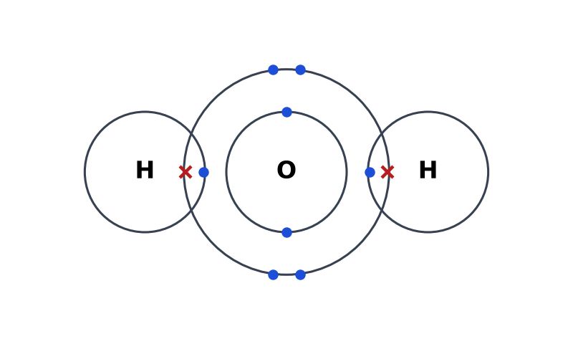

Ammonia, NH₃
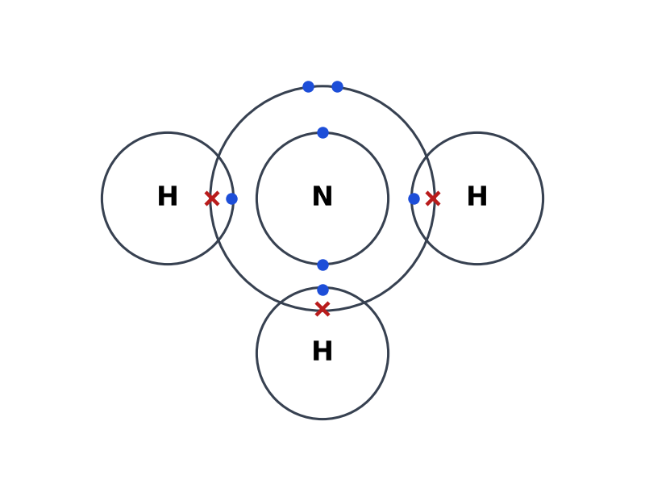

Carbon dioxide, CO₂
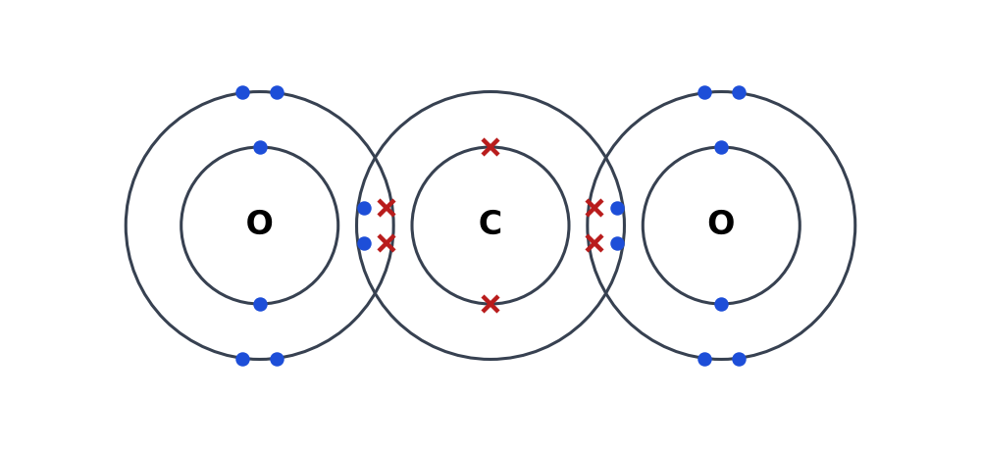

Nitrogen, N₂
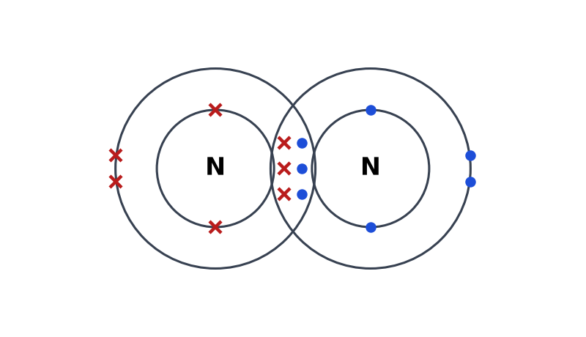

Part D: Spot the Mistake
On the sim: Open the Spot the Mistake tab and try the diagrams there. Then find the mistake in each diagram below.
D1 A student's diagram of sodium chloride. [2]
Electrons are shared, as in a covalent bond. NaCl is ionic: Na transfers 1 electron to Cl, forming Na⁺ [2.8] and Cl⁻ [2.8.8] in separate brackets with charges.
D2 A student's diagram of magnesium oxide. [2]
Mg²⁺ still shows its outer shell with 2 electrons. Those 2 electrons have been transferred to O, so Mg²⁺ should have only 2 shells (2.8).
D3 A student's diagram of water. [2]
The 4 non-bonding electrons (2 lone pairs) on oxygen are missing; O has only 4 electrons in its outer shell instead of 8.
D4 A student's diagram of nitrogen. [2]
Only one shared pair is shown, so each N has 6 outer electrons. N₂ has a triple bond (3 shared pairs), with one lone pair on each N.

Part E: Practice Questions
E1 Aluminium (2.8.3) reacts with oxygen (2.6) to form aluminium oxide.
(a) State the charges on the two ions formed. [2]
Al³⁺ and O²⁻
(b) Deduce the formula of aluminium oxide. Explain your answer using the charges. [2]
Al₂O₃. Two Al³⁺ give +6 and three O²⁻ give −6, so the charges balance.
E2 Explain why the formula of water is H₂O and not HO, in terms of electrons. [2]
Oxygen has 6 valence electrons and needs 2 more for an octet, so it forms two covalent bonds. Each hydrogen forms only one bond, so two H atoms are needed.
E3 Compare how the bonds form in magnesium chloride and in hydrogen chloride. [3]
In MgCl₂, electrons are transferred: Mg loses 2 electrons (one to each Cl), forming Mg²⁺ and Cl⁻ ions held by electrostatic attraction. In HCl, H and Cl each contribute one electron to a shared pair (covalent bond); no ions form.

