
Infectious Diseases in Humans
Outbreak at Seaview Secondary
Simulation: edtechsims.com/disease-outbreak
Name: ____________________ Class: ______ Date: _______

Part A: The Investigation
On the sim: Students at Seaview Secondary are falling ill with flu and pneumonia, and the Health Ministry has called in your Rapid Response Team. Clear stations to collect evidence. The Final Case Report unlocks after 6 of the 9 stations.
A1 Record your progress. For each station you clear, note one misconception it warned you about.
Station | Cleared (✓) | Misconception I learned about
Infectious or Not?
Build-a-Pathogen
Friend or Foe?
The Clinic
Outbreak Simulator
Second Encounter
Antibiotic Lab
The Prescription Desk
Superbug Evolution
A2 Record your final results.
Final time | Wrong answers | Hints used

Part B: Station Practice
The game's questions change every time. Use these questions to practise the same skills.
B1 Infectious or Not?
Classify each disease as infectious (I) or non-infectious (N). [4]
Disease | I / N | Disease | I / N
Influenza |  | Type 2 diabetes
Pneumococcal pneumonia |  | Lung cancer
Tuberculosis |  | Scurvy (vitamin C deficiency)
COVID-19 |  | Sickle-cell anaemia
B2 Build-a-Pathogen
Complete Table 1 to compare a virus with a bacterium. [5]
Feature | Virus | Bacterium
Relative size
Genetic material
Has a cell wall?
Can reproduce on its own?
Killed by antibiotics?
Table 1
B3 Friend or Foe?
Give one example of a bacterium that causes disease and one that is generally helpful to humans, and explain its role. [2]

B4 The Clinic
(a) State two ways in which influenza differs from a common cold. [2]

(b) Name two diseases, other than pneumonia, that can be caused by the pneumococcus bacterium. [2]

B5 Outbreak Simulator
(a) Describe two ways in which influenza spreads from person to person. [2]

(b) Suggest three measures the school could take, and explain why using only one measure may not stop the outbreak. [4]

B6 Second Encounter
Fig. 1 shows the antibody concentration in a student's blood after vaccination and after later exposure to the real pathogen.
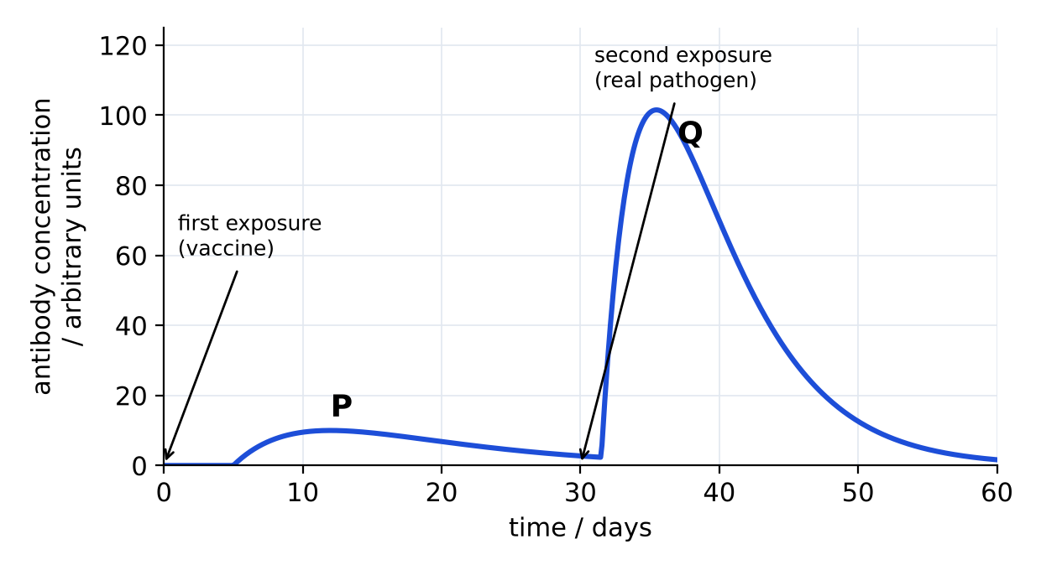
Fig. 1
(a) Describe two differences between response P and response Q. [2]

(b) Explain why the student does not become ill after the second exposure. [2]

(c) A classmate says the vaccine contains the live, dangerous pathogen. Correct this statement. [1]

B7 Antibiotic Lab
Discs soaked in four antibiotics, A to D, were placed on a dish of bacteria. After incubation, a clear zone formed around some discs (Fig. 2).
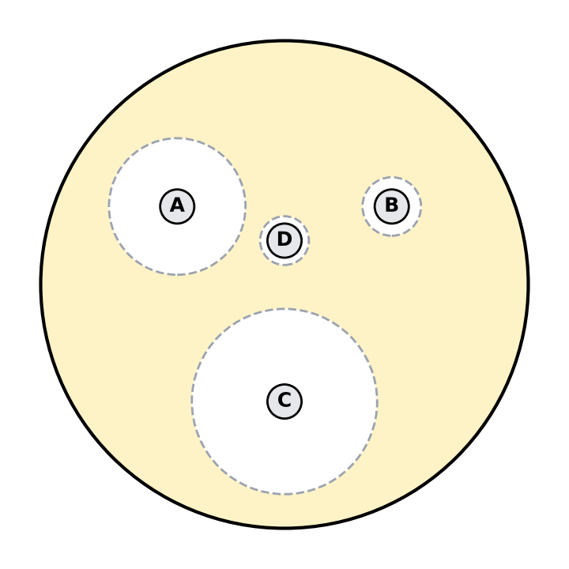
Fig. 2
Antibiotic | Diameter of clear zone / mm | Antibiotic | Diameter of clear zone / mm
A | 25 | B | 11
C | 34 | D | 0 (no clear zone)
(a) Which antibiotic is most effective against these bacteria? Explain. [2]

(b) Suggest why there is no clear zone around disc D. [1]

(c) The experiment is repeated with influenza viruses instead of bacteria. Predict and explain the result. [2]

B8 The Prescription Desk
Decide whether each patient should be given antibiotics. [3]
Patient | Antibiotics? | Reason
Mei, 15: runny nose, sore throat, mild cough for 2 days
Mr Tan, 72: high fever, chest pain, coughing up thick mucus; tests show Streptococcus pneumoniae
Arif, 16: sudden high fever, aching muscles, extreme tiredness; tests show influenza virus
Explain why Mr Tan must finish the whole course of antibiotics, even when he feels better. [2]

B9 Superbug Evolution
Number the stages in the development of an antibiotic-resistant population of bacteria from 1 to 5. [3]
Stage | Order
The antibiotic kills the non-resistant bacteria
A random mutation makes one bacterium resistant
The whole population is now resistant
The antibiotic is used to treat an infection
Resistant bacteria survive and reproduce, passing on the resistance gene
A patient says, "I have taken so many antibiotics that my body is now resistant to them." Correct this statement. [2]

Part C: The Final Case Report
Present your findings on the Seaview outbreak to the Principal.
1. Identify the two pathogens causing the outbreak, and state whether each is a virus or a bacterium. [2]

2. State how each pathogen is transmitted. [2]

3. Recommend three interventions to the Principal. [3]

4. Explain why antibiotics will help the students hospitalised with pneumonia but not those with flu. [2]

Part D: Practice Questions
D1 Define the term pathogen. [1]

D2 Explain why doctors are concerned about the overuse of antibiotics. [3]

D3 Explain why a new flu vaccine is needed every year. [2]

TEACHER COPY
Answer Key: Outbreak at Seaview Secondary

Part A: The Investigation
On the sim: Students at Seaview Secondary are falling ill with flu and pneumonia, and the Health Ministry has called in your Rapid Response Team. Clear stations to collect evidence. The Final Case Report unlocks after 6 of the 9 stations.
A1 Record your progress. For each station you clear, note one misconception it warned you about.
Station | Cleared (✓) | Misconception I learned about
Infectious or Not?
Build-a-Pathogen
Friend or Foe?
The Clinic
Outbreak Simulator
Second Encounter
Antibiotic Lab
The Prescription Desk
Superbug Evolution
Student's own records. Examples: any serious illness is infectious; viruses are tiny bacteria; all bacteria cause disease; flu is just a bad cold; one intervention alone is enough; vaccines contain live dangerous pathogens or are a cure; antibiotics kill viruses; stop antibiotics when you feel better; the person (not the bacteria) becomes resistant.
A2 Record your final results.
Final time | Wrong answers | Hints used

Part B: Station Practice
The game's questions change every time. Use these questions to practise the same skills.
B1 Infectious or Not?
Classify each disease as infectious (I) or non-infectious (N). [4]
Disease | I / N | Disease | I / N
Influenza | I | Type 2 diabetes | N
Pneumococcal pneumonia | I | Lung cancer | N
Tuberculosis | I | Scurvy (vitamin C deficiency) | N
COVID-19 | I | Sickle-cell anaemia | N
B2 Build-a-Pathogen
Complete Table 1 to compare a virus with a bacterium. [5]
Feature | Virus | Bacterium
Relative size | Much smaller | Larger (but still microscopic)
Genetic material | DNA or RNA, inside a protein coat | Circular DNA in the cytoplasm (no nucleus)
Has a cell wall? | No | Yes
Can reproduce on its own? | No; only inside a host cell | Yes; by binary fission
Killed by antibiotics? | No | Yes (if not resistant)
Table 1
B3 Friend or Foe?
Give one example of a bacterium that causes disease and one that is generally helpful to humans, and explain its role. [2]
Pathogenic: Streptococcus pneumoniae causes pneumonia. Generally helpful: Lactobacillus, used to make yoghurt / found in the gut; or decomposers that recycle nutrients.
B4 The Clinic
(a) State two ways in which influenza differs from a common cold. [2]
Influenza has a sudden onset, high fever, muscle aches and severe tiredness, and can lead to serious complications such as pneumonia; a cold is milder with mainly a runny nose and sore throat.
(b) Name two diseases, other than pneumonia, that can be caused by the pneumococcus bacterium. [2]
Any two: meningitis; middle ear infection (otitis media); blood infection (septicaemia/bacteraemia); sinusitis.
B5 Outbreak Simulator
(a) Describe two ways in which influenza spreads from person to person. [2]
Airborne droplets from coughs and sneezes are inhaled; touching contaminated surfaces (door handles, desks) then touching the mouth, nose or eyes.
(b) Suggest three measures the school could take, and explain why using only one measure may not stop the outbreak. [4]
Any three: vaccination; mask wearing; hand washing / sanitiser; isolating sick students; cleaning surfaces; ventilation. One measure blocks only one route of transmission (e.g. masks do not stop spread from surfaces), so several measures are needed together.
B6 Second Encounter
Fig. 1 shows the antibody concentration in a student's blood after vaccination and after later exposure to the real pathogen.
Fig. 1
(a) Describe two differences between response P and response Q. [2]
Q is faster (starts sooner after exposure) and produces a much higher concentration of antibodies; Q also lasts longer.
(b) Explain why the student does not become ill after the second exposure. [2]
Memory cells made after vaccination recognise the antigen quickly and produce large amounts of antibodies, destroying the pathogen before symptoms develop.
(c) A classmate says the vaccine contains the live, dangerous pathogen. Correct this statement. [1]
Vaccines contain weakened or dead pathogens, or parts of them (antigens), which cannot cause the disease.
B7 Antibiotic Lab
Discs soaked in four antibiotics, A to D, were placed on a dish of bacteria. After incubation, a clear zone formed around some discs (Fig. 2).
Fig. 2
Antibiotic | Diameter of clear zone / mm | Antibiotic | Diameter of clear zone / mm
A | 25 | B | 11
C | 34 | D | 0 (no clear zone)
(a) Which antibiotic is most effective against these bacteria? Explain. [2]
C. It has the largest clear zone, so it killed / stopped the growth of bacteria over the largest area.
(b) Suggest why there is no clear zone around disc D. [1]
The bacteria are resistant to antibiotic D (or D does not affect this type of bacterium).
(c) The experiment is repeated with influenza viruses instead of bacteria. Predict and explain the result. [2]
No clear zones; antibiotics act on structures such as the bacterial cell wall, which viruses do not have, so they do not affect viruses.
B8 The Prescription Desk
Decide whether each patient should be given antibiotics. [3]
Patient | Antibiotics? | Reason
Mei, 15: runny nose, sore throat, mild cough for 2 days | No | Probably a cold (virus); antibiotics have no effect on viruses
Mr Tan, 72: high fever, chest pain, coughing up thick mucus; tests show Streptococcus pneumoniae | Yes | Bacterial pneumonia; antibiotics kill bacteria
Arif, 16: sudden high fever, aching muscles, extreme tiredness; tests show influenza virus | No | Influenza is viral; rest, fluids, antiviral drugs if prescribed
Explain why Mr Tan must finish the whole course of antibiotics, even when he feels better. [2]
Some bacteria may still be alive; these are likely to be the more resistant ones. Stopping early lets them survive and multiply, leading to a relapse and spread of resistant bacteria.
B9 Superbug Evolution
Number the stages in the development of an antibiotic-resistant population of bacteria from 1 to 5. [3]
Stage | Order
The antibiotic kills the non-resistant bacteria | 3
A random mutation makes one bacterium resistant | 1
The whole population is now resistant | 5
The antibiotic is used to treat an infection | 2
Resistant bacteria survive and reproduce, passing on the resistance gene | 4
A patient says, "I have taken so many antibiotics that my body is now resistant to them." Correct this statement. [2]
It is the bacteria, not the person, that become resistant. Antibiotics do not cause the mutation; they select for resistant bacteria that already exist.

Part C: The Final Case Report
Present your findings on the Seaview outbreak to the Principal.
1. Identify the two pathogens causing the outbreak, and state whether each is a virus or a bacterium. [2]
Influenza virus (virus); Streptococcus pneumoniae / pneumococcus (bacterium).
2. State how each pathogen is transmitted. [2]
Both: airborne droplets from coughing and sneezing; also by contact with contaminated hands and surfaces.
3. Recommend three interventions to the Principal. [3]
Any three: vaccination (flu and pneumococcal); masks; hand hygiene; isolate sick students; clean surfaces; improve ventilation.
4. Explain why antibiotics will help the students hospitalised with pneumonia but not those with flu. [2]
Pneumonia here is caused by bacteria, which antibiotics kill. Flu is caused by a virus, which antibiotics cannot kill.

Part D: Practice Questions
D1 Define the term pathogen. [1]
A disease-causing organism (e.g. a bacterium or virus).
D2 Explain why doctors are concerned about the overuse of antibiotics. [3]
Overuse kills susceptible bacteria and selects for resistant ones, which survive and multiply. Infections caused by resistant bacteria are hard to treat, as antibiotics no longer work.
D3 Explain why a new flu vaccine is needed every year. [2]
The influenza virus mutates and changes its antigens, so antibodies and memory cells from last year's vaccine may not recognise the new strain.

