Enzymes  Models of Enzyme Action  Simulation: edtechsims.com/models-of-enzyme-action  Name: ____________________ Class: ______ Date: _______ |   Scan to open
By the end of this activity, you should be able to:
- describe enzymes as biological catalysts that are not used up in a reaction
- explain enzyme specificity using the idea of a complementary active site
- describe the lock-and-key hypothesis and the induced fit hypothesis
- compare the two hypotheses and explain why induced fit is the more widely accepted model
- explain how temperature affects enzyme activity, including denaturation

Part A: Lock-and-Key Hypothesis
On the sim: Open the Lock-and-Key tab. Read the Key Concepts panel, then open Guided Activities 1 and 2.
A1 Drag the Correct substrate into the active site. Describe what happens when it docks. [1]

A2 Why does the substrate need to approach from a specific angle to fit? [1]

A3 Click Distractor substrate and try to drag it into the active site from different angles. What happens? Explain why. [2]

A4 Dock the Correct substrate again and click Release products. What happens to the substrate? Is the enzyme changed by the reaction? [2]

A5 Fig. 1 shows the lock-and-key hypothesis.
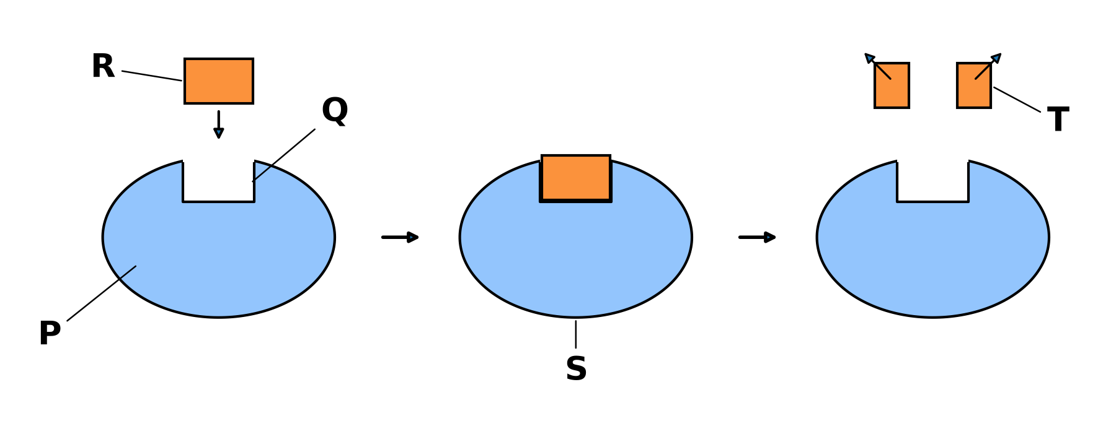
Fig. 1
Name the parts labelled P, Q, R, S and T. [5]
P: ...................................... Q: ......................................
R: ...................................... S: ......................................
T: ......................................

Part B: Induced Fit Hypothesis
On the sim: Switch to the Induced Fit tab. Open Guided Activities 3 and 4.
B1 Drag the substrate in slowly. Describe what happens to the active site as the substrate approaches. [2]

B2 What is different about how the active site behaves here compared with the Lock-and-Key tab? [1]

B3 Once the substrate is docked, STOP before clicking Release products.
(a) Predict what will happen to the shape of the enzyme once the products leave. [1]

(b) Now click Release products. Describe what actually happened. Was your prediction correct? [1]

B4 Complete Table 1 (Guided Activity 5). Check your answers against Key Concepts only after you have finished. [6]
 | Lock-and-key hypothesis | Induced fit hypothesis
Proposed by (and year)
Does the active site change shape?
What happens to a wrong-shaped substrate?
Table 1
B5 Complete the sentence:
An enzyme is specific because the shape of its ____________________ is ____________________ to the shape of only one type of substrate.

Part C: Check Your Understanding
On the sim: Complete the Check Your Understanding quiz in the sim.
C1 Record your score.
My score: ______ / 5
C2 Choose one statement you got wrong or were unsure about. Explain the correct idea in your own words. [2]

Part D: Applying Your Knowledge
D1 The enzyme amylase breaks down starch, but it cannot break down protein. Explain why, using the lock-and-key hypothesis. [2]

D2 Some enzymes can act on a small range of substrates that have slightly different shapes. Explain why the induced fit hypothesis explains this better than the lock-and-key hypothesis. [2]

D3 A student says, "Under induced fit, the active site can change shape to fit any substrate." Explain why this is wrong. [2]

Part E: Practice Questions
E1 Fig. 2 shows how the rate of an enzyme-catalysed reaction changes with temperature.
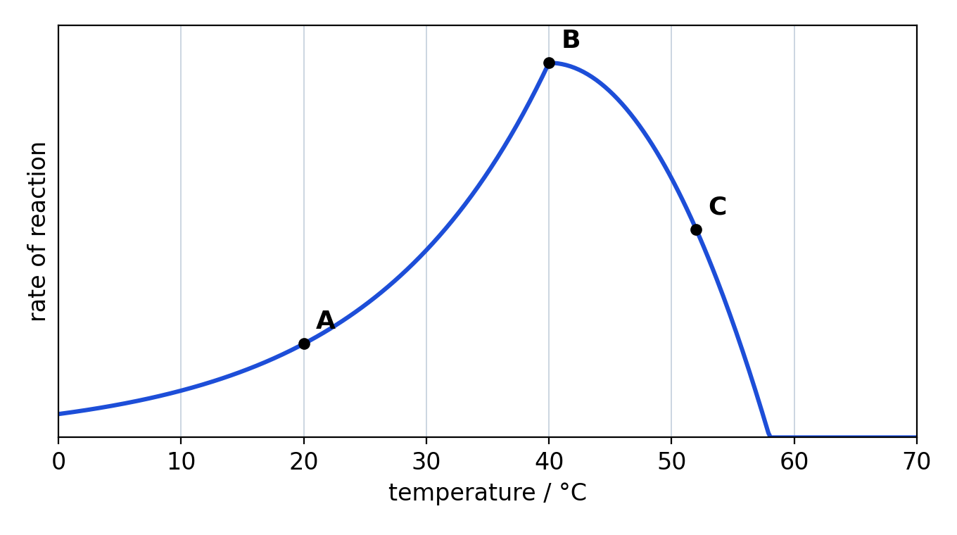
Fig. 2
(a) State the optimum temperature of this enzyme. [1]

(b) Explain why the rate of reaction at A is lower than at B. [2]

(c) Explain, in terms of the active site, why the rate of reaction falls between B and C. [3]

(d) Explain why the reaction stops completely above 58 °C, even when the temperature is lowered again. [2]

TEACHER COPY
Answer Key: Models of Enzyme Action

Part A
A1 The substrate fits into the active site; it glows and a chime sounds, showing an enzyme-substrate complex has formed.
A2 The active site has a fixed, specific shape, so the substrate must be lined up so that its shape matches (is complementary to) the active site.
A3 It is stopped at the rim of the active site from every angle. Its shape is not complementary to the active site, so it cannot bind.
A4 The substrate is broken down into two products, which leave the active site. The enzyme is unchanged and can be used again.
A5 P: enzyme. Q: active site. R: substrate. S: enzyme-substrate complex. T: products.

Part B
B1 The active site changes shape and moulds more closely around the substrate as it approaches and binds.
B2 In Lock-and-Key the active site is rigid and does not change; in Induced Fit the active site is flexible and changes shape to fit the substrate more closely.
B3(a) Student's own prediction.
B3(b) The products leave and the active site returns to its original shape, ready for another substrate molecule.
B4
 | Lock-and-key hypothesis | Induced fit hypothesis
Proposed by (and year) | Emil Fischer, 1894 | Daniel Koshland, 1958
Does the active site change shape? | No; it is rigid | Yes; it moulds around the substrate
What happens to a wrong-shaped substrate? | Cannot enter or bind | Cannot bind; the site only adjusts around a substrate that is already a close fit
B5 active site; complementary

Part C
C1 Sim answers: 1 True, 2 False, 3 False, 4 True, 5 False.
C2 The student's correction should match the sim's explanation for that statement.

Part D
D1 The active site of amylase has a shape complementary only to starch. Protein molecules have a different shape, so they cannot fit into the active site and no enzyme-substrate complex forms.
D2 In induced fit, the active site is flexible. It can adjust slightly to fit substrates with similar (but not identical) shapes, whereas a rigid lock-and-key site would fit only one exact shape.
D3 The substrate must already be a close fit for the active site. The active site only moulds more tightly around a suitable substrate; a substrate with the wrong shape still cannot bind.

Part E
E1(a) 40 °C
E1(b) At A the temperature is lower, so the enzyme and substrate molecules have less kinetic energy. They move more slowly and collide less often, so fewer enzyme-substrate complexes form per unit time.
E1(c) Above the optimum, the high temperature breaks bonds that hold the enzyme in its 3D shape. The active site changes shape, so it is no longer complementary to the substrate. Fewer enzyme-substrate complexes form, so the rate falls.
E1(d) The enzyme has been denatured. The change to the active site is permanent, so the substrate can no longer bind even at a lower temperature.

