Enzymes  Models of Enzyme Action  Simulation: edtechsims.com/models-of-enzyme-action  Name: ____________________ Class: ______ Date: _______ |   Scan to open
By the end of this activity, you should be able to:
- describe enzymes as biological catalysts that are not used up in a reaction
- explain enzyme specificity using the idea of a complementary active site
- describe the lock-and-key hypothesis and the induced fit hypothesis
- compare the two hypotheses and explain why induced fit is the more widely accepted model
- explain how temperature affects enzyme activity, including denaturation

Part A: Lock-and-Key Hypothesis
On the sim: Open the Lock-and-Key tab. Read the Key Concepts panel, then open Guided Activities 1 and 2.
A1 Drag the Correct substrate into the active site. Describe what happens when it docks. [1]

A2 Why does the substrate need to approach from a specific angle to fit? [1]

A3 Click Distractor substrate and try to drag it into the active site from different angles. What happens? Explain why. [2]

A4 Dock the Correct substrate again and click Release products. What happens to the substrate? Is the enzyme changed by the reaction? [2]

A5 Fig. 1 shows the lock-and-key hypothesis.
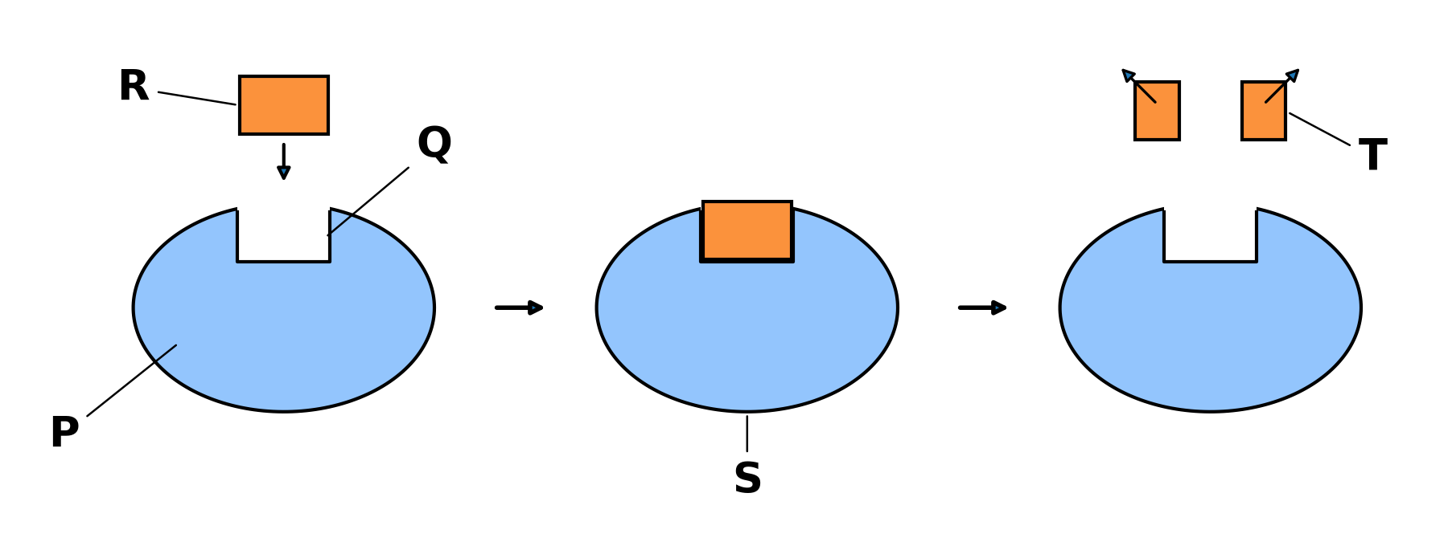
Fig. 1
Name the parts labelled P, Q, R, S and T. [5]
P: ...................................... Q: ......................................
R: ...................................... S: ......................................
T: ......................................

Part B: Induced Fit Hypothesis
On the sim: Switch to the Induced Fit tab. Open Guided Activities 3 and 4.
B1 Drag the substrate in slowly. Describe what happens to the active site as the substrate approaches. [2]

B2 What is different about how the active site behaves here compared with the Lock-and-Key tab? [1]

B3 Once the substrate is docked, STOP before clicking Release products.
(a) Predict what will happen to the shape of the enzyme once the products leave. [1]

(b) Now click Release products. Describe what actually happened. Was your prediction correct? [1]

B4 Complete Table 1 (Guided Activity 5). Check your answers against Key Concepts only after you have finished. [6]
 | Lock-and-key hypothesis | Induced fit hypothesis
Proposed by (and year)
Does the active site change shape?
What happens to a wrong-shaped substrate?
Table 1
B5 Complete the sentence:
An enzyme is specific because the shape of its ____________________ is ____________________ to the shape of only one type of substrate.

Part C: Check Your Understanding
On the sim: Complete the Check Your Understanding quiz in the sim.
C1 Record your score.
My score: ______ / 5
C2 Choose one statement you got wrong or were unsure about. Explain the correct idea in your own words. [2]

Part D: Applying Your Knowledge
D1 The enzyme amylase breaks down starch, but it cannot break down protein. Explain why, using the lock-and-key hypothesis. [2]

D2 Some enzymes can act on a small range of substrates that have slightly different shapes. Explain why the induced fit hypothesis explains this better than the lock-and-key hypothesis. [2]

D3 A student says, "Under induced fit, the active site can change shape to fit any substrate." Explain why this is wrong. [2]

Part E: Practice Questions
E1 Fig. 2 shows how the rate of an enzyme-catalysed reaction changes with temperature.
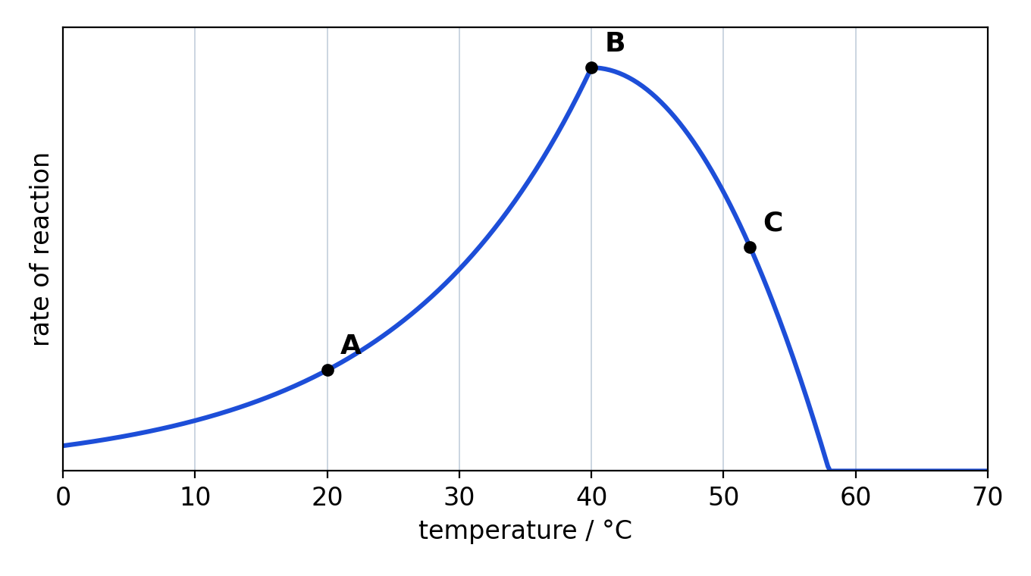
Fig. 2
(a) State the optimum temperature of this enzyme. [1]

(b) Explain why the rate of reaction at A is lower than at B. [2]

(c) Explain, in terms of the active site, why the rate of reaction falls between B and C. [3]

(d) Explain why the reaction stops completely above 58 °C, even when the temperature is lowered again. [2]

