Magnetism  Magnetic Fields  Simulation: edtechsims.com/magnetic-field  Name: ____________________ Class: ______ Date: _______ |   Scan to open
By the end of this activity, you should be able to:
- draw the magnetic field pattern around a bar magnet
- state the direction of magnetic field lines
- relate the spacing of field lines to the strength of the field
- draw the field patterns between like and unlike poles, and identify a neutral point
- use a plotting compass to find the direction of a magnetic field

Part A: Field Around One Bar Magnet
On the sim: Open Key Concepts and read it. Place ONE bar magnet on the canvas and select the Field Lines view.
A1 On Fig. 1, sketch the magnetic field pattern around the bar magnet. Draw at least six field lines and add arrows to show their direction. [3]
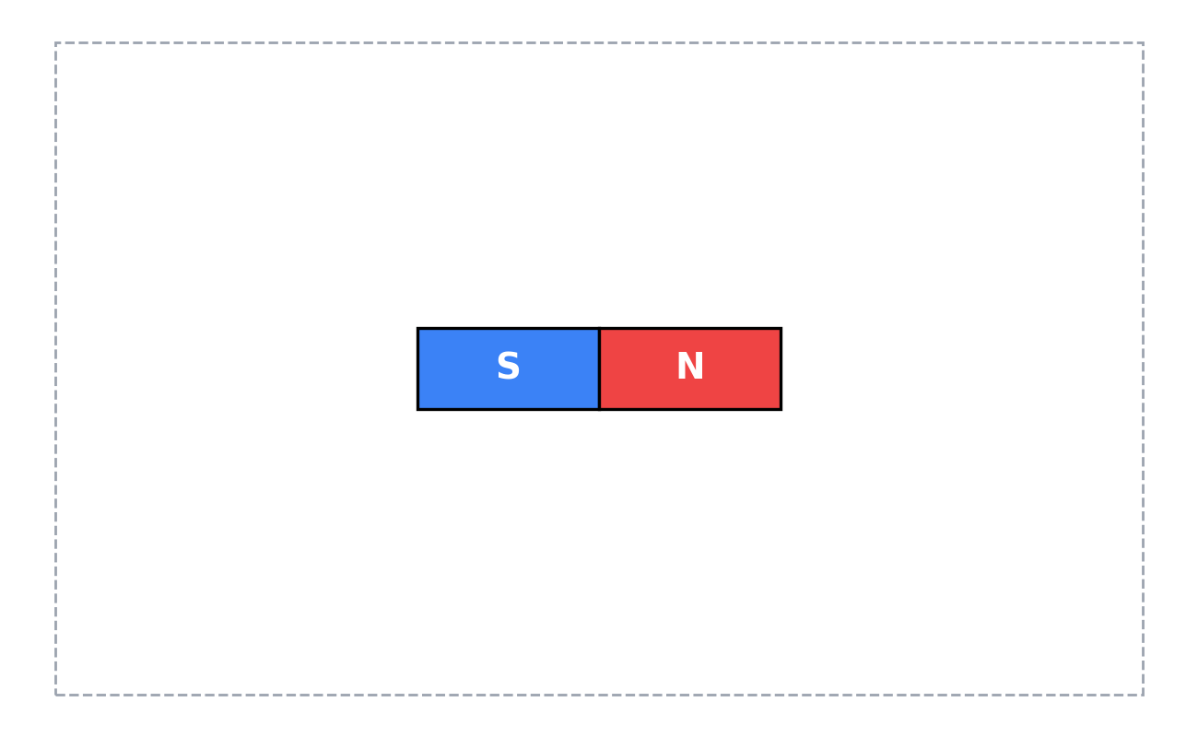
Fig. 1
A2 Complete the sentence:
Outside the magnet, magnetic field lines point from the ________ pole to the ________ pole.
A3 Where is the magnetic field strongest? How can you tell from the field lines? [2]

A4 Why can magnetic field lines never cross? [1]

A5 Switch to the Compass view. Which way does the north end of each compass needle point, compared with the field lines? [1]

Part B: Two Bar Magnets
On the sim: Place a SECOND bar magnet. Drag and rotate the magnets to match each figure. Use the Field Lines view.
B1 Arrange the magnets so that unlike poles (N and S) face each other. Sketch the field pattern on Fig. 2, with arrows. [3]
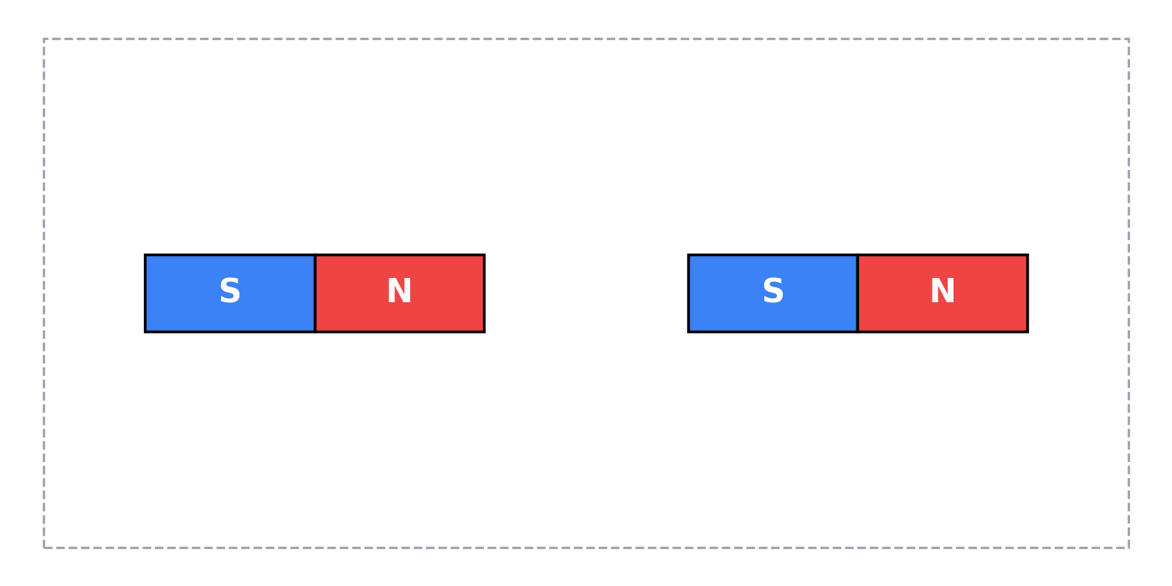
Fig. 2
B2 Rotate one magnet so that like poles (N and N) face each other. Sketch the field pattern on Fig. 3, with arrows. Mark with an X the point between the magnets where the field is zero. [4]
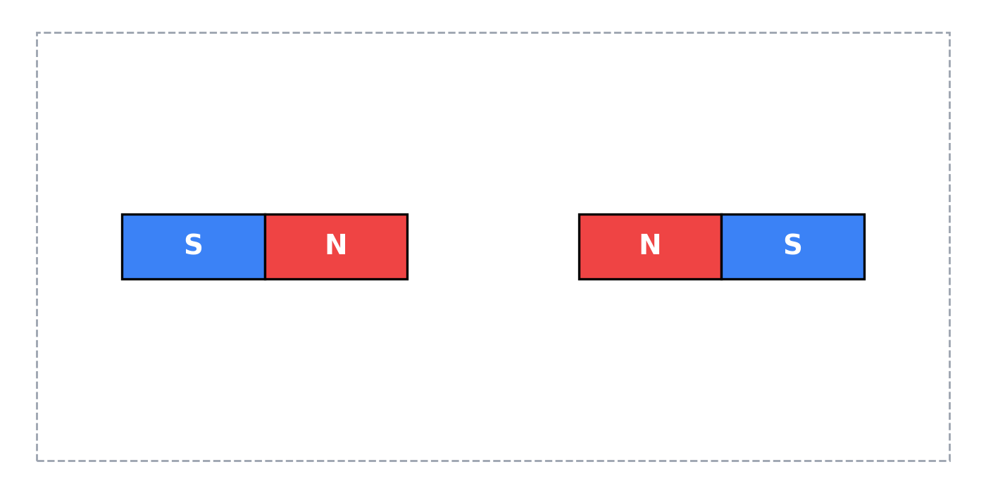
Fig. 3
B3 The point marked X in Fig. 3 is called a ______________________ point. What would a compass placed there do? [2]

B4 Increase the strength of one magnet. Describe how the field lines change near that magnet. [1]

B5 Using your sketches, state whether the magnets attract or repel in Fig. 2 and in Fig. 3. [2]
Fig. 2: ....................................................
Fig. 3: ....................................................

Part C: Guided Activities and Quiz
On the sim: Work through the Guided Activities in the sim, then complete the quiz.
C1 Record your quiz score.
My score: ______ / 5
C2 For one quiz question you got wrong or were unsure about, write the correct idea in your own words. [2]

Part D: Applying Your Knowledge
D1 Fig. 4 shows four plotting compasses, A, B, C and D, placed near a bar magnet. In each circle, draw an arrow to show the direction in which the north end of the compass needle points. [4]
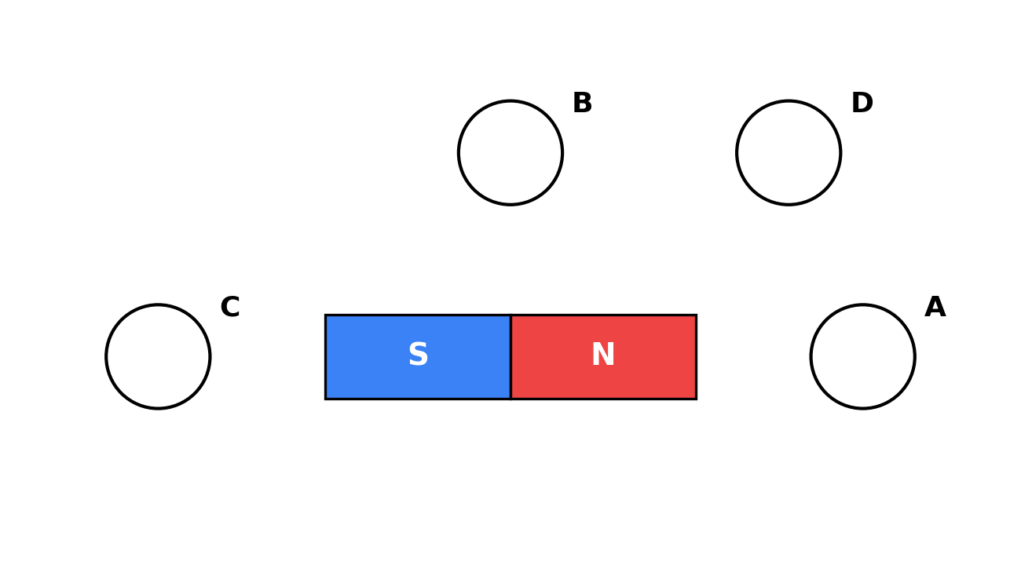
Fig. 4
D2 Describe how you would use a plotting compass to draw one field line around a bar magnet on a sheet of paper. [3]

D3 A student has two identical-looking metal bars. One is a magnet and the other is unmagnetised iron. Explain why repulsion, not attraction, is the only reliable test to find out which bar is the magnet. [2]

Part E: Exam-Style Questions
E1 Fig. 5 shows the magnetic field pattern around two bar magnets placed in a line. The left end of the first magnet is a north pole.
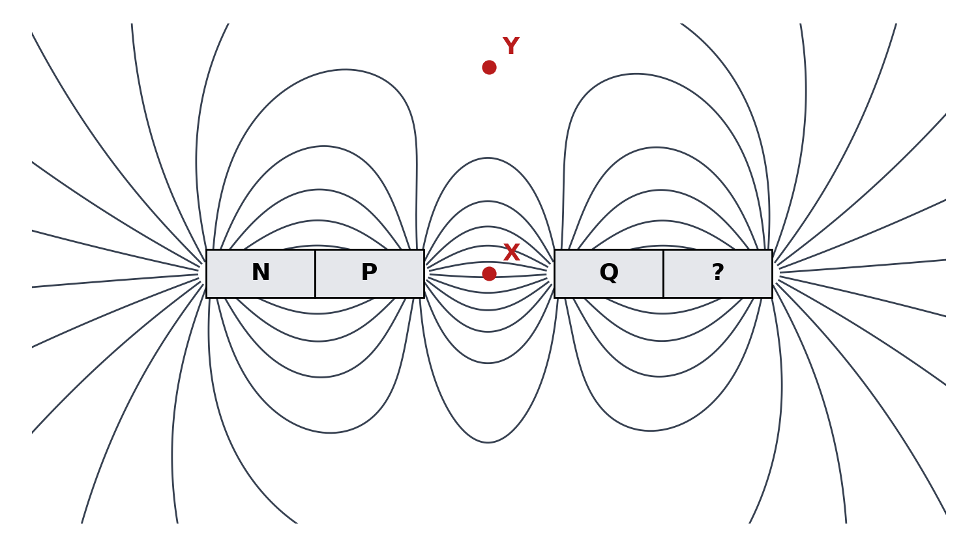
Fig. 5
(a) Identify the poles P, Q and the pole marked ?. [2]
P: ....................................................
Q: ....................................................
?: ....................................................
(b) On Fig. 5, draw arrows on two field lines to show the direction of the field. [1]
(c) State whether the magnetic field is stronger at X or at Y. Explain your answer. [2]

(d) State whether the two magnets attract or repel each other. [1]

E2 A bar magnet is placed on a bench. A student places a plotting compass at many points around it.
(a) Explain why the compass needle points in different directions at different points. [2]

(b) The magnet is removed. State the direction the compass now points, and explain why. [2]

TEACHER COPY
Answer Key: Magnetic Fields

Part A
A1 Closed curved lines leaving the N pole and entering the S pole; lines closest together at the poles; lines symmetrical above and below the magnet; no lines crossing; arrows from N to S outside the magnet.
A2 north; south
A3 At the poles. The field lines are closest together there.
A4 The field has only one direction at any point. If two lines crossed, the field would have two directions at that point.
A5 The north end of each compass needle points along the field line, in the direction of the field (away from N, towards S).

Part B
B1 Lines run from the N pole of the left magnet straight across the gap to the S pole of the right magnet; lines in the gap are close together and nearly parallel.
B2 Lines from each N pole curve away from each other and turn back towards their own S poles; no lines cross the gap. X marked midway between the two N poles.
B3 neutral. The compass would not point in any particular direction (it would stay in whatever direction it was left, or respond only to the Earth's field).
B4 The field lines around that magnet become closer together (denser), showing a stronger field; its field extends further.
B5 Fig. 2: attract. Fig. 3: repel.

Part C
C1 Score recorded from the sim.
C2 Open response; the student's correction should match the sim's explanation for that question.

Part D
D1 A: points right (away from N). B: points left (parallel to the magnet, from the N end towards the S end). C: points right (towards S). D: points up and slightly right, away from the N pole.
D2 Place the magnet on paper and put the compass near the N pole. Mark a dot at the end the needle points to. Move the compass so its other end is over that dot, and mark a new dot. Repeat until the compass reaches the S pole. Join the dots with a smooth curve and add an arrow from N to S.
D3 A magnet attracts both a magnet and an unmagnetised iron bar, so attraction cannot tell them apart. Repulsion only happens between two magnets (like poles), so if the bars repel, the bar must be a magnet.

Part E
E1(a) P: south. Q: north. ?: south.
E1(b) Arrows pointing away from the N and Q poles and towards the P and ? poles.
E1(c) X. The field lines are closer together at X than at Y.
E1(d) Attract (unlike poles, S and N, face each other).
E2(a) The direction of the magnetic field is different at different points around the magnet; the compass needle lines up with the field at each point.
E2(b) It points north (to magnetic north), because it now lines up with the Earth's magnetic field.

