Magnetism  Magnetic Fields  Simulation: edtechsims.com/magnetic-field  Name: ____________________ Class: ______ Date: _______ |   Scan to open
By the end of this activity, you should be able to:
- draw the magnetic field pattern around a bar magnet
- state the direction of magnetic field lines
- relate the spacing of field lines to the strength of the field
- draw the field patterns between like and unlike poles, and identify a neutral point
- use a plotting compass to find the direction of a magnetic field

Part A: Field Around One Bar Magnet
On the sim: Open Key Concepts and read it. Place ONE bar magnet on the canvas and select the Field Lines view.
A1 On Fig. 1, sketch the magnetic field pattern around the bar magnet. Draw at least six field lines and add arrows to show their direction. [3]
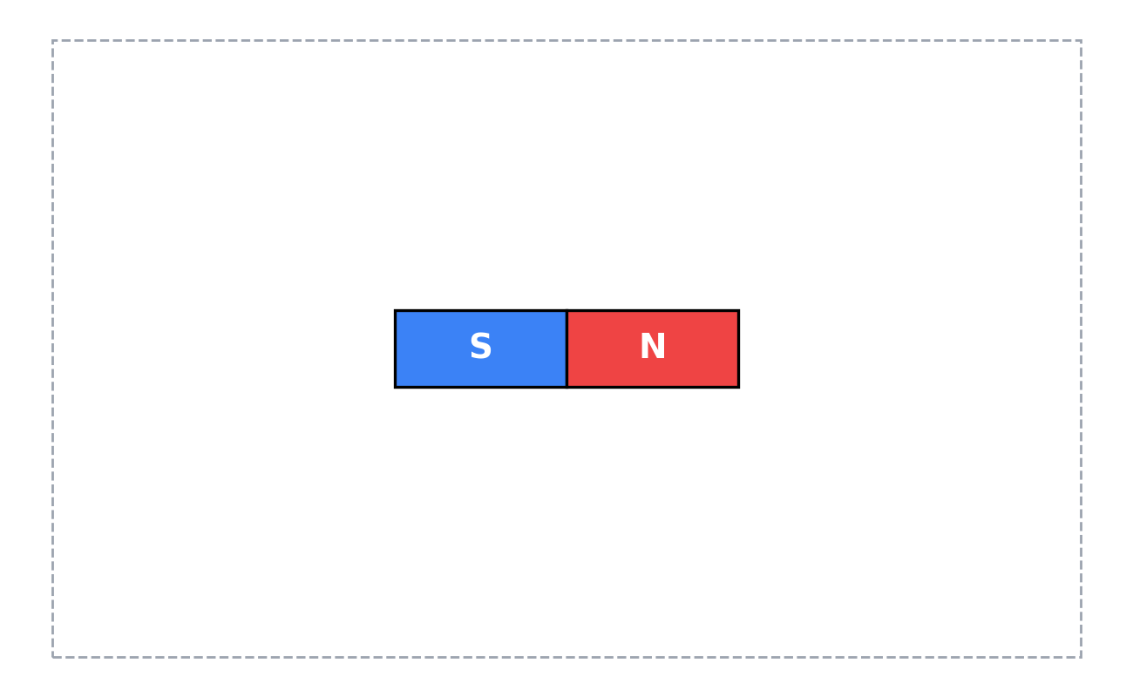
Fig. 1
A2 Complete the sentence:
Outside the magnet, magnetic field lines point from the ________ pole to the ________ pole.
A3 Where is the magnetic field strongest? How can you tell from the field lines? [2]

A4 Why can magnetic field lines never cross? [1]

A5 Switch to the Compass view. Which way does the north end of each compass needle point, compared with the field lines? [1]

Part B: Two Bar Magnets
On the sim: Place a SECOND bar magnet. Drag and rotate the magnets to match each figure. Use the Field Lines view.
B1 Arrange the magnets so that unlike poles (N and S) face each other. Sketch the field pattern on Fig. 2, with arrows. [3]
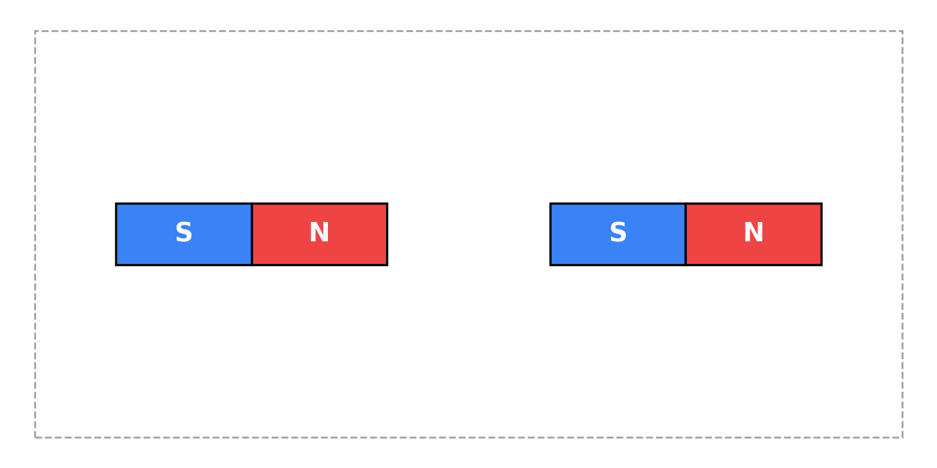
Fig. 2
B2 Rotate one magnet so that like poles (N and N) face each other. Sketch the field pattern on Fig. 3, with arrows. Mark with an X the point between the magnets where the field is zero. [4]
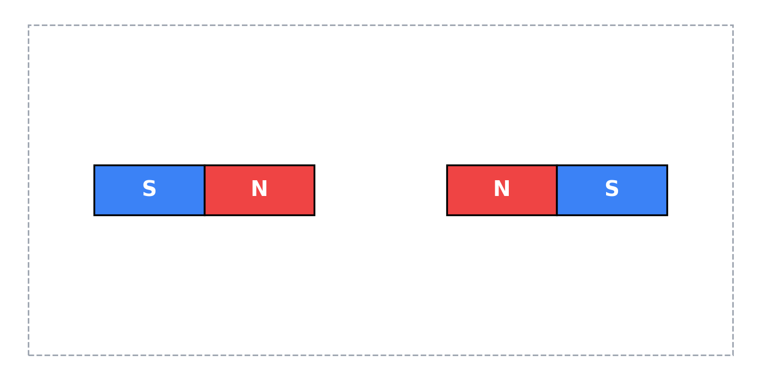
Fig. 3
B3 The point marked X in Fig. 3 is called a ______________________ point. What would a compass placed there do? [2]

B4 Increase the strength of one magnet. Describe how the field lines change near that magnet. [1]

B5 Using your sketches, state whether the magnets attract or repel in Fig. 2 and in Fig. 3. [2]
Fig. 2: ....................................................
Fig. 3: ....................................................

Part C: Guided Activities and Quiz
On the sim: Work through the Guided Activities in the sim, then complete the quiz.
C1 Record your quiz score.
My score: ______ / 5
C2 For one quiz question you got wrong or were unsure about, write the correct idea in your own words. [2]

Part D: Applying Your Knowledge
D1 Fig. 4 shows four plotting compasses, A, B, C and D, placed near a bar magnet. In each circle, draw an arrow to show the direction in which the north end of the compass needle points. [4]
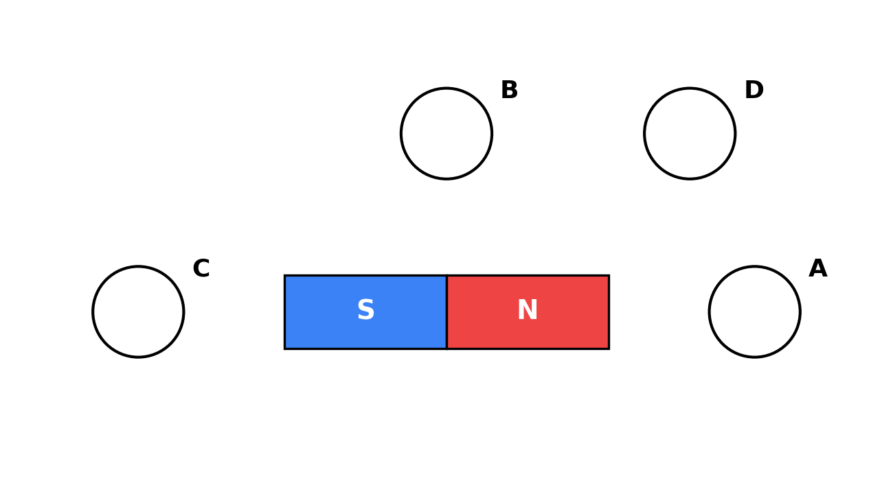
Fig. 4
D2 Describe how you would use a plotting compass to draw one field line around a bar magnet on a sheet of paper. [3]

D3 A student has two identical-looking metal bars. One is a magnet and the other is unmagnetised iron. Explain why repulsion, not attraction, is the only reliable test to find out which bar is the magnet. [2]

Part E: Exam-Style Questions
E1 Fig. 5 shows the magnetic field pattern around two bar magnets placed in a line. The left end of the first magnet is a north pole.
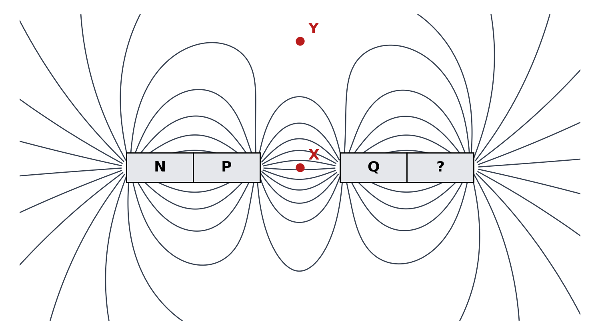
Fig. 5
(a) Identify the poles P, Q and the pole marked ?. [2]
P: ....................................................
Q: ....................................................
?: ....................................................
(b) On Fig. 5, draw arrows on two field lines to show the direction of the field. [1]
(c) State whether the magnetic field is stronger at X or at Y. Explain your answer. [2]

(d) State whether the two magnets attract or repel each other. [1]

E2 A bar magnet is placed on a bench. A student places a plotting compass at many points around it.
(a) Explain why the compass needle points in different directions at different points. [2]

(b) The magnet is removed. State the direction the compass now points, and explain why. [2]

