
Statistics
Scatter Plots & Lines of Best Fit
Simulation: edtechsims.com/line-of-best-fit
Name: ____________________ Class: ______ Date: _______
By the end of this activity, you should be able to:
- plot a scatter plot and describe the correlation it shows
- draw a line of best fit by eye and use it to make estimates
- explain how an outlier affects a line of best fit
- explain the difference between interpolation and extrapolation
- understand that correlation does not mean one variable causes the other

Part A: Exploring the Scatter Plot
On the sim: Read Learning Goals and How to use. Click on the graph to add points; click a point to remove it. Watch the red dashed line of best fit.
A1 Complete the sentences. [3]
A line of best fit shows the general ____________________ of the data points.
In a positive correlation, as one variable increases, the other ____________________.
In a negative correlation, as one variable increases, the other ____________________.
A2 Work through each Try This! challenge. Record the Correlation (r) value and the description shown (e.g. Strong Positive), and describe what happens to the line. [4]
Try This! | r value | Description | What happens to the line of best fit?
Add points that create a perfect line
Add an outlier far from the others
Create a negative correlation
Make points with no clear pattern
Table 1
A3 What does an r value close to 1, close to –1 and close to 0 tell you about the data? [3]
Close to 1: ....................................................
Close to –1: ....................................................
Close to 0: ....................................................
A4 Explain why one outlier can change the line of best fit a lot when there are only a few points. [2]

Part B: Draw Your Own Line of Best Fit
On the sim: Go to the Practice Activity. For each dataset, adjust the slope and y-intercept sliders until your line fits the data, click Check My Line, then click Show Best Fit Line.
B1 Record your results in Table 2. [5]
Dataset | My slope (m) | My y-intercept (b) | Feedback | Actual best fit line
1: Positive Trend
2: Strong Positive Trend
3: Negative Trend
4: Gentle Positive Trend
5: Scattered Data
Table 2
B2 Which dataset was the hardest to fit? Explain why. [2]

B3 For the Negative Trend dataset, was your slope positive or negative? Explain. [1]

B4 In the equation y = mx + b, what do m and b tell you about the line? [2]
m: ....................................................
b: ....................................................
B5 Tick (✓) the tips for drawing a good line of best fit by eye. [3]
☐ Use a ruler to draw one straight line.
☐ Join the first point to the last point.
☐ Have roughly the same number of points above and below the line.
☐ Make the line pass through the origin every time.
☐ Ignore any obvious outlier.
☐ Join up all the points dot-to-dot.

Part C: Practice Questions
C1 The table shows the number of hours eight students studied and their test scores.
Hours studied | 1 | 2 | 3 | 4 | 5 | 6 | 7 | 8
Test score | 35 | 42 | 50 | 52 | 61 | 66 | 74 | 80
(a) On Fig. 1, plot the scatter plot. [2]
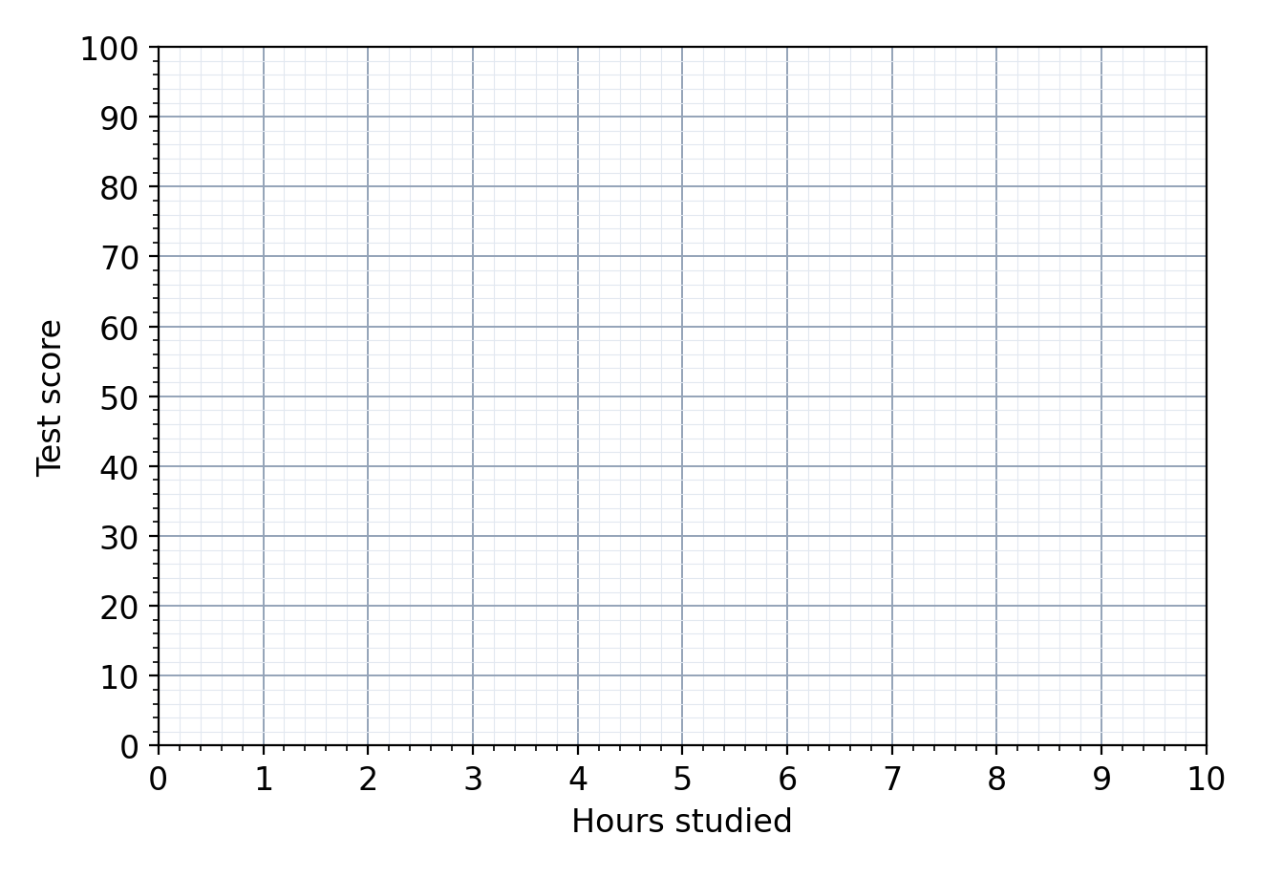
Fig. 1
(b) Describe the correlation shown. [1]

(c) Draw a line of best fit on Fig. 1. [1]
(d) Use your line to estimate the test score of a student who studied for 5.5 hours. [1]
score = ................
(e) Explain why it would not be reliable to use your line to estimate the score of a student who studied for 15 hours. [2]

C2 Fig. 2 shows the temperature on 11 days and the number of hot drinks sold by a café.
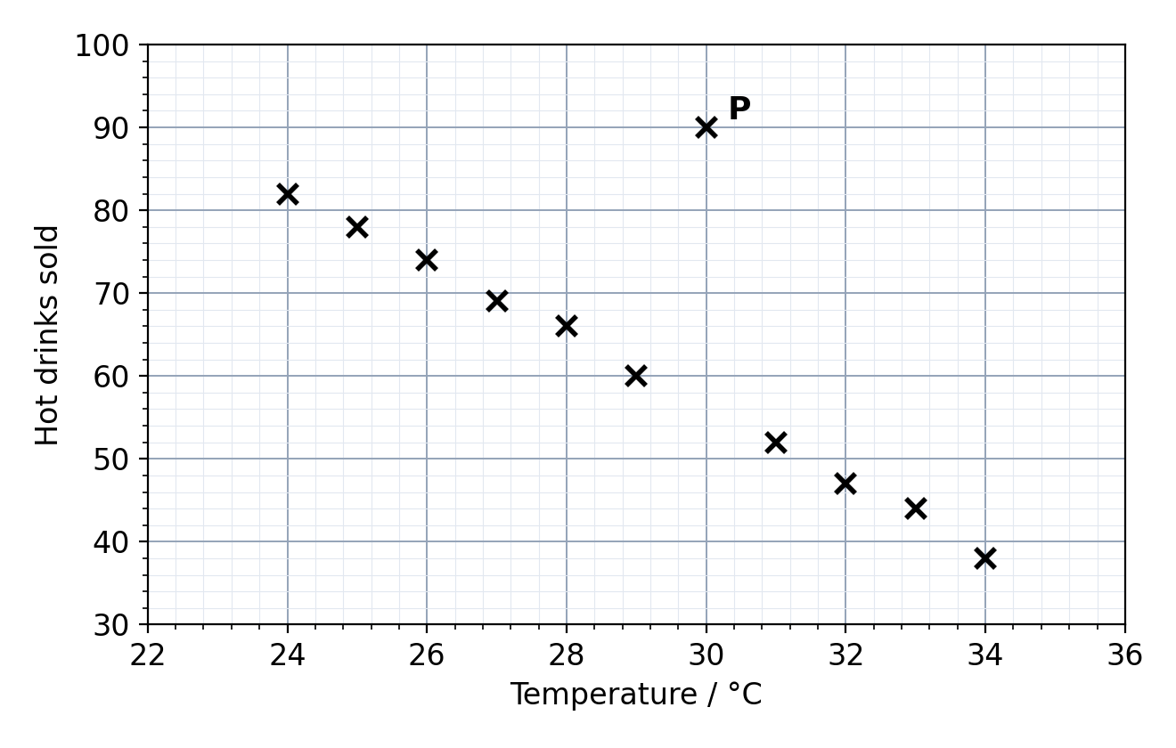
Fig. 2
(a) Describe the relationship between the temperature and the number of hot drinks sold. [2]

(b) Point P does not fit the pattern. What is this point called? Suggest a reason for it. [2]

(c) Draw a line of best fit on Fig. 2, ignoring point P. [1]
(d) Estimate the number of hot drinks sold on a day when the temperature is 27.5 °C. [1]
................ drinks
C3 A study found a positive correlation between ice cream sales and the number of people who drown at the beach. Jun says, "Eating ice cream causes people to drown." Explain why Jun is wrong. [2]

