Particulate Nature of Matter  Kinetic Particle Theory  Simulation: edtechsims.com/kinetic-particle-theory  Name: ____________________ Class: ______ Date: _______ |   Scan to open
By the end of this activity, you should be able to:
- describe the movement of particles using the kinetic particle theory
- relate temperature to the kinetic energy and speed of particles
- explain how the mass of particles affects their speed and rate of diffusion
- explain gas pressure in terms of particles colliding with the walls of a container
- describe the arrangement and movement of particles in solids, liquids and gases, and interpret a heating curve

Part A: Temperature
On the sim: Click Reset. Keep Particle Mass and No. of particles at their starting values. Change only the Temperature slider.
A1 Set the temperature to its lowest value. Describe how the particles move. [1]

A2 Slowly increase the temperature to its highest value. Describe what happens to the particles. [2]

A3 Complete the sentence:
As the temperature increases, the particles gain ____________________ energy and move ____________________.
A4 Watch the particles hitting the walls of the container. How does the number of collisions with the walls change as the temperature increases? [1]

A5 Why is it wrong to say that the particles themselves get bigger when a substance is heated? [1]

Part B: Particle Mass
On the sim: Click Reset. Keep the temperature and No. of particles fixed. Change only the Particle Mass slider.
B1 Compare how fast light particles and heavy particles move at the same temperature. [1]

B2 Complete the sentence:
At the same temperature, particles with a ____________________ mass move faster.
B3 Use your answer to B2 to predict which gas diffuses faster: hydrogen (Mr = 2) or carbon dioxide (Mr = 44). Explain. [2]

Part C: Number of Particles
On the sim: Click Reset. Keep the temperature and Particle Mass fixed. Change only the No. of particles slider.
C1 Increase the number of particles. What happens to how often the particles hit the walls of the container? [1]

C2 Use your answer to C1 to explain why pumping more air into a tyre increases the pressure inside it. [2]

C3 Complete Table 1 by writing increases, decreases or no change. [3]
Change made (others kept constant) | Speed of particles | Collisions with walls per second
Temperature increased
Particle mass increased
Number of particles increased
Table 1

Part D: States of Matter
D1 In Fig. 1, draw about 12 particles in each box to show the arrangement of particles in a solid, a liquid and a gas. [3]
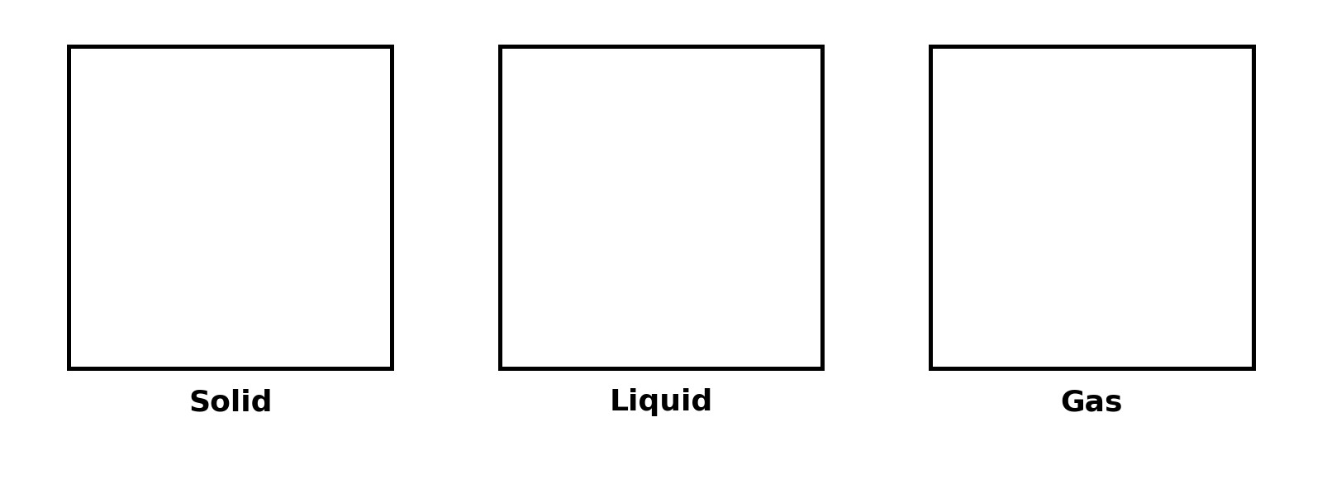
Fig. 1

D2 Complete Table 2. [6]
 | Solid | Liquid | Gas
Arrangement
Distance between particles
Movement
Table 2

Part E: Exam-Style Questions
E1 Fig. 2 shows the heating curve for a pure substance X.
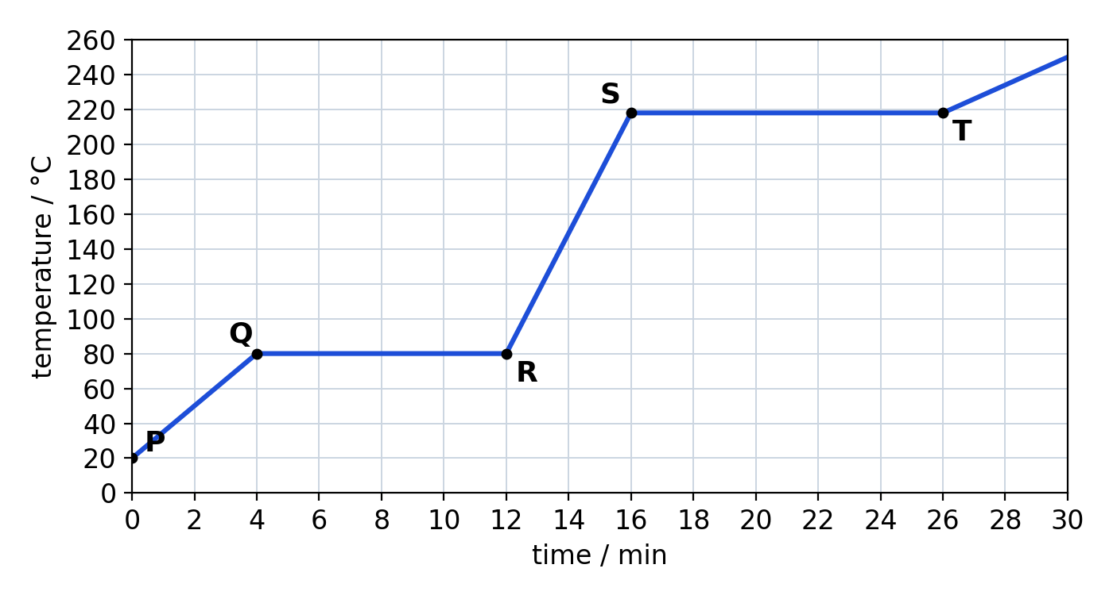
Fig. 2
(a) State the melting point and boiling point of X. [2]
melting point = ............ °C boiling point = ............ °C
(b) State the physical state(s) of X between Q and R, and between S and T. [2]
Q to R: ....................................................
S to T: ....................................................
(c) Explain, in terms of particles, why the temperature stays constant from Q to R even though heat is still being supplied. [2]

E2 Fig. 3 shows a long glass tube. Cotton wool soaked in concentrated ammonia is placed at one end, and cotton wool soaked in concentrated hydrochloric acid at the other end. After a few minutes, a white ring of ammonium chloride forms inside the tube.
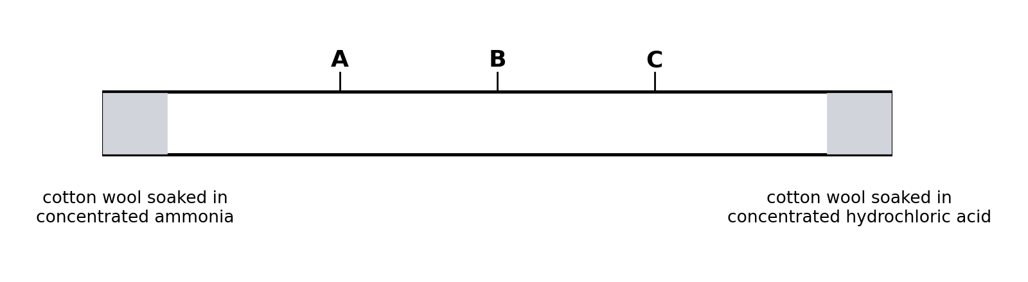
Fig. 3
(a) State the letter, A, B or C, where the white ring forms. [1]

(b) Explain your answer to (a). [Mr: NH₃ = 17, HCl = 36.5] [2]

(c) State and explain how the time taken for the ring to form would change if the experiment were done at a higher temperature. [2]

