Kinematics  Kinematics Graphs  Simulation: edtechsims.com/kinematics  Name: ____________________ Class: ______ Date: _______ |   Scan to open
By the end of this activity, you should be able to:
- sketch s–t, v–t and a–t graphs for an object that is stationary, moving at constant velocity, accelerating or decelerating
- state that the gradient of an s–t graph is the velocity and the gradient of a v–t graph is the acceleration
- state that the area under a v–t graph is the distance travelled
- calculate velocity, acceleration and distance from kinematics graphs
- match s–t, v–t and a–t graphs for multi-stage journeys

Part A: Motion Simulator (Tab 1)
On the sim: Open Tab 1. Read Key Concepts, then try each of the four motion cases. Use the sliders and watch the three graphs as the car moves.
A1 Complete Table 1 by stating the quantity and its S.I. unit. [3]
Quantity | Meaning | S.I. unit
Displacement, s
Velocity, v
Acceleration, a
Table 1
A2 Sketch the shape of each graph for the four motion cases in Table 2. [6]
Motion | s–t graph | v–t graph | a–t graph
Stationary | 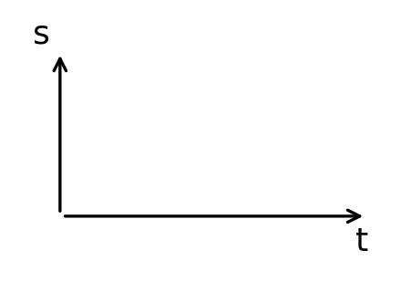 | 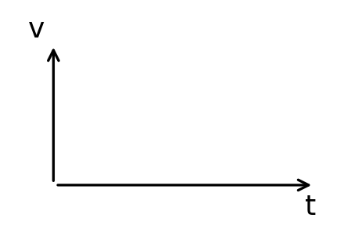 | 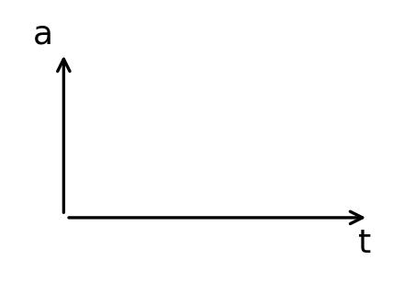
Constant velocity
Constant acceleration
Constant deceleration (until it stops)
Table 2
A3 Choose Constant velocity. Increase the initial velocity slider. What happens to the s–t graph? Explain. [2]

A4 Choose Constant deceleration. After the car stops, why does the s–t graph become horizontal instead of going down? [2]

A5 Complete Check Your Understanding for Tab 1.
My score: ______ / 7

Part B: Gradient & Area (Tab 2)
On the sim: Open Tab 2. Read Key Concepts, then use the Guided Activity to find gradients and areas.
B1 Complete the sentences. [3]
The gradient of an s–t graph gives the ____________________.
The gradient of a v–t graph gives the ____________________.
The area under a v–t graph gives the ____________________.
B2 Why must you draw a tangent to find the gradient of a curved s–t graph? [1]

B3 Choose Constant acceleration and Gradient of s–t. Pick a time, then record the values from the worked example in Table 3. [3]
Time t / s | Δs / m | Δt / s | Gradient / (m/s) | v from v–t graph / (m/s)
Table 3
Do the gradient and the velocity match? ____________________
B4 Choose Area under v–t. For each case, state the shape used to calculate the area. [3]
Motion case | Shape of area
Constant velocity
Constant acceleration from rest
Constant acceleration from a non-zero velocity
Table 4
B5 Complete Check Your Understanding for Tab 2.
My score: ______ / 8

Part C: Match the Graphs (Tab 3)
On the sim: Open Tab 3. Read Key Concepts, then work through the Guided Activity journeys.
C1 A car decelerates to rest. A student draws its s–t graph sloping downwards. Explain the mistake. [2]

C2 A student copies the shape of a v–t graph to draw the s–t graph. Explain why this is wrong. [2]

C3 Choose one journey from the Guided Activity. Describe each stage of the motion. [3]
Stage | Time / s | Description of motion
1
2
3
4
Table 5
C4 Complete Check Your Understanding for Tab 3.
My score: ______ / 6

Part D: Graph Challenge (Tab 4)
On the sim: Open Tab 4 and complete the Graph Challenge.
D1 Record your score.
My score: ______ / ______
D2 Which type of question did you find hardest? Why? [1]

Part E: Practice Questions
E1 Fig. 1 shows the v–t graph of a car travelling along a straight road.
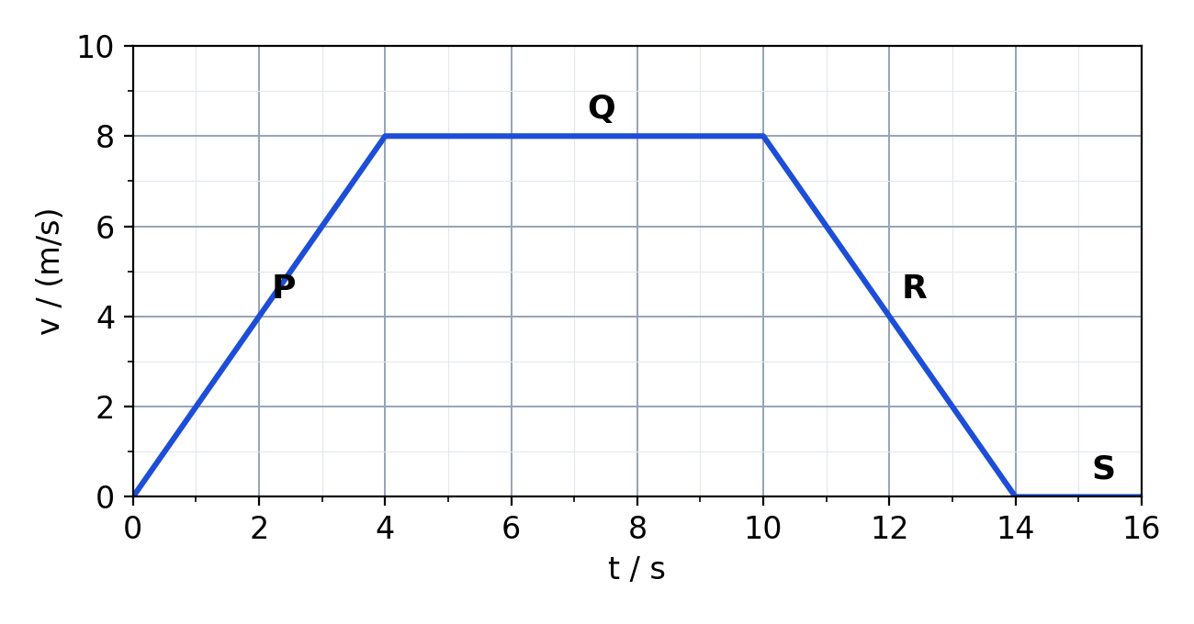
Fig. 1
(a) Describe the motion of the car in each section P, Q, R and S. [4]

(b) Calculate the acceleration of the car in section P. [2]
acceleration = ................ m/s²
(c) Calculate the total distance travelled by the car. [3]
distance = ................ m
(d) Calculate the average speed of the car for the whole journey. [2]
average speed = ................ m/s
(e) On Fig. 2, sketch the s–t graph for the car's journey. [3]
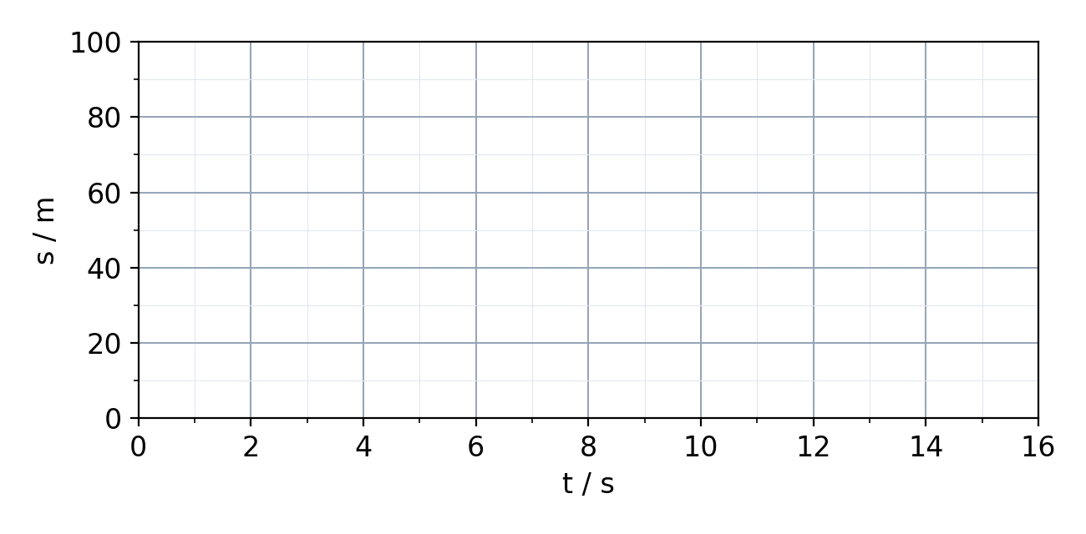
Fig. 2
(f) On Fig. 3, sketch the a–t graph for the car's journey. [3]
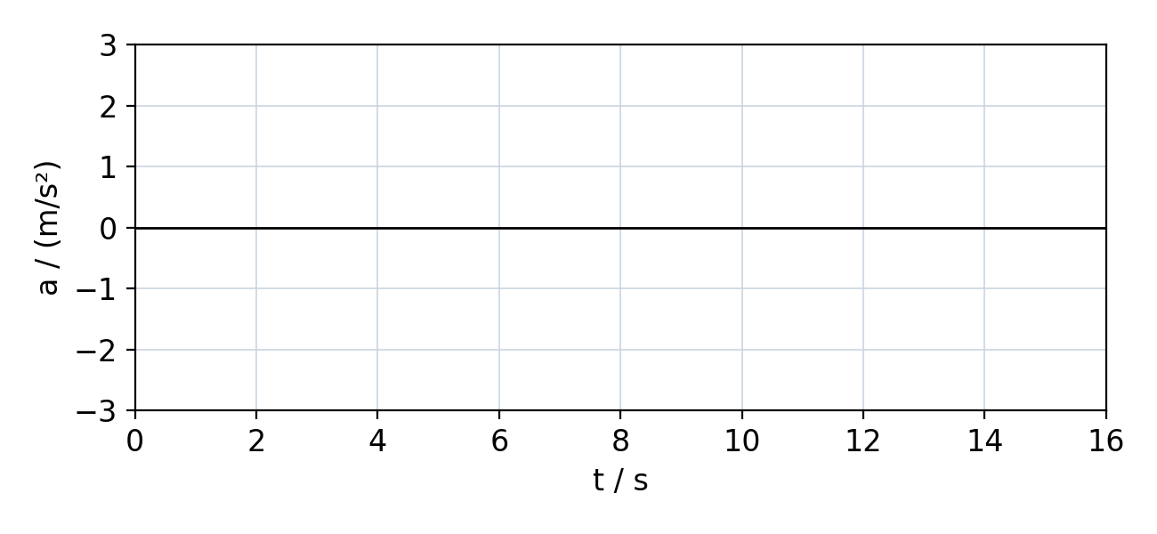
Fig. 3
E2 Fig. 4 shows the s–t graph of a cyclist.
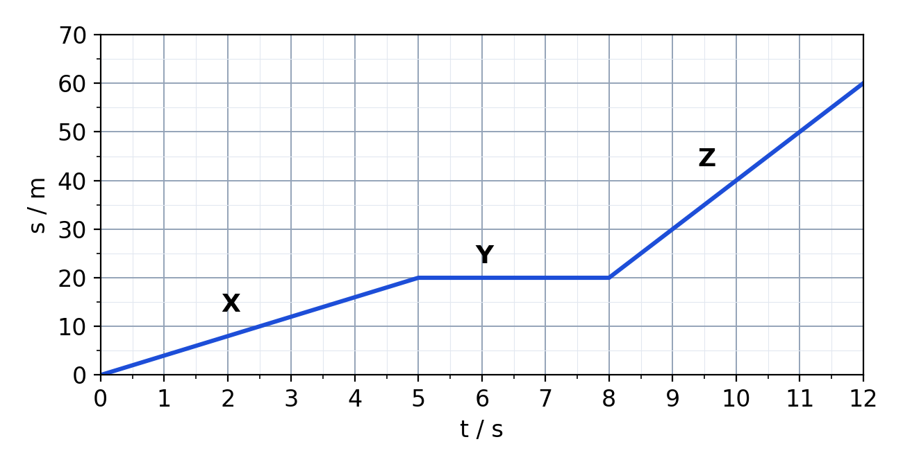
Fig. 4
(a) Calculate the speed of the cyclist in section X. [2]
speed = ................ m/s
(b) Describe the motion of the cyclist in section Y. [1]

(c) State, with a reason, the section in which the cyclist is fastest. [2]

(d) Calculate the average speed of the cyclist for the whole 12 s. [2]
average speed = ................ m/s
TEACHER COPY
Answer Key: Kinematics Graphs

Part A
Quantity | Meaning | S.I. unit
Displacement, s | Distance moved in a specified direction | m
Velocity, v | Rate of change of displacement | m/s
Acceleration, a | Rate of change of velocity | m/s²

Motion | s–t | v–t | a–t
Stationary | Horizontal line | Horizontal line on the t-axis (v = 0) | On the t-axis (a = 0)
Constant velocity | Straight sloping line | Horizontal line above the t-axis | On the t-axis (a = 0)
Constant acceleration | Curve, getting steeper | Straight line sloping upwards | Horizontal line above the t-axis
Constant deceleration | Curve, getting less steep, then horizontal | Straight line sloping down to zero, then on the t-axis | Horizontal line below the t-axis, then zero
A3 The s–t line becomes steeper. The gradient of the s–t graph is the velocity, so a larger velocity gives a steeper line.
A4 When the car stops, its displacement stays constant. It does not move backwards, so s stays the same and the graph is horizontal.
A5 Score from the sim.

Part B
B1 velocity; acceleration; distance travelled
B2 The gradient of a curve changes at every point. A tangent gives the gradient (instantaneous velocity) at one particular time.
B3 Values from the sim. The gradient should equal the velocity read from the v–t graph at that time.
B4 Constant velocity: rectangle. From rest: triangle. From a non-zero velocity: trapezium.
B5 Score from the sim.

Part C
C1 A decelerating car is still moving forwards, so its displacement keeps increasing (more slowly). The s–t graph should curve and level off, not slope down.
C2 The s–t and v–t graphs show different quantities. The v–t graph shows the gradient of the s–t graph, not its shape; e.g. a horizontal v–t line gives a sloping s–t line.
C3 Depends on the journey chosen; each stage should state the time interval and whether the car accelerates, moves at constant velocity, decelerates or is at rest.
C4 Score from the sim.

Part D
D1–D2 Score from the sim; open response.

Part E
E1(a) P: constant acceleration from rest to 8 m/s. Q: constant velocity of 8 m/s. R: constant deceleration to rest. S: at rest.
E1(b) a = Δv ÷ Δt = 8 ÷ 4 = 2.0 m/s²
E1(c) Area = ½ × 4 × 8 + 6 × 8 + ½ × 4 × 8 = 16 + 48 + 16 = 80 m
E1(d) Average speed = 80 ÷ 16 = 5.0 m/s
E1(e) Curve from (0, 0) getting steeper to (4, 16); straight line to (10, 64); curve getting less steep to (14, 80); horizontal line at 80 m to 16 s.
E1(f) a = +2 m/s² from 0 to 4 s; a = 0 from 4 to 10 s; a = –2 m/s² from 10 to 14 s; a = 0 from 14 to 16 s.
E2(a) Speed = 20 ÷ 5 = 4.0 m/s
E2(b) The cyclist is at rest (stationary).
E2(c) Section Z. It has the steepest gradient (40 m in 4 s = 10 m/s).
E2(d) Average speed = 60 ÷ 12 = 5.0 m/s

