Kinematics  Kinematics Graphs  Simulation: edtechsims.com/kinematics  Name: ____________________ Class: ______ Date: _______ |   Scan to open
By the end of this activity, you should be able to:
- sketch s–t, v–t and a–t graphs for an object that is stationary, moving at constant velocity, accelerating or decelerating
- state that the gradient of an s–t graph is the velocity and the gradient of a v–t graph is the acceleration
- state that the area under a v–t graph is the distance travelled
- calculate velocity, acceleration and distance from kinematics graphs
- match s–t, v–t and a–t graphs for multi-stage journeys

Part A: Motion Simulator (Tab 1)
On the sim: Open Tab 1. Read Key Concepts, then try each of the four motion cases. Use the sliders and watch the three graphs as the car moves.
A1 Complete Table 1 by stating the quantity and its S.I. unit. [3]
Quantity | Meaning | S.I. unit
Displacement, s
Velocity, v
Acceleration, a
Table 1
A2 Sketch the shape of each graph for the four motion cases in Table 2. [6]
Motion | s–t graph | v–t graph | a–t graph
Stationary | 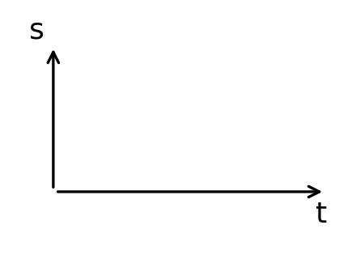 | 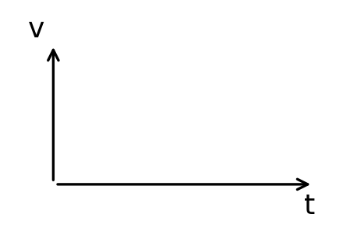 | 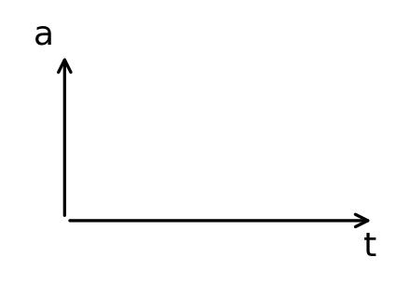
Constant velocity
Constant acceleration
Constant deceleration (until it stops)
Table 2
A3 Choose Constant velocity. Increase the initial velocity slider. What happens to the s–t graph? Explain. [2]

A4 Choose Constant deceleration. After the car stops, why does the s–t graph become horizontal instead of going down? [2]

A5 Complete Check Your Understanding for Tab 1.
My score: ______ / 7

Part B: Gradient & Area (Tab 2)
On the sim: Open Tab 2. Read Key Concepts, then use the Guided Activity to find gradients and areas.
B1 Complete the sentences. [3]
The gradient of an s–t graph gives the ____________________.
The gradient of a v–t graph gives the ____________________.
The area under a v–t graph gives the ____________________.
B2 Why must you draw a tangent to find the gradient of a curved s–t graph? [1]

B3 Choose Constant acceleration and Gradient of s–t. Pick a time, then record the values from the worked example in Table 3. [3]
Time t / s | Δs / m | Δt / s | Gradient / (m/s) | v from v–t graph / (m/s)
Table 3
Do the gradient and the velocity match? ____________________
B4 Choose Area under v–t. For each case, state the shape used to calculate the area. [3]
Motion case | Shape of area
Constant velocity
Constant acceleration from rest
Constant acceleration from a non-zero velocity
Table 4
B5 Complete Check Your Understanding for Tab 2.
My score: ______ / 8

Part C: Match the Graphs (Tab 3)
On the sim: Open Tab 3. Read Key Concepts, then work through the Guided Activity journeys.
C1 A car decelerates to rest. A student draws its s–t graph sloping downwards. Explain the mistake. [2]

C2 A student copies the shape of a v–t graph to draw the s–t graph. Explain why this is wrong. [2]

C3 Choose one journey from the Guided Activity. Describe each stage of the motion. [3]
Stage | Time / s | Description of motion
1
2
3
4
Table 5
C4 Complete Check Your Understanding for Tab 3.
My score: ______ / 6

Part D: Graph Challenge (Tab 4)
On the sim: Open Tab 4 and complete the Graph Challenge.
D1 Record your score.
My score: ______ / ______
D2 Which type of question did you find hardest? Why? [1]

Part E: Practice Questions
E1 Fig. 1 shows the v–t graph of a car travelling along a straight road.
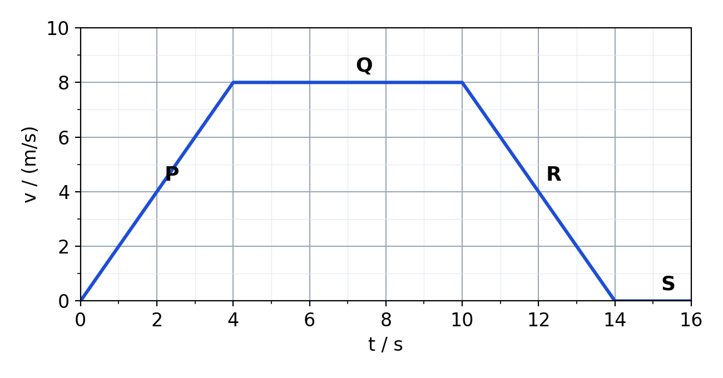
Fig. 1
(a) Describe the motion of the car in each section P, Q, R and S. [4]

(b) Calculate the acceleration of the car in section P. [2]
acceleration = ................ m/s²
(c) Calculate the total distance travelled by the car. [3]
distance = ................ m
(d) Calculate the average speed of the car for the whole journey. [2]
average speed = ................ m/s
(e) On Fig. 2, sketch the s–t graph for the car's journey. [3]
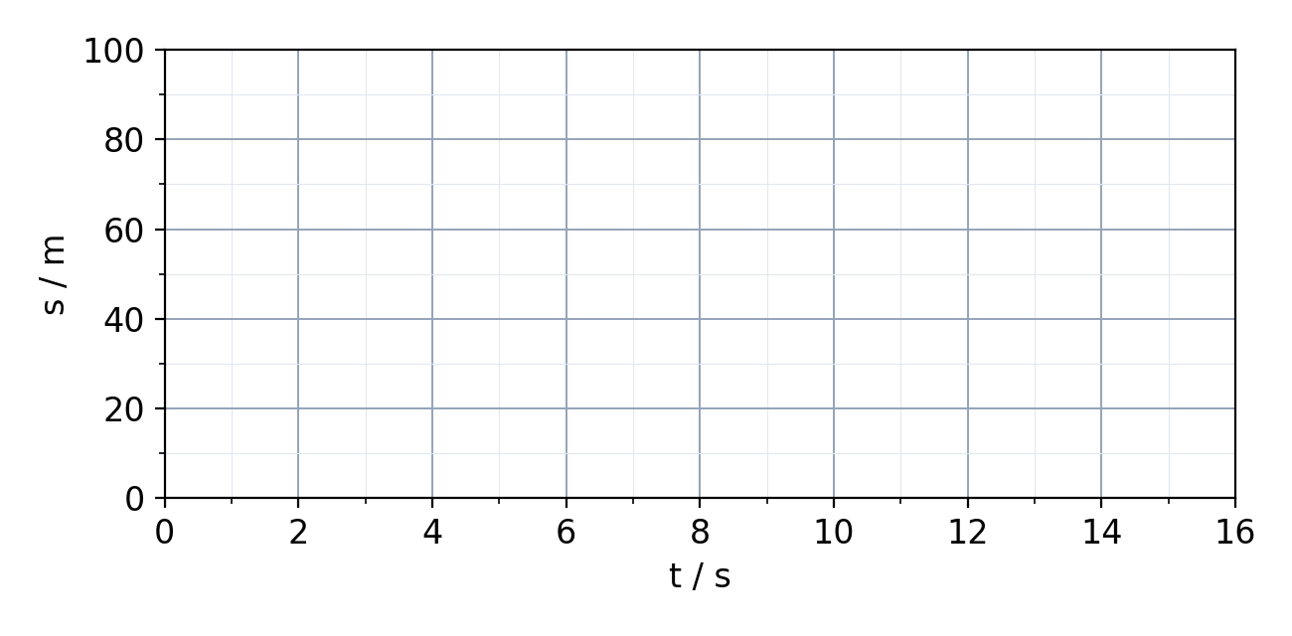
Fig. 2
(f) On Fig. 3, sketch the a–t graph for the car's journey. [3]
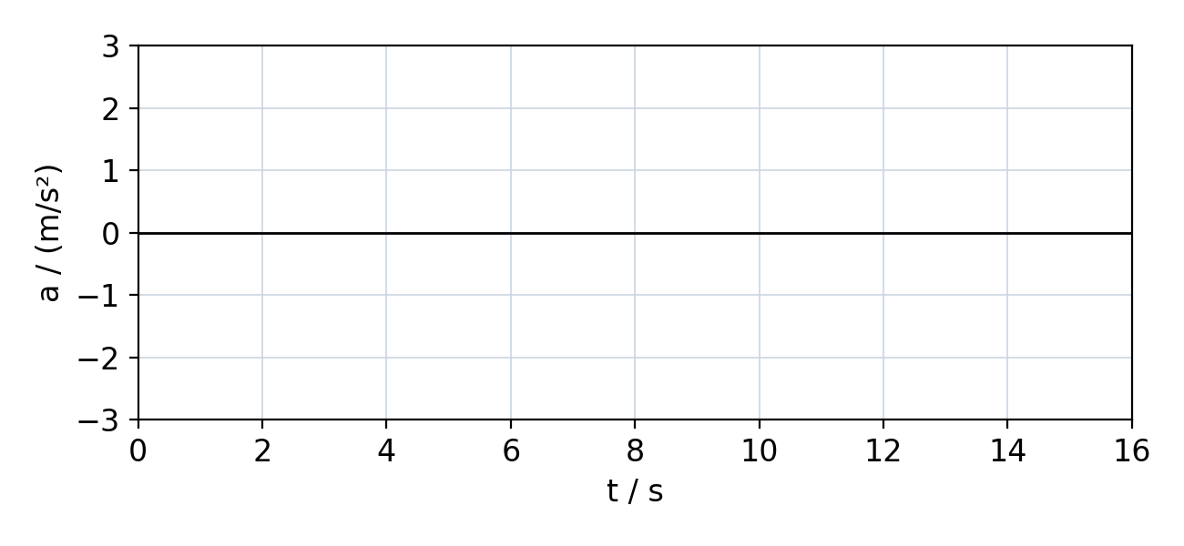
Fig. 3
E2 Fig. 4 shows the s–t graph of a cyclist.
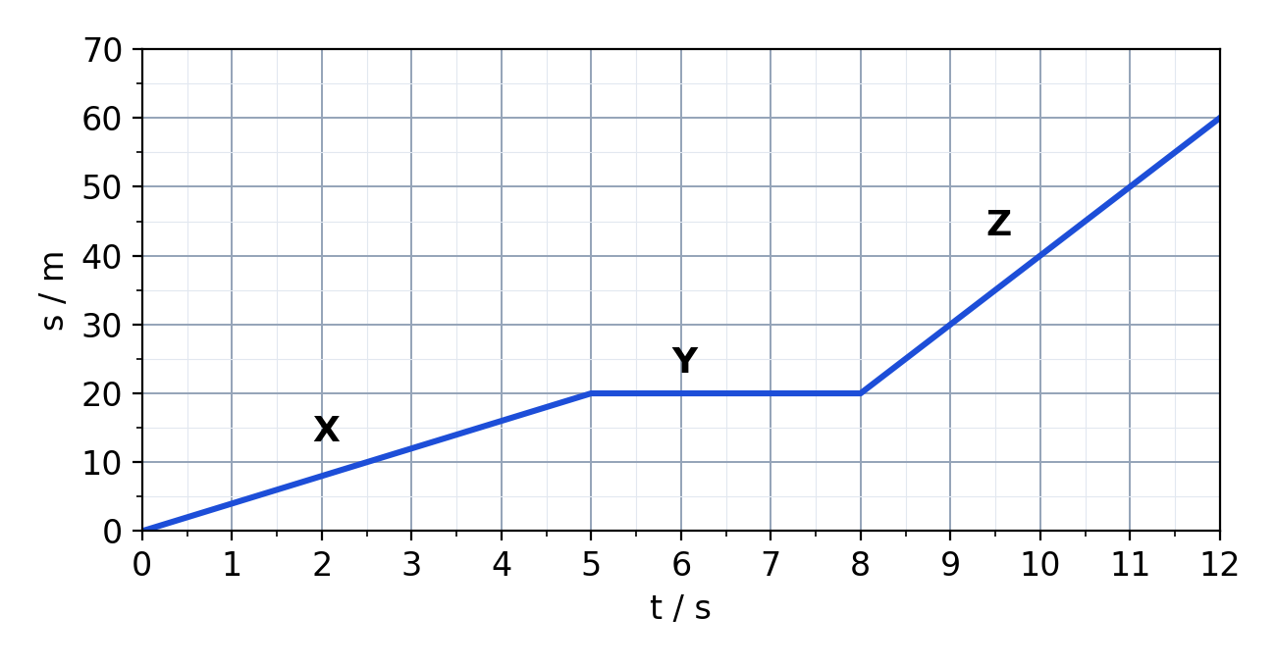
Fig. 4
(a) Calculate the speed of the cyclist in section X. [2]
speed = ................ m/s
(b) Describe the motion of the cyclist in section Y. [1]

(c) State, with a reason, the section in which the cyclist is fastest. [2]

(d) Calculate the average speed of the cyclist for the whole 12 s. [2]
average speed = ................ m/s

