Heating and Cooling Curves of Water

ANSWER KEY
For teacher use only
⚠ This document is intended for teachers. Please do not distribute to students.

Section 1 — Sketching the Heating Curve

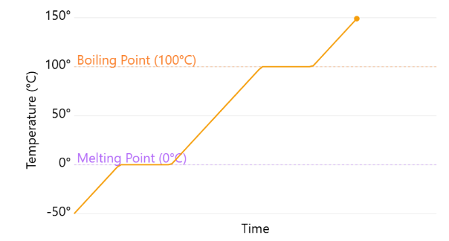

Section 2 — Recording Observations
Stage | Temperature range / plateau | What do you observe on the graph? | What are the particles doing?
Solid | −50°C to 0°C | Temperature rises steadily. | Particles vibrate about fixed positions. They are very closely packed in an orderly arrangement.
Melting | 0°C (plateau) | Temperature stays constant at 0°C. | Energy is absorbed to overcome forces of attraction between particles. Particles break free from fixed positions.
Liquid | 0°C to 100°C | Temperature rises steadily. | Particles move randomly and slide past one another. They are closely packed but not in an orderly manner.
Boiling | 100°C (plateau) | Temperature stays constant at 100°C. | Energy is absorbed to overcome forces of attraction between particles. Particles escape into the gas state.
Gas | Above 100°C | Temperature rises steadily. | Particles move rapidly and randomly. They are very far apart and not in any orderly arrangement.

Section 3 — Energy Changes
Process | Endothermic or Exothermic? | What happens to the energy and why does temperature stay constant?
Melting | Endothermic | Energy is absorbed to overcome forces of attraction between particles. Since all the energy is used to break these forces rather than increase kinetic energy, temperature stays constant.
Boiling | Endothermic | Energy is absorbed to overcome forces of attraction between particles. All energy goes into separating particles, so temperature stays constant.
Condensation | Exothermic | Energy is released as particles attract one another and come closer together. Temperature stays constant as energy is released to the surroundings rather than changing kinetic energy.
Freezing | Exothermic | Energy is released as particles attract one another and settle into fixed positions. Temperature stays constant as energy is released to the surroundings.

Section 4 — Macroscopic, Microscopic & Symbolic
Melting
Level | Description
Macroscopic  What we observe | Ice turns into liquid water. Temperature stays constant at 0°C. The substance changes from a solid (fixed shape and volume) to a liquid (no fixed shape, fixed volume).
Microscopic  What particles do | Particles absorb energy and overcome forces of attraction. They break free from their fixed positions and begin to slide past one another. Spacing between particles increases slightly.
Symbolic  Representations | H₂O (s) → H₂O (l) | Melting point: 0°C | Endothermic process | Plateau on heating curve at 0°C
Boiling
Level | Description
Macroscopic  What we observe | Liquid water turns into steam (water vapour). Temperature stays constant at 100°C. Bubbles form throughout the liquid.
Microscopic  What particles do | Particles absorb energy and overcome remaining forces of attraction. They move apart rapidly and randomly, with very large spaces between them.
Symbolic  Representations | H₂O (l) → H₂O (g) | Boiling point: 100°C | Endothermic process | Plateau on heating curve at 100°C

Section 5 — Short Answer Questions
1. Why does the temperature remain constant during melting, even though energy is still being added?

All energy absorbed is used to overcome forces of attraction between particles, converting the solid into a liquid. Since no energy goes into increasing the kinetic energy of particles, the temperature stays constant.

2. How does the particle arrangement differ between the liquid state and the gas state?

In the liquid state, particles are closely packed but not in an orderly arrangement, and they slide past one another. In the gas state, particles are very far apart, move rapidly and randomly, and have no orderly arrangement.

3. A student says: "Freezing releases energy, so the surroundings get colder." Do you agree? Explain.

Disagree. Freezing is exothermic — the substance releases energy to the surroundings. This means the surroundings gain energy and get warmer, not colder. For example, when water freezes, the air around it becomes slightly warmer.

4. Compare the heating curve and cooling curve of water. What is the same and what is different?

Same: Both curves have plateaus at 0°C and 100°C. The temperatures at which phase changes occur are the same.
Different: On the heating curve, temperature increases and phase changes are endothermic (melting, boiling). On the cooling curve, temperature decreases and phase changes are exothermic (condensation, freezing). The curve is essentially reversed.

5. State one piece of evidence from the simulation that supports the kinetic particle model.

Accept any valid answer, e.g.: The particles in the liquid state move randomly and continuously, consistent with the kinetic particle model. / Gas particles move rapidly and randomly in all directions, with large spaces between them. / During melting, solid particles begin to break free and move, showing that energy increases particle motion.

Section 6 — True or False
Statement | Answer | Correction (if false)
During melting, the temperature of a substance remains constant. | True | —
Boiling is an exothermic process. | False | Boiling is an endothermic process — energy is absorbed to overcome forces of attraction between particles.
Gas particles are very far apart and move rapidly in random directions. | True | —
Freezing is an endothermic process. | False | Freezing is an exothermic process — energy is released as particles attract one another and settle into fixed positions.
During condensation, the kinetic energy of particles increases. | False | During condensation, kinetic energy decreases — energy is released as particles slow down and come closer together.

