Heating and Cooling Curves of Water

A worksheet on states of matter and phase changes
Name: Class: Date:

Instructions: Use the interactive simulation to complete this worksheet. Heat the substance from −50°C to 150°C, then cool it back down. Observe the graph and particle arrangement at each stage.

Section 1 — Sketch the Heating Curve
Using the simulation, sketch the heating curve of water in the grid below. Label the axes and mark the melting point and boiling point.
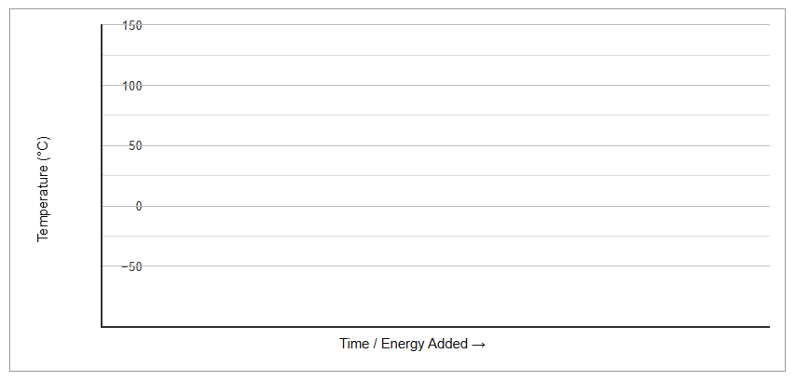
On your sketch, label: Solid, Melting, Liquid, Boiling, Gas | Mark the Melting Point (0°C) and Boiling Point (100°C)

Section 2 — Recording Observations
Complete the table as you heat the substance from −50°C to 150°C.
Stage | Temperature range / plateau | What do you observe on the graph? | What are the particles doing?
Solid | −50°C to 0°C | Temperature rises steadily. | Particles vibrate about fixed positions. They are very closely packed in an orderly arrangement.
Melting | 0°C (plateau) | Temperature stays constant at 0°C. | Energy is absorbed to overcome forces of attraction between particles. Particles break free from fixed positions.
Liquid
Boiling
Gas

Section 3 — Energy Changes
Complete the table by classifying each process and explaining the energy change. Details for boiling and freezing are provided for you.
Process | Endothermic or Exothermic? | What happens to the energy and why does temperature stay constant?
Melting
Boiling | Endothermic | Energy is absorbed to overcome forces of attraction between particles. All energy goes into separating particles, so temperature stays constant.
Condensation
Freezing | Exothermic | Energy is released as particles attract one another and settle into fixed positions. Temperature stays constant as energy is released to the surroundings.

Section 4 — Macroscopic, Microscopic & Symbolic
For the process of melting, the following information is provided:
Level | Description
Macroscopic  What we observe | Ice turns into liquid water. Temperature stays constant at 0°C. The substance changes from a solid (fixed shape and volume) to a liquid (no fixed shape, fixed volume).
Microscopic  What particles do | Particles absorb energy and overcome forces of attraction. They break free from their fixed positions and begin to slide past one another. Spacing between particles increases slightly.
Symbolic  Representations | H₂O (s) → H₂O (l) | Melting point: 0°C | Endothermic process | Plateau on heating curve at 0°C

Now do the same for boiling.
Level | Description
Macroscopic
What we observe
Microscopic
What particles do
Symbolic
Representations

Section 5 — Short Answer Questions
- Why does the temperature remain constant during melting, even though energy is still being added?
- How does the particle arrangement differ between the liquid state and the gas state?
- A student says: "Freezing releases energy, so the surroundings get colder." Do you agree? Explain.
- Compare the heating curve and cooling curve of water. What is the same and what is different?
- State one piece of evidence from the simulation that supports the kinetic particle model.
Choose two questions to answer:
Question number:

My answer:

Question number:

My answer:

Section 6 — True or False
Circle True or False for each statement. If false, write the correct statement on the line below.
Statement | True / False | Correction (if false)
During melting, the temperature of a substance remains constant. | T / F
Boiling is an exothermic process. | T / F
Gas particles are very far apart and move rapidly in random directions. | T / F
Freezing is an endothermic process. | T / F
During condensation, the kinetic energy of particles increases. | T / F

