Electric Fields: Guided Inquiry Activity
Name: ____________________________ Class: _________ Date: _________
Instructions: Use the Interactive Electric Field Simulator (https://edtechsims.com/electric-field/) to complete the following activities. Click to place charges, drag to move them, and shift+click to measure the field at a point. Answer all questions in the spaces provided. | 

Activity 1: Field Pattern Exploration
Objective: Understand how charge magnitude and polarity affect field patterns.
Steps:
- Load the Empty Canvas preset and place a single positive charge on the canvas.
- Observe the pattern of field lines around the charge.
- Click on the charge to select it, then use the slider to gradually increase the charge magnitude.
- Now gradually decrease the charge magnitude (make it negative).
Drawings:
Draw the electric field around a single positive charge and a single negative charge.
Single positive charge  Field lines point radially outward (away) from the positive charge in all directions.  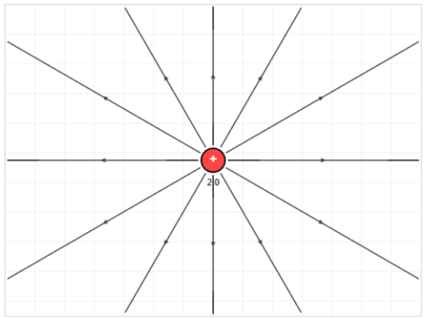 | Single negative charge  Field lines point radially inward to the negative charge in all directions.  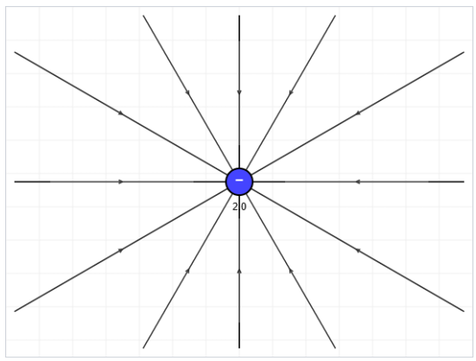
Questions:
a) What happened to the number/density of field lines as you increased the charge magnitude?
The number (density) of field lines increased, showing that the field is stronger for a larger charge magnitude. Line density represents field strength.
b) Why do field lines point away from positive charges but toward negative charges?

By convention, field lines represent the direction of the force that would act on a small positive test charge. A positive test charge is repelled by another positive charge (so lines point away) and attracted to a negative charge (so lines point toward it).
Activity 2: Electric Dipole Investigation
Objective: Study the dipole field configuration.
Steps:
- Load the Electric Dipole preset (one positive and one negative charge).
- Observe the shape of the field lines between and around the two charges.
- Drag the charges closer together, then drag them farther apart.
Questions:
a) Sketch or describe the field line pattern between the two charges.
Field lines leave the positive charge and curve around to terminate on the negative charge. The lines are most concentrated (straightest and densest) in the region directly between the two charges.
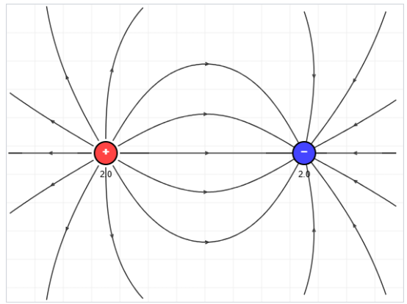
b) What did you notice about the field lines when the charges were moved closer together?
The field lines became more curved/compressed and denser in the region between the charges, indicating the field became stronger there as the charges were brought closer together.

c) Where is the electric field strongest? Where is it weakest?
The field is strongest in the region directly between the two charges (where field line density is highest) and close to either charge. The field is weakest far away from both charges, where field lines are sparse.

Activity 3: Field Line Rules Investigation
Objective: Discover the rules governing electric field lines.
Steps:
- Create at least three different charge configurations of your choice (e.g., two positives, three charges in a triangle, etc.).
- For each configuration, carefully observe the field lines.
Questions:
a) Do field lines ever cross each other?
No.
b) Where do field lines always start?
On positive charges.
c) Where do field lines always end (or where do they go if there is no negative charge)?
On negative charges. If there is no negative charge present, the lines extend outward to infinity (in this simulator, they exit toward the edge of the canvas).
d) Do field lines ever form closed loops?
No.
e) Why can't field lines cross each other?
At any given point in space, the electric field can only point in one direction. If two field lines crossed, it would mean the field had two directions at that single point, which is impossible — the field is a unique vector at every location (a result of the superposition of all charges' contributions).

Extension Challenge
Using the simulator, try to create an arrangement of charges where the electric field at the center of your arrangement is zero. Describe your charge arrangement below, and explain why the field cancels out at that point.
A student could place two identical positive charges of equal magnitude an equal distance apart, on either side of a chosen center point. By symmetry, the field contributions from each charge at the center point are equal in magnitude but opposite in direction, so they cancel out, giving a net field of zero at the midpoint.
(Accept any valid symmetric arrangement, e.g., two equal negative charges, or four charges arranged symmetrically around a center point.)

Check Your Understanding
Attempt the multiple choice questions on the website and record key ideas here:

