Movement of Substances
Diffusion, Osmosis and Active Transport
Name: ____________________ Class: ______ Date: _______
  Simulation 1: Diffusion  edtechsims.com/diffusion |   Simulation 2: Osmosis  edtechsims.com/osmosis |   Simulation 3: Active Transport  edtechsims.com/active-transport
By the end of this activity, you should be able to:
- define diffusion, osmosis and active transport
- describe how temperature and particle size affect the rate of diffusion
- explain the movement of water by osmosis across a partially permeable membrane
- explain why active transport needs energy from respiration
- compare the three processes and apply them to plant and animal cells

Part A: Diffusion (Simulation 1)
On the sim: Open Simulation 1. Read the Key Concepts, then work through the Guided Activities.
A1 Define diffusion. [2]

A2 Start the simulation. Describe how the particles move and how they become spread out over time. [2]

A3 Change ONLY the Temperature slider. Describe and explain its effect on the rate of diffusion. [2]

A4 Reset. Change ONLY the Particle size slider. Describe its effect on the rate of diffusion. [1]

A5 When the particles are evenly spread out, do they stop moving? Explain. [2]

A6 Complete Check Your Understanding in the sim.
My score: ______ / ______

Part B: Osmosis (Simulation 2)
On the sim: Open Simulation 2. Read the Key Concepts, then use the Guided Activities to complete this part.
B1 Define osmosis. [2]

B2 Set Mass of glucose added to 6 units on the right side. Click Apply & Reset, then Start.
(a) Describe what happens to the water levels on the left and right. [2]

(b) Why can't glucose molecules cross to the left? [1]

B3 Repeat with different masses of glucose. Record the final water volumes in Table 1. [3]
Glucose added / units | Left side / cm³ | Right side / cm³ | Difference / cm³
0
2
6
10
Table 1
B4 Describe the relationship between the mass of glucose added and the difference in water level. [1]

B5 Run the simulation until Dynamic Equilibrium ⇌ appears, and turn on Show water and glucose molecules. Are water molecules still crossing the membrane? Why do the water levels stay constant? [2]

B6 Complete the sentences using hypotonic, hypertonic or isotonic. [3]
A solution with a higher solute concentration is ____________________.
A solution with a lower solute concentration is ____________________.
Two solutions with equal solute concentrations are ____________________.

B7 Complete Check Your Understanding in the sim.
My score: ______ / ______

Part C: Active Transport (Simulation 3)
On the sim: Open Simulation 3. Read the Key Concepts, then use the Guided Activities to complete this part.
C1 Define active transport. [2]

C2 Set the Number of Na⁺ ions to 8. Click Apply & Reset, then Start.
(a) In which direction are the Na⁺ ions transported? Is this with or against the concentration gradient? [2]

(b) What role do the yellow carrier proteins play? [1]

C3 Let the simulation run until ATP reaches 0. What happens to Na⁺ transport? What does this show? [2]

C4 Repeat with different numbers of Na⁺ ions. Record your observations in Table 2. [2]
Number of Na⁺ ions | Observations (how quickly ATP is used, how many ions cross)
2
8
12
Table 2
C5 Explain why a cell that stops respiring can no longer carry out active transport. [2]

Part D: Comparing the Three Processes
D1 Complete Table 3. Part of the table has been completed for you. [8]
 | Diffusion | Osmosis | Active transport
What moves | Any particles (e.g. O₂, CO₂) |  | Particles such as ions or glucose
Direction (relative to concentration gradient) |  | High → low water potential
Energy from respiration needed? | No |  | Yes
Partially permeable membrane needed? |  |  | Yes (with carrier proteins)
One example in living organisms |  | Water into root hair cells
Table 3

Part E: Practice Questions
E1 Potato cylinders of equal size were placed in sucrose solutions of different concentrations for 24 hours. Fig. 1 shows the percentage change in mass of each cylinder.
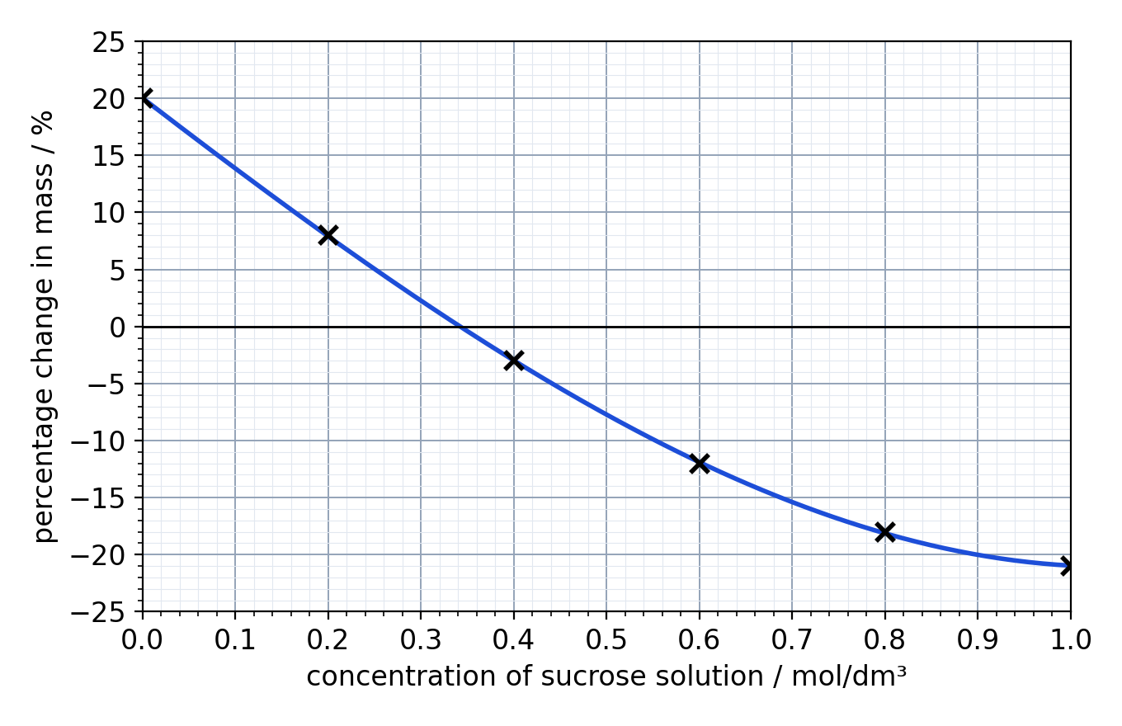
Fig. 1
(a) Explain why the cylinder in 0.0 mol/dm³ (distilled water) gained mass. [2]

(b) Use Fig. 1 to estimate the concentration of sucrose solution that has the same water potential as the potato cells. Explain your answer. [2]
concentration = .............. mol/dm³

(c) Explain why the cylinder in 1.0 mol/dm³ lost mass. [2]

E2 Root hair cells absorb mineral ions from the soil, even when the concentration of ions in the soil is lower than inside the cell.
(a) Name the process by which these ions are absorbed. Explain your answer. [2]

(b) Suggest why root hair cells contain many mitochondria. [2]

E3 A red blood cell and a plant cell are both placed in distilled water. Explain why the red blood cell bursts but the plant cell does not. [3]

