Cells  Cell Structure and Organisation  Simulation: edtechsims.com/cell-structure-organisation  Name: ____________________ Class: ______ Date: _______ |   Scan to open
By the end of this activity, you should be able to:
- arrange the levels of organisation from organelle to organism, with examples
- identify the main organelles in plant and animal cells and state their functions
- compare the structure of plant and animal cells
- relate the structure of a cell to its function

Part A: Key Concepts
On the sim: Open the Key Concepts tab and read the Levels of Organisation table.
A1 Complete Table 1 by arranging the levels of organisation from the simplest to the most complex, and giving one example of each. [6]
 | Level of organisation | Example
1 (simplest)
2
3
4
5
6 (most complex)
Table 1
A2 Define the term tissue. [1]

A3 The heart is described as an organ, not a tissue. Explain why. [2]

Part B: Escape The Cell
On the sim: Open the Escape The Cell tab. Play the game for BOTH the plant cell and the animal cell.
B1 Record your results in Table 2.
 | Plant cell | Animal cell
Number of stations
Final score
Hints used
Table 2
B2 Name the organelle stations that appear in the plant cell game but NOT in the animal cell game. [1]

B3 Complete Table 3 by stating the function of each organelle. [7]
Organelle | Function
Nucleus
Cell membrane
Cytoplasm
Mitochondrion
Vacuole
Chloroplast
Cell wall
Table 3

Part C: Sorting Challenge
On the sim: Open the Sorting Challenge tab. Sort all the cards into Plant and Animal, then check your answers.
C1 Record your score.
My score: ______ / ______
C2 Write down any cards you placed in the wrong group, and explain why they belong in the other group. [2]

Part D: Cell Biology Quiz and Summary
On the sim: Complete the Cell Biology Quiz tab, then read the Summary & Reflection tab.
D1 Record your quiz score.
My score: ______ / ______
D2 Choose one question you got wrong or found difficult. Explain the correct answer in your own words. [2]

D3 Using the Plant vs Animal Cells table in Summary & Reflection, complete Table 4 with ✓ (present) or ✗ (absent). [4]
Structure | Plant cell | Animal cell
Cell wall
Chloroplasts
Large central vacuole
Nucleus
Cell membrane
Mitochondria
Table 4

Part E: Practice Questions
E1 Fig. 1 shows a plant cell.
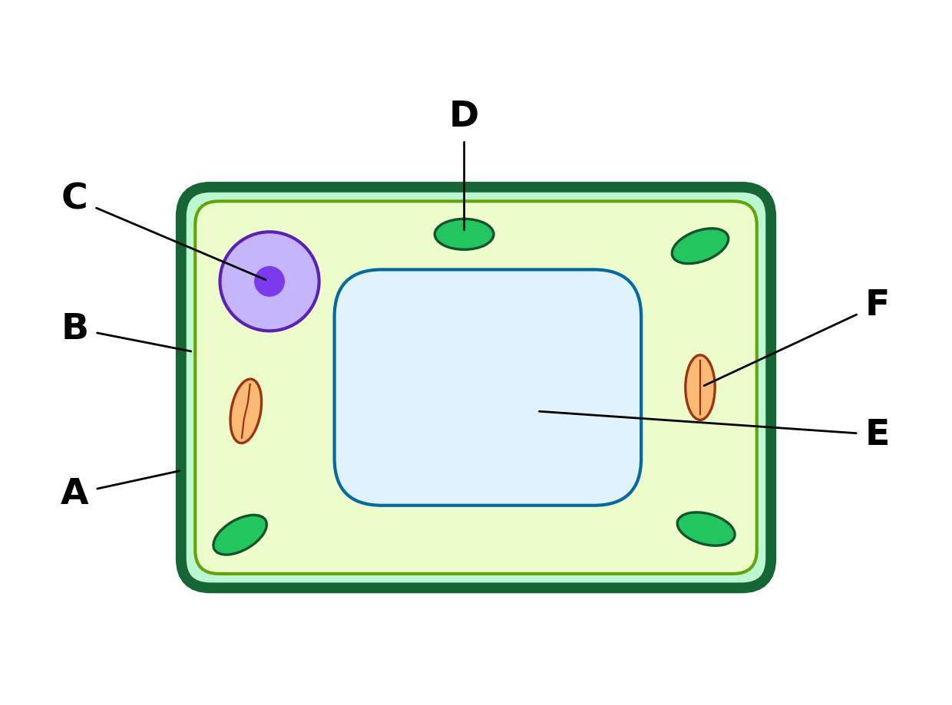
Fig. 1
(a) Name the structures labelled A to F. [6]
A: ...................................... B: ......................................
C: ...................................... D: ......................................
E: ...................................... F: ......................................
(b) State one function of structure A and one function of structure E. [2]

(c) A root hair cell is a plant cell that does not contain structure D. Suggest why. [2]

E2 Fig. 2 shows an animal cell.
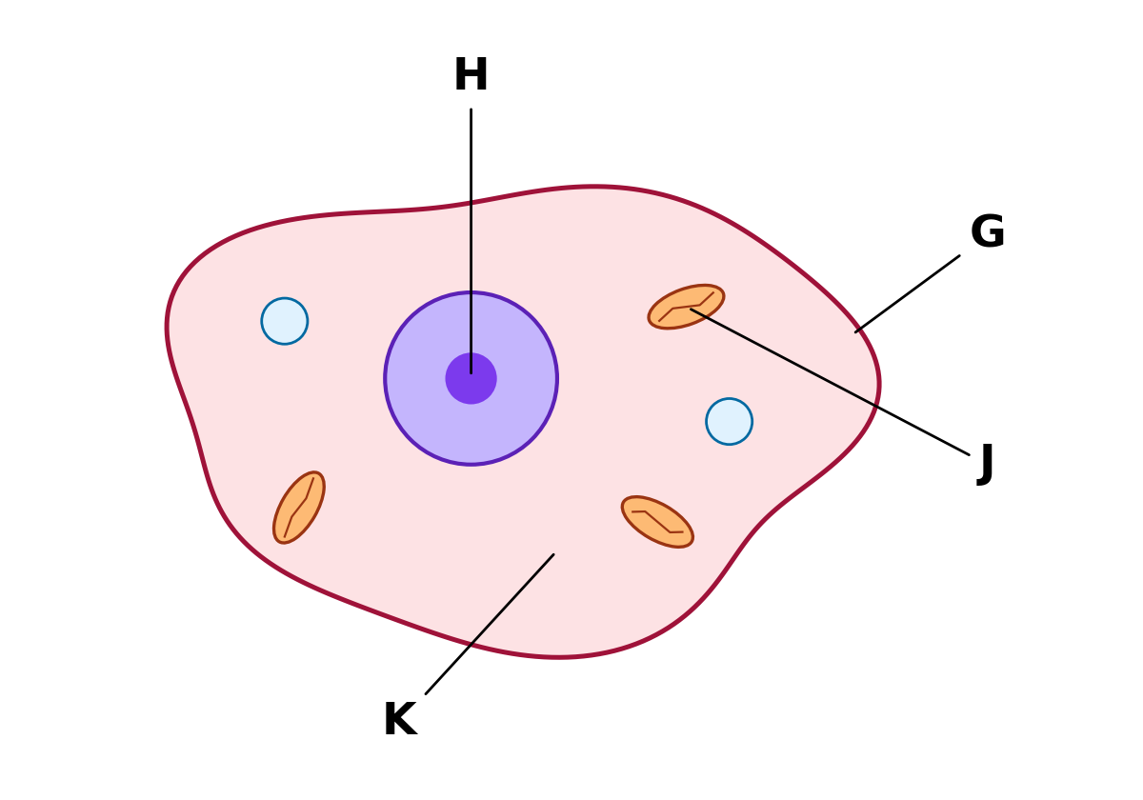
Fig. 2
(a) Name the structures labelled G, H, J and K. [4]
G: ...................................... H: ......................................
J: ...................................... K: ......................................
(b) Muscle cells contain many more of structure J than skin cells. Explain why. [2]

(c) State two structural differences between the cell in Fig. 1 and the cell in Fig. 2. [2]

