Name: ________________________( ) Class:________ Date:________
Let’s visit this website: https://edtechsims.com/titration-ph-curves/
- Acid vs Base
An acid produces ………. in aqueous solution while a base produces ………… in aqueous solution.

2. Strong Acid vs Weak Acid
A strong acid is …………………….. ionised in aqueous solution to produce H⁺, while a weak acid is ……………………….. ionised.

- Overlay NaOH+HCl and NaOH+CH₃COOH curves.
Why does strong acid HCl start at pH 1.0? What about CH₃COOH?

2. Monobasic vs Dibasic Acid Comparison
A monobasic acid produces ……….. H⁺ per acid molecule while a dibasic acid produces ……….. H⁺ per acid molecule.

- Overlay NaOH+HCl and NaOH+H₂SO₄ curves.
Why does H₂SO₄ need twice the volume (50 cm³) to reach equivalence compared to HCl (25 cm³)?

3. Indicator Selection Challenge
- Enable an indicator one-by-one and select different combinations.
Which indicator(s) work for strong acid-strong alkali titrations?
Explain using the pH range at equivalence.

For the NaOH+CH₃COOH titration, why is methyl orange not a suitable indicator but phenolphthalein is a suitable indicator?

4. Data-based Question

A pH meter and a data logger are used to monitor the pH changes during a series of titrations.

In each titration, 0.1 mol dm⁻³ sodium hydroxide is added from a burette into a solution of a different dilute acid.

During the titrations the pH does not change smoothly.

The data logger gives a graph for each titration.

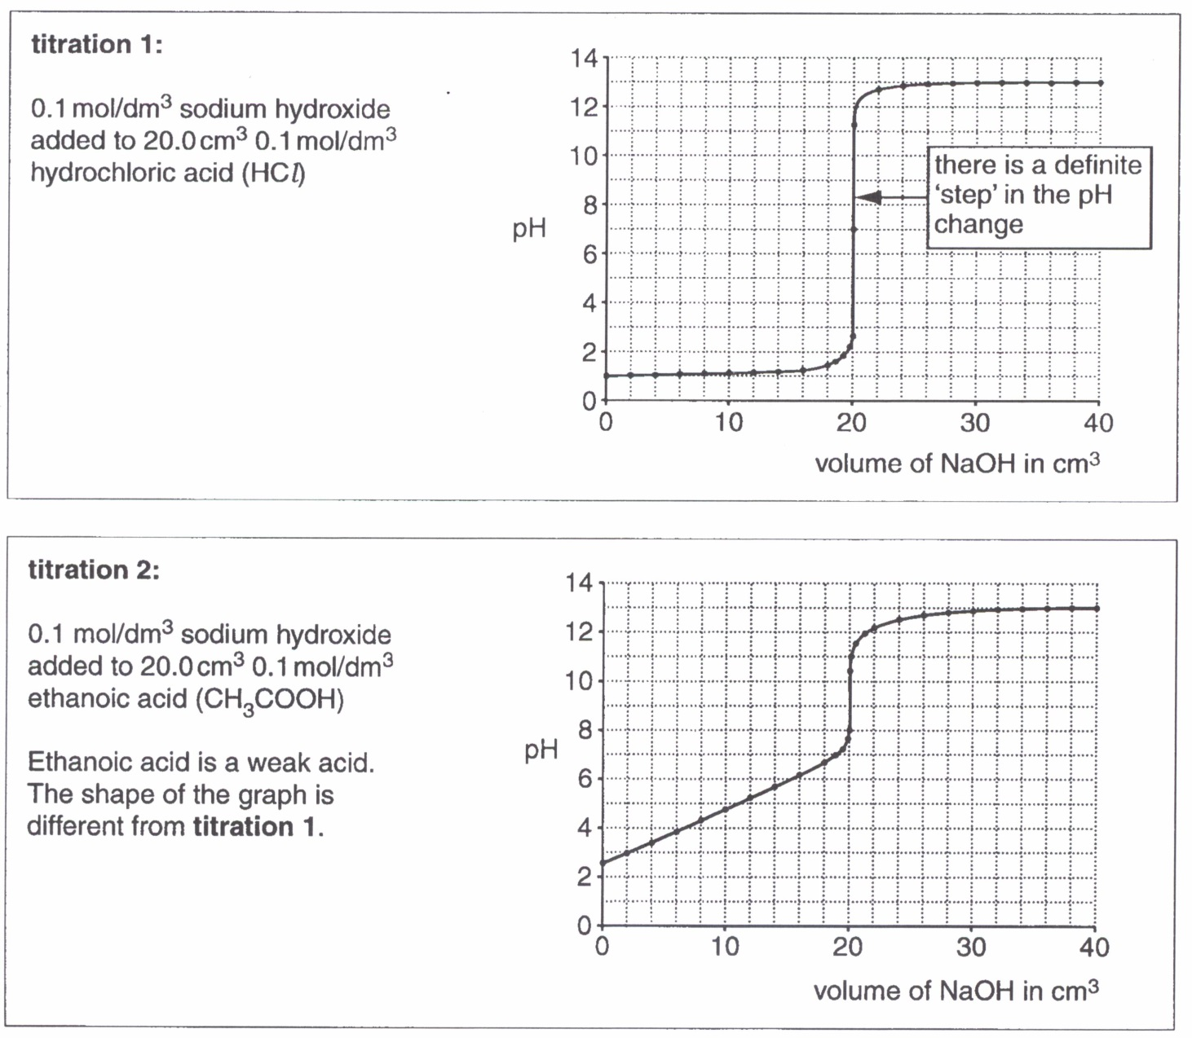

 | (a) | Identify two differences between the pH graphs for titration 1 and titration 2.
 |  | …………………………………………………………………………………………………..  …………………………………………………………………………………………………..  …………………………………………………………………………………………………..  ………………………………………………………………………………………………….. | [2]

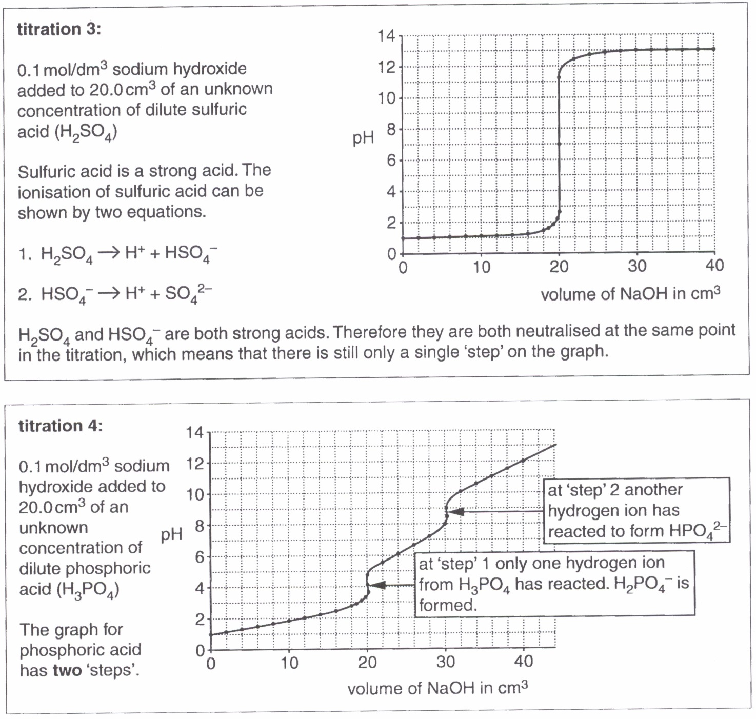

There appears to be three hydrogen atoms in phosphoric acid that may ionise. In practice, only the first two hydrogen atoms form ions. At the end of the titration, HPO₄²⁻ ions are left.

 | (b) | Write two equations to show how phosphoric acid produces the hydrogen ions involved in the two ‘steps’ on the pH graph in titration 4.  step 1…………………………………………………………………………………………..  step 2………………………………………………………………………………………….. | [2]
 | (c) | Give the formula for the salt formed at the end of titration 4.  ………………………………… | [1]
An indicator can also be used to see when a ‘step’ happens in the pH change. The endpoint of each indicator happens when the indicator changes colour.

The diagram below shows the colours of some indicators at different pH values. In between the colours, most indicators change colour gradually over a range of pH values.

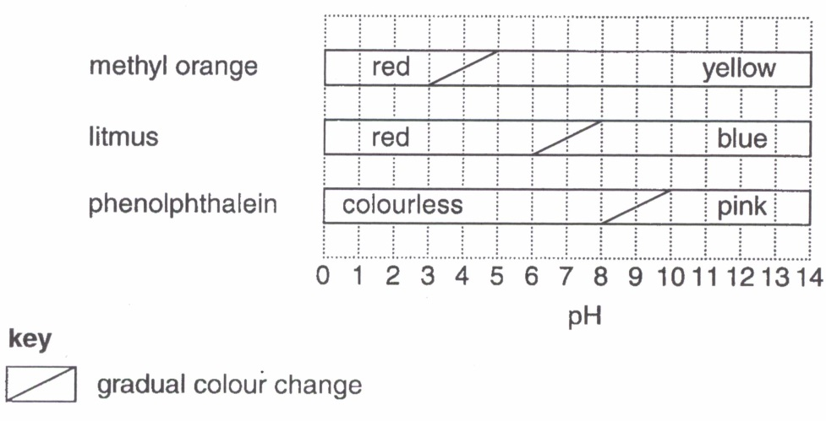

The best indicator for a titration gives a distinct colour change when a ‘step’ occurs.
For a titration between a strong acid and a strong alkali, every indicator in the diagram would give an accurate titration volume.

 | (d) | Explain why any of the indicators in the diagram can be used to give an accurate titration volume when strong acids are titrated with dilute sodium hydroxide.
 |  | …………………………………………………………………………………………………..  …………………………………………………………………………………………………..  …………………………………………………………………………………………………..  ………………………………………………………………………………………………….. | [2]
 | (e) | Explain why methyl orange would not be suitable to use when titrating ethanoic acid with dilute sodium hydroxide. (Refer to titration 2 above)
 |  | …………………………………………………………………………………………………..  ………………………………………………………………………………………………….. | [1]
 | (f) | Suggest the best indicator to use when titrating ethanoic acid with dilute sodium hydroxide.
 |  | ………………………………………………………………………………………………….. | [1]

