Name: ________________________( ) Class:________ Date:________
Let’s visit this website: https://edtechsims.com/titration-ph-curves/
- Acid vs Base
An acid produces H⁺ in aqueous solution while a base produces OH⁻ in aqueous solution.

2. Strong Acid vs Weak Acid
A strong acid is completely ionised in aqueous solution to produce H⁺, while a weak acid is partially ionised.

- Overlay NaOH+HCl and NaOH+CH₃COOH curves.
Why does HCl start at pH 1.0? What about CH₃COOH?
HCl is a strong acid which ionises completely in water to give a higher concentration of H⁺ ions. CH₃COOH is a weak acid which ionises partially and thus produces a solution with a lower concentration of H⁺ ions. As such, HCl has a lower pH than CH₃COOH.
2. Monobasic vs Dibasic Acid Comparison
A monobasic acid produces one H⁺ per acid molecule while a dibasic acid produces two H⁺ per acid molecule.

- Overlay NaOH+HCl and NaOH+H₂SO₄ curves.
Why does H₂SO₄ need twice the volume (50 cm³) to reach equivalence compared to HCl (25 cm³)?
H₂SO₄ is a strong dibasic acid which ionises completely in water to give 2 H⁺ ions per acid molecule while HCl is a strong monobasic acid which ionises completely in water to give 1 H+ ions per acid molecule. As such, more alkali is needed to neutralize H₂SO₄ than HCl.
3. Indicator Selection Challenge
- Enable an indicator one-by-one and select different combinations.
Which indicator(s) work for strong acid-strong alkali titrations?
Explain using the pH range at equivalence.
- Methyl Orange (pH 3.1-4.4): Best for strong acid titrations
- Screened Methyl Orange (pH 3.2-4.2): Provides sharper colour transition for strong acids
- Litmus (pH 4.5-8.3): Wide range, useful for demonstrating acid/base but not precise
For the NaOH+CH₃COOH titration, why is methyl orange not a suitable indicator but phenolphthalein is a suitable indicator?
An indicator should change color within the 'step' of the titration curve.
Methyl orange is not a suitable indicator as the colour change would have occurred before the ‘step’ of the titration curve/ neutralisation has taken place completely.
Phenolphthalein is a suitable indicator as its colour change occurs within the ‘step’ of the titration curve.
4. Data-based Question

A pH meter and a data logger are used to monitor the pH changes during a series of titrations.

In each titration, 0.1 mol dm⁻³ sodium hydroxide is added from a burette into a solution of a different dilute acid.

During the titrations the pH does not change smoothly.

The data logger gives a graph for each titration.
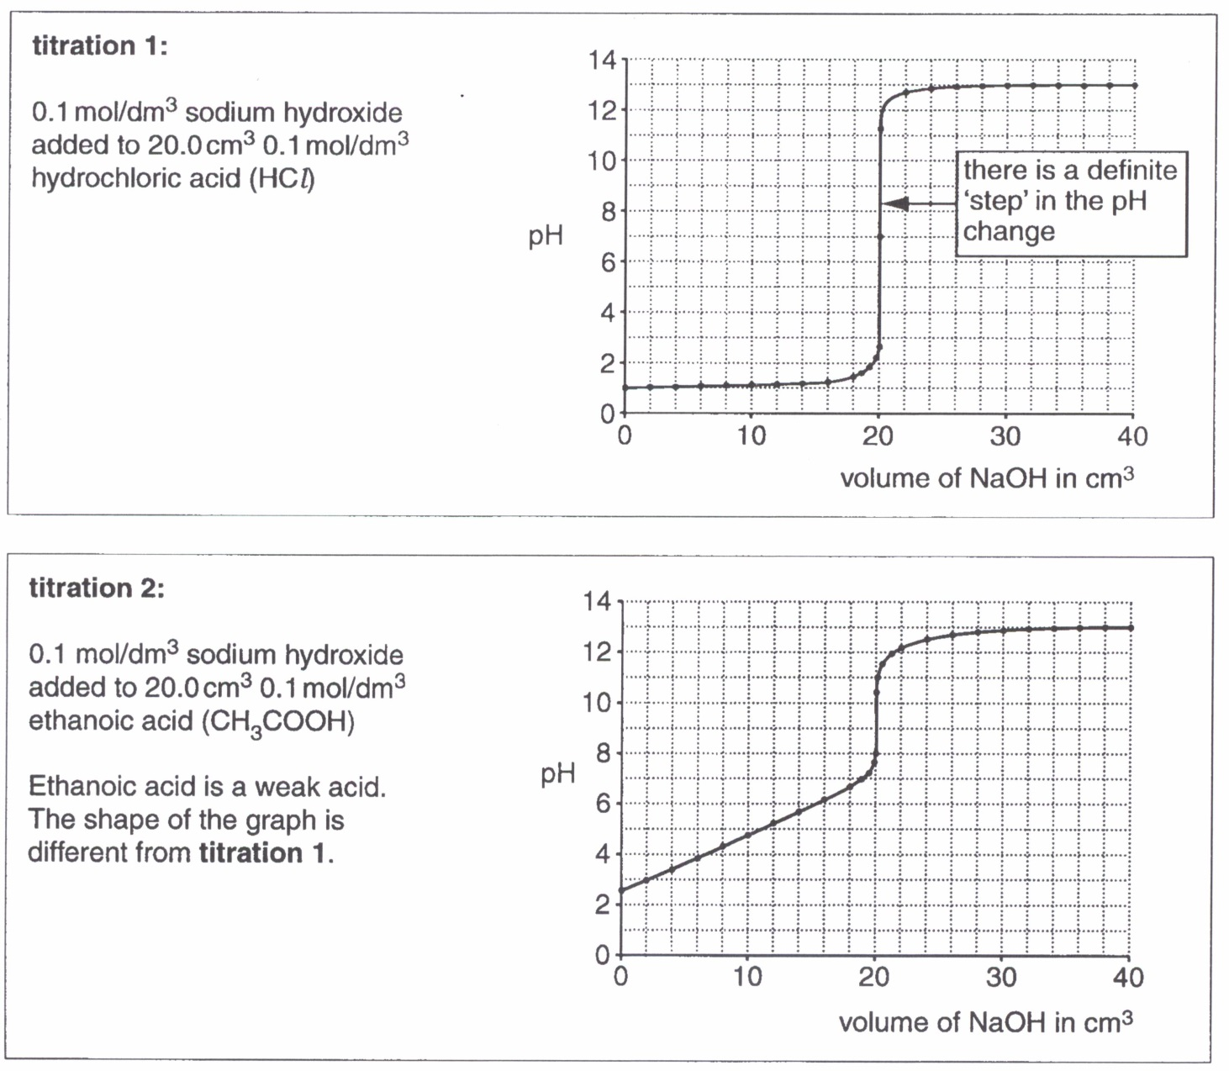

 | (a) | Identify two differences between the pH graphs for titration 1 and titration 2.  - Starting pH of titration 1 is 1 but starting pH of titration 2 is 2.5.  - The ‘step’ in titration 1 is large (from about pH 3 to pH 11) while the ‘step’ in titration 2 is small (from about pH 8 to pH 11).  - Equivalence point of titration 1 is at pH 7 but that of titration 2 is at about pH 9.5. (Midpoint of titration 1’s ‘step’ is at pH 7 but midpoint of titration 2’s ‘step’ is at pH 9.5).  - For titration 1, the rise in pH before 20 cm³ of NaOH was added is minimal but for titration 2, the rise is substantial (from pH 2.5 to about pH 7). | [2]
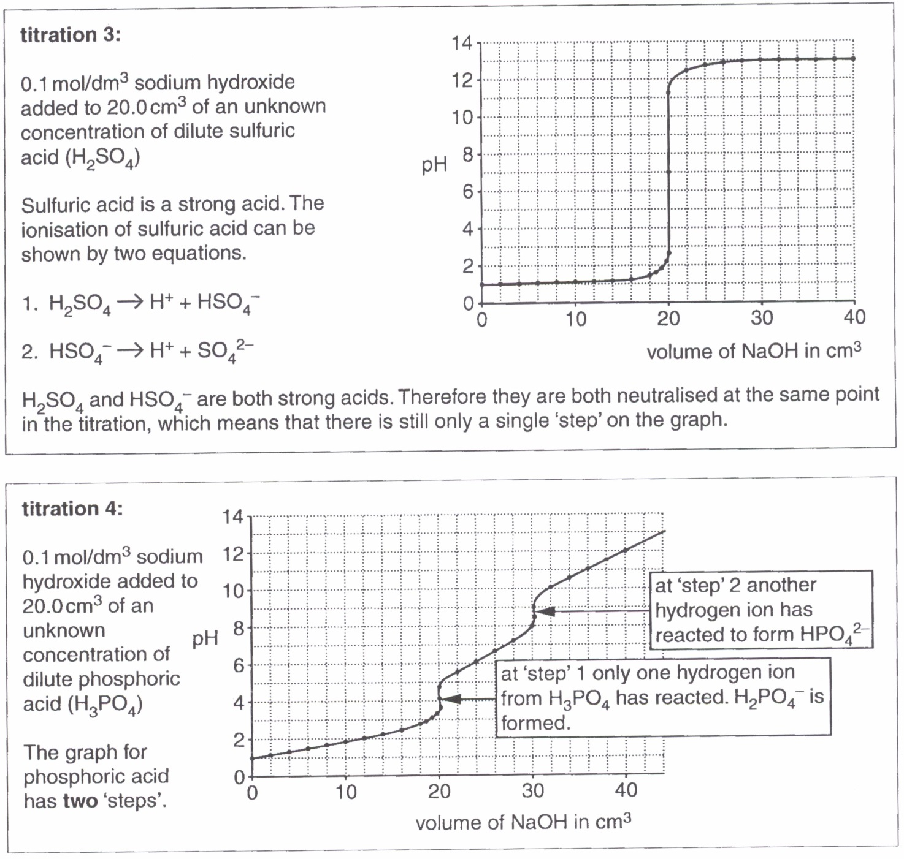

There appears to be three hydrogen atoms in phosphoric acid that may ionise. In practice, only the first two hydrogen atoms form ions. At the end of the titration, HPO₄²⁻ ions are left.

 | (b) | Write two equations to show how phosphoric acid produces the hydrogen ions involved in the two ‘steps’ on the pH graph in titration 4.  step 1 H₃PO₄ H⁺ + H₂PO₄⁻ [1]  step 2 H₂PO₄⁻ H⁺ + HPO₄²⁻ [1] | [2]
 | (c) | Give the formula for the salt formed at the end of titration 4.  Na₂HPO₄ | [1]

An indicator can also be used to see when a ‘step’ happens in the pH change. The endpoint of each indicator happens when the indicator changes colour.

The diagram below shows the colours of some indicators at different pH values. In between the colours, most indicators change colour gradually over a range of pH values.

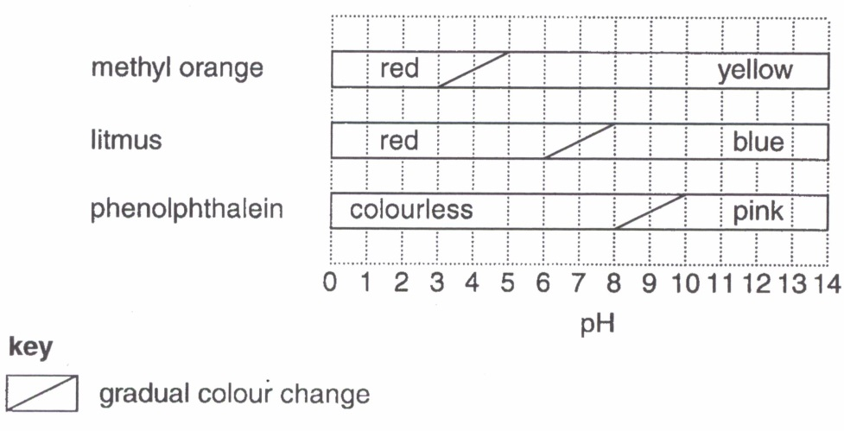

The best indicator for a titration gives a distinct colour change when a ‘step’ occurs.
For a titration between a strong acid and a strong alkali, every indicator in the diagram would give an accurate titration volume.

 | (d) | Explain why any of the indicators in the diagram can be used to give an accurate titration volume when strong acids are titrated with dilute sodium hydroxide.
 |  | For titration between strong acids and NaOH (e.g. titration 1 and titration 3), the pH change at equivalence point (or the ‘step’) is very large,  from about pH 2 to pH 12. [1]  The above 3 indicators all change colour within pH 2 to pH 12 thus they are all suitable to be used. [1] | [2]
 | (e) | Explain why methyl orange would not be suitable to use when titrating ethanoic acid with dilute sodium hydroxide. (Refer to titration 2 above)
 |  | The graph of titration 2 shows that the pH change at end-point is from pH 8 to pH 11. However, methyl orange changes colour at about pH 4, which is outside of this range. | [1]
 | (f) | Suggest the best indicator to use when titrating ethanoic acid with dilute sodium hydroxide.
 |  | Phenolphthalein | [1]

