
Work, Energy and Power
Blackout at Adventure Theme Park
Simulation: edtechsims.com/adventure-theme-park
Name: ____________________ Class: ______ Date: _______

Data
Useful equations (take g = 10 N/kg)
W = F × d KE = ½mv² GPE = mgh P = W ÷ t = E ÷ t
efficiency = useful energy output ÷ total energy input × 100%

Part A: Switch the Park Back On
On the sim: Choose Solo or Team mode. Clear the rides (stations) to restore power and unlock the Final Vault. In the vault, sort true statements from traps; you need 7 of 8 correct.
A1 Record your progress. For each station you clear, note one misconception it warned you about.
Station | Cleared (✓) | Misconception I learned about
The Control Room
The Loading Bay
The Bumper Cars
The Ferris Wheel
Thunder Coaster
The Drop Tower
The Generator Room
The Solar Farm
The Pirate Ship
A2 Record your final results.
Final time | Wrong answers | Hints used

Part B: Station Practice
The game's numbers change each time. Use these questions to practise the same skills. Take g = 10 N/kg.
B1 The Control Room: energy types and conversions
Situation | Energy conversion
A bungee jumper falls and the cord stretches
A phone is charged
A firework explodes
A wind turbine turns
B2 The Loading Bay: work done
(a) Tick (✓) the situations in which work is done on the object. [2]
☐ Lifting a crate onto a shelf
☐ Holding a crate still above the ground
☐ Pushing hard against a wall that does not move
☐ Pushing a trolley 5 m along the floor
(b) A worker pushes a crate 4.0 m with a force of 50 N. Calculate the work done. [1]
work done = ................ J
B3 The Bumper Cars: kinetic energy
(a) A bumper car and rider (total mass 200 kg) move at 3.0 m/s. Calculate the KE. [2]
KE = ................ J
(b) The speed is doubled. By what factor does the KE change? Explain. [2]

B4 The Ferris Wheel: gravitational potential energy
(a) A 60 kg rider is carried 25 m up to the top of the wheel. Calculate the GPE gained. [2]
GPE = ................ J
(b) Would the GPE gained change if the rider reached the same height by a longer, gentler path? Explain. [1]

B5 Thunder Coaster: conservation of energy
(a) A 500 kg cart starts from rest at the top of a 20 m drop. Ignoring friction, calculate its speed at the bottom. [3]
speed = ................ m/s
(b) A heavier cart is used on the same drop. Does it reach a higher speed? Explain. [1]

(c) With friction, the cart's speed at the bottom is lower. Where does the 'missing' energy go? [1]

B6 The Drop Tower: power
(a) A motor lifts an 80 kg rider 30 m in 12 s. Calculate the useful power output. [2]
power = ................ W
(b) In a stair race up 4.0 m of stairs, Ali (50 kg) takes 6.0 s and Ben (60 kg) takes 9.0 s. Who does more work? Who has more power? [3]

B7 The Generator Room: efficiency
(a) A generator receives 5 000 J of kinetic energy and produces 1 500 J of electrical energy. Calculate its efficiency. [2]
efficiency = ................ %
(b) How much energy is wasted, and in what form is most of it lost? [2]

B8 The Solar Farm: energy resources
(a) Classify each energy resource as renewable (R) or non-renewable (N). [3]
Resource | R / N | Resource | R / N
Solar |  | Coal
Wind |  | Natural gas
Hydroelectric |  | Nuclear (uranium)
(b) Give one advantage and one disadvantage of solar panels. [2]

B9 The Pirate Ship: energy graphs
(a) Fig. 1 shows how the energy of the swinging pirate ship changes during one swing, ignoring air resistance. Identify graphs X, Y and Z. [3]
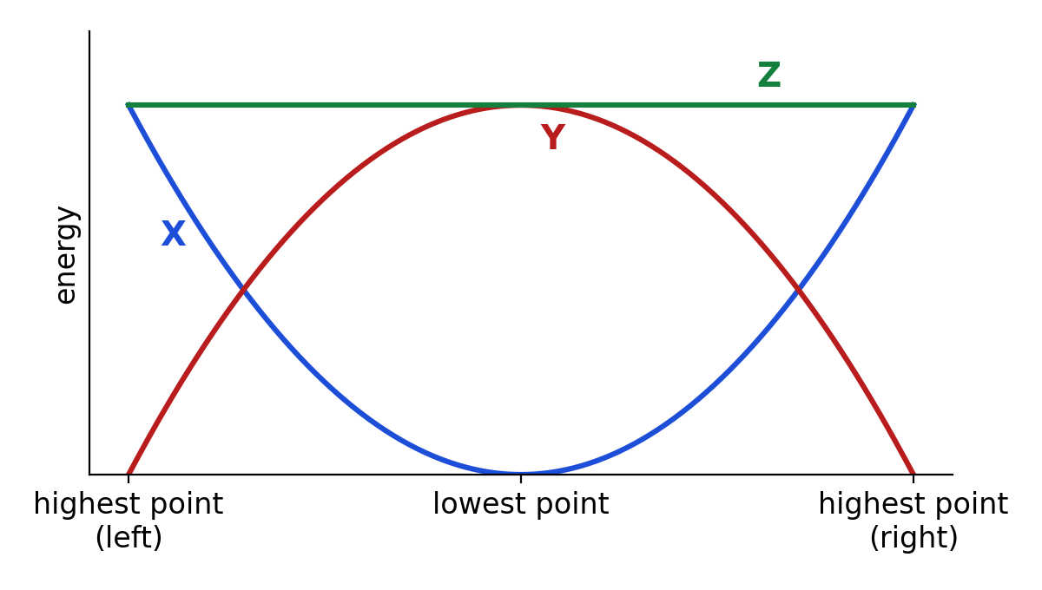
Fig. 1
X: ............................ Y: ............................ Z: ............................
(b) Describe how graph Z would change if there were air resistance. [1]

Part C: The Final Vault
Like the Final Vault in the game, there are 8 statements. Circle True or Trap. If a statement is a trap, correct it.
1. Energy can be created by a generator.
True / Trap Correction:
2. Holding a heavy box still above your head does no work on the box.
True / Trap Correction:
3. Doubling the speed of a bumper car doubles its kinetic energy.
True / Trap Correction:
4. A heavier coaster cart reaches a higher speed at the bottom of a frictionless drop.
True / Trap Correction:
5. The rider who does more work always has the greater power.
True / Trap Correction:
6. A machine can have an efficiency of 120%.
True / Trap Correction:
7. Solar energy is a renewable energy resource.
True / Trap Correction:
8. On a frictionless pirate ship, KE + GPE stays constant throughout the swing.
True / Trap Correction:

Part D: Practice Questions
D1 A motor pulls a 400 kg roller coaster car to the top of a 30 m lift hill in 40 s.
(a) Calculate the GPE gained by the car. [2]
GPE = ................ J
(b) Calculate the useful power output of the motor. [2]
power = ................ W
(c) The motor's input power is 5 000 W. Calculate its efficiency. [2]
efficiency = ................ %
(d) The car then rolls from rest down the full 30 m. Calculate its maximum possible speed at the bottom, and state one reason why the real speed is lower. [3]

TEACHER COPY
Answer Key: Blackout at Adventure Theme Park

Data
Useful equations (take g = 10 N/kg)
W = F × d KE = ½mv² GPE = mgh P = W ÷ t = E ÷ t efficiency = useful energy output ÷ total energy input × 100%

Part A: Switch the Park Back On
On the sim: Choose Solo or Team mode. Clear the rides (stations) to restore power and unlock the Final Vault. In the vault, sort true statements from traps; you need 7 of 8 correct.
A1 Record your progress. For each station you clear, note one misconception it warned you about.
Station | Cleared (✓) | Misconception I learned about
The Control Room
The Loading Bay
The Bumper Cars
The Ferris Wheel
Thunder Coaster
The Drop Tower
The Generator Room
The Solar Farm
The Pirate Ship
Student's own records. Examples: energy gets used up; holding something still is work; doubling speed doubles KE; GPE depends on the path not the height; heavier carts go faster; more work means more power; efficiency above 100%; solar is non-renewable because the panels wear out.
A2 Record your final results.
Final time | Wrong answers | Hints used

Part B: Station Practice
The game's numbers change each time. Use these questions to practise the same skills. Take g = 10 N/kg.
B1 The Control Room: energy types and conversions
Situation | Energy conversion
A bungee jumper falls and the cord stretches | gravitational potential → kinetic → elastic potential
A phone is charged | electrical → chemical
A firework explodes | chemical → light + sound + thermal + kinetic
A wind turbine turns | kinetic → electrical
B2 The Loading Bay: work done
(a) Tick (✓) the situations in which work is done on the object. [2]
☑ Lifting a crate onto a shelf
☐ Holding a crate still above the ground
☐ Pushing hard against a wall that does not move
☑ Pushing a trolley 5 m along the floor
(b) A worker pushes a crate 4.0 m with a force of 50 N. Calculate the work done. [1]
W = 50 × 4.0 = 200 J
B3 The Bumper Cars: kinetic energy
(a) A bumper car and rider (total mass 200 kg) move at 3.0 m/s. Calculate the KE. [2]
KE = ½ × 200 × 3.0² = 900 J
(b) The speed is doubled. By what factor does the KE change? Explain. [2]
It becomes 4 times larger, because KE ∝ v² (2² = 4).
B4 The Ferris Wheel: gravitational potential energy
(a) A 60 kg rider is carried 25 m up to the top of the wheel. Calculate the GPE gained. [2]
GPE = 60 × 10 × 25 = 15 000 J
(b) Would the GPE gained change if the rider reached the same height by a longer, gentler path? Explain. [1]
No. GPE depends only on the vertical height gained, not the path taken.
B5 Thunder Coaster: conservation of energy
(a) A 500 kg cart starts from rest at the top of a 20 m drop. Ignoring friction, calculate its speed at the bottom. [3]
mgh = ½mv² → v = √(2gh) = √(2 × 10 × 20) = 20 m/s
(b) A heavier cart is used on the same drop. Does it reach a higher speed? Explain. [1]
No. The mass cancels (v = √(2gh)), so every cart reaches the same speed without friction.
(c) With friction, the cart's speed at the bottom is lower. Where does the 'missing' energy go? [1]
It is converted to thermal (heat) energy and sound by friction and air resistance.
B6 The Drop Tower: power
(a) A motor lifts an 80 kg rider 30 m in 12 s. Calculate the useful power output. [2]
W = 80 × 10 × 30 = 24 000 J; P = 24 000 ÷ 12 = 2 000 W
(b) In a stair race up 4.0 m of stairs, Ali (50 kg) takes 6.0 s and Ben (60 kg) takes 9.0 s. Who does more work? Who has more power? [3]
Ali: W = 2 000 J, P = 333 W. Ben: W = 2 400 J, P = 267 W. Ben does more work, but Ali has the greater power.
B7 The Generator Room: efficiency
(a) A generator receives 5 000 J of kinetic energy and produces 1 500 J of electrical energy. Calculate its efficiency. [2]
(1 500 ÷ 5 000) × 100 = 30%
(b) How much energy is wasted, and in what form is most of it lost? [2]
3 500 J, mostly as thermal energy (heat) due to friction and resistance, and some as sound.
B8 The Solar Farm: energy resources
(a) Classify each energy resource as renewable (R) or non-renewable (N). [3]
Resource | R / N | Resource | R / N
Solar | R | Coal | N
Wind | R | Natural gas | N
Hydroelectric | R | Nuclear (uranium) | N
(b) Give one advantage and one disadvantage of solar panels. [2]
Advantage: renewable / no greenhouse gas emissions while operating. Disadvantage: no output at night and less on cloudy days / large area needed.
B9 The Pirate Ship: energy graphs
(a) Fig. 1 shows how the energy of the swinging pirate ship changes during one swing, ignoring air resistance. Identify graphs X, Y and Z. [3]
Fig. 1
X: gravitational potential energy. Y: kinetic energy. Z: total energy (KE + GPE).
(b) Describe how graph Z would change if there were air resistance. [1]
Z would slope gradually downwards, because some energy is converted to thermal energy on each swing.

Part C: The Final Vault
Like the Final Vault in the game, there are 8 statements. Circle True or Trap. If a statement is a trap, correct it.
1. Energy can be created by a generator.
Trap. Energy cannot be created or destroyed; a generator converts kinetic energy into electrical energy.
2. Holding a heavy box still above your head does no work on the box.
True. The box does not move, so the distance moved is zero.
3. Doubling the speed of a bumper car doubles its kinetic energy.
Trap. KE ∝ v², so doubling v makes KE four times larger.
4. A heavier coaster cart reaches a higher speed at the bottom of a frictionless drop.
Trap. mgh = ½mv², so m cancels: v = √(2gh) for any mass.
5. The rider who does more work always has the greater power.
Trap. Power = work ÷ time; a rider who does less work faster can have more power.
6. A machine can have an efficiency of 120%.
Trap. Useful output can never exceed input, so efficiency is at most 100%.
7. Solar energy is a renewable energy resource.
True. It will not run out on a human timescale.
8. On a frictionless pirate ship, KE + GPE stays constant throughout the swing.
True. Energy is only converted between KE and GPE; the total is conserved.

Part D: Practice Questions
D1 A motor pulls a 400 kg roller coaster car to the top of a 30 m lift hill in 40 s.
(a) Calculate the GPE gained by the car. [2]
GPE = 400 × 10 × 30 = 120 000 J
(b) Calculate the useful power output of the motor. [2]
P = 120 000 ÷ 40 = 3 000 W
(c) The motor's input power is 5 000 W. Calculate its efficiency. [2]
(3 000 ÷ 5 000) × 100 = 60%
(d) The car then rolls from rest down the full 30 m. Calculate its maximum possible speed at the bottom, and state one reason why the real speed is lower. [3]
v = √(2 × 10 × 30) = √600 = 24.5 m/s. Real speed is lower because some energy is converted to thermal energy by friction and air resistance.

